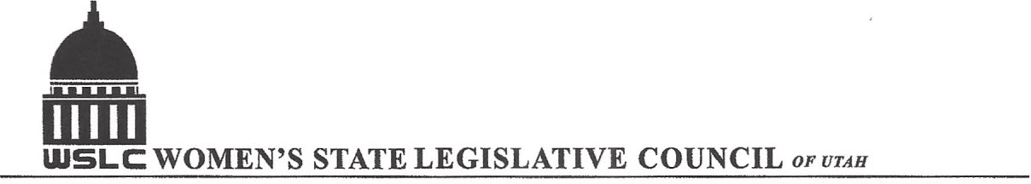
SALT LAKE CITY, UTAH
GENERAL SESSION AGENDA

WEDNESDAY, SEPTEMBER 27, 2017
12:00-1:30 PM COPPER ROOM

12:00 PM CALL TO ORDER/WELCOME: PRESIDENT SUZANNE MULET
PLEDGE OF ALLEGIANCE:
TREASURER’S REPORT: GWEN SPRINMEYER
MEMBERSHIP REPORT: PRESIDENT ELECT JOSIE VALDEZ
UNFINISHED BUSINESS
NEW BUSINESS: BOARD CHANGES AND APPOINTMENTS
PROGRAM UNDER THE DIRECTION OF STATE ISSUES: SHAUNA SCOTT-BELLACCOMO AND KENDRA SEELEY
12:15-12:45 PM: Mayor Jackie Biskupski
12:45-1:30: TBA
ADJOURN 1:30 PM
ANNOUNCEMENTS: NEXT MTG NATIONAL ISSUES- OCT 18, 2017 @COPPER ROOM 12 -1:30 PM
THANKS TO ALL WHO ASSISTED WITH TODAY’S PROGRAM
TO JOIN WOMEN’S STATE LEGISLATIVE COUNCIL, CONTACT GWEN SPRINMEYER: treasurer@wslcofutah.org
FOR MORE INFORMATION VISIT OUR WEBSITE: www.wslcofutah.org or Facebook page

