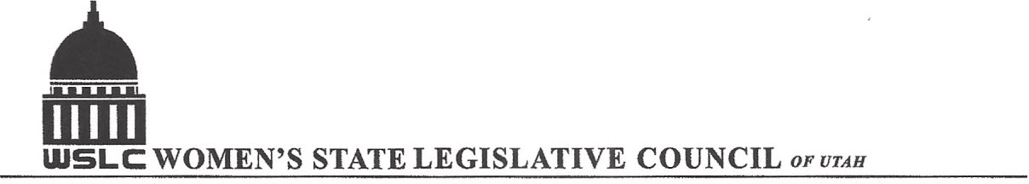
SALT LAKE CITY, UTAH

GENERAL SESSION AGENDA

WEDNESDAY, FEBRUARY 24, 2016
12PM-1:30 PM OLMSTEAD ROOM

12:00 PM CALL TO ORDER/WELCOME: PRESIDENT SHAUNA SCOTT-BELLACCOMO
PLEDGE OF ALLEGIANCE: JULIE FERRIN
INSPIRATIONAL THOUGHT: CAROL HARLEY
MINUTES: KATIE WITT
TREASURER’S REPORT: RENEE LOWREY
MEMBERSHIP REPORT: PRESIDENT ELECT SUZANNE MULET
UNFINISHED BUSINESS
NEW BUSINESS
PROGRAM BY NATURAL RESOURCES CHAIRS KIMBER GABRYSZAK & KENDRA SEELY
12:15-12:30 PM: HB 144 Food Freedom Act, Rep. Marc Roberts (R)
12:30-12:45 PM: Sterling Brown, Farm Bureau, con
12:45-1:00 PM: HB 157 Age Limit for Tobacco and Related Products, Sen. Brian Shiozawa (R)
1:00- 1:15 PM: Dave Davis, Utah Food Industry Association, con
1:15- 1:30 PM: Resolution
1:30- 1:45 PM: HB 249 Statute of Limitations Reform Amendments, Rep. Ken Ivory (R)
ADJOURN 2:00 PM
ANNOUNCEMENTS: NEXT GENERAL MTG March 2, 2016 @Copper ROOM 12 -1:30 PM
THANKS TO ALL WHO ASSISTED WITH TODAY’S PROGRAM
TO JOIN WOMEN’S STATE LEGISLATIVE COUNCIL, CONTACT RENEE LOWREY: treasurer@wslcofutah.org
FOR MORE INFORMATION VISIT OUR WEBSITE: www.wslcofutah.org or Facebook page

