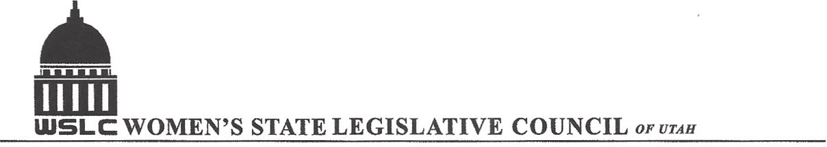
SALT LAKE CITY, UTAH
GENERAL SESSION AGENDA
WEDNESDAY, OCTOBER 12, 2016
12:00-2:00 PM ASPEN ROOM

12:00 PM CALL TO ORDER/WELCOME: PRESIDENT SHAUNA SCOTT-BELLACCOMO PLEDGE OF ALLEGIANCE: LORRAINE TURNER MINUTES: KATIE WITT TREASURER’S REPORT: SHANNON HUFF JACOBS MEMBERSHIP REPORT: PRESIDENT ELECT SUZANNE MULET UNFINISHED BUSINESS NEW BUSINESS: APPOINT SHANNON
PROGRAM UNDER THE DIRECTION OF NATIONAL ISSUES: MELANIE BOWEN & JOSIE VALDEZ
UNITED STATE SENATE 12:20-12:30 pm: Allyson Bell for Senator Mike Lee (R) 12:30-12:40 pm: Rikkie Wells for Misty K. Snow (D)
1st CONGRESSIONAL DISTRICT 12:40-12:50 pm: Peter Clemens (D) 12:50-1:00 pm: Andy Pierucci for Congressman Rob Bishop (R)
2nd CONGRESSIONAL DISTRICT 1:00-1:10 pm: Charlene Albarron (D) 1:10-1:20 pm: Candice Pierucci for Congressman Chris Stewart (R)
3rd CONGRESSIONAL DISTRICT 1:20-1:30 pm: Stephen Tryon (D) 1:30-1:40 pm: Congressman Jason Chaffetz (R)
4th CONGRESSIONAL DISTRICT 1:40-1:50 pm: Congresswoman Mia Love (R) 1:50-2:00 pm: Doug Owens (D)
ADJOURN 2:00 PM ANNOUNCEMENTS: NEXT GENERAL MTG JAN. 18, 2017 COPPER ROOM 12 – 1:30 PM
**HOLIDAY LUNCHEON DEC. 7, 2016 AT LITTLE AMERICA HOTEL< WYOMING RM FROM 12 -2:30 PM** RSVP WITH CHECK TO SUSAN VAUGHN – SEE FLYER THANKS TO ALL WHO ASSISTED WITH TODAY’S PROGRAM
TO JOIN WOMEN’S STATE LEGISLATIVE COUNCIL, CONTACT SUZANNE MULET: treasurer@wslcofutah.org FOR MORE INFORMATION VISIT OUR WEBSITE: www.wslcofutah.org or Facebook page

