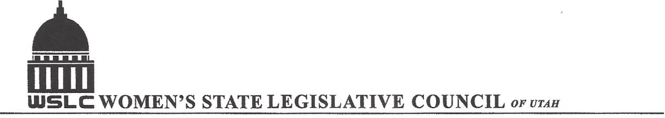
SALT LAKE CITY, UTAH

GENERAL SESSION AGENDA

WEDNESDAY, FEBRUARY 3, 2016
12PM-1:30 PM COPPER ROOM

12:00 PM CALL TO ORDER/WELCOME: PRESIDENT SHAUNA SCOTT-BELLACCOMO
PLEDGE OF ALLEGIANCE: BRANDY FARMER
INSPIRATIONAL THOUGHT: LORRAINE TURNER
MINUTES: KATIE WITT
TREASURER’S REPORT: RENEE LOWREY
MEMBERSHIP REPORT: PRESIDENT ELECT SUZANNE MULET
UNFINISHED BUSINESS
NEW BUSINESS
PROGRAM UNDER DIRECTION OF EDUCATION COMMITTEE: ERIN PRESTON & SERAYA AMIRTHALINGAM
BILLS: S.J.R.4; SB 43; HB 164: SPEAKERS TO BE ANNOUNCED
ADJOURN 1:30 PM

ANNOUNCEMENTS: NEXT GENERAL MTG FEB 10, 2016 @COOPER ROOM 12 -1:30 PM UNDER DIRECTION OF BUSINESS/LABOR COMMITTEE
THANKS TO ALL WHO ASSISTED WITH TODAY’S PROGRAM
TO JOIN WOMEN’S STATE LEGISLATIVE COUNCIL, CONTACT RENEE LOWREY: treasurer@wslcofutah.org
FOR MORE INFORMATION VISIT OUR WEBSITE: www.wslcofutah.org or Facebook page

