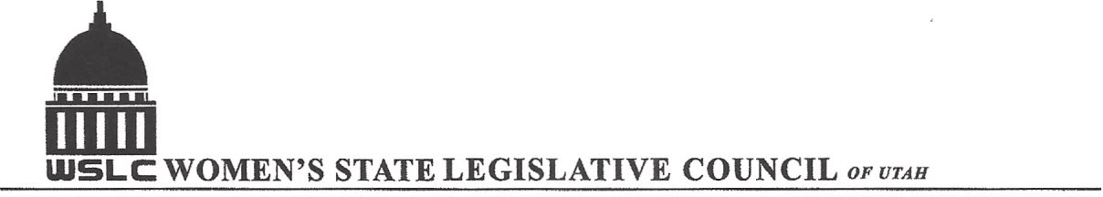
SALT LAKE CITY, UTAH

GENERAL SESSION AGENDA

WEDNESDAY, FEBRUARY 3, 2016
12PM-1:30 PM COPPER ROOM

12:00 PM CALL TO ORDER/WELCOME: PRESIDENT SHAUNA SCOTT-BELLACCOMO
PLEDGE OF ALLEGIANCE: BRANDY FARMER
INSPIRATIONAL THOUGHT: LORRAINE TURNER
MINUTES: KATIE WITT
TREASURER’S REPORT: RENEE LOWREY
MEMBERSHIP REPORT: PRESIDENT ELECT SUZANNE MULET
UNFINISHED BUSINESS
NEW BUSINESS
PROGRAM UNDER DIRECTION OF EDUCATION COMMITTEE: ERIN PRESTON & SERAYA AMIRTHALINGAM
12:20-12:40 PM: S.J.R.4 Proposal to Amend Utah Constitution-Education Funding, Sen. Jim Dabakis (D)
12:45-1:05 PM: SB 43 Firearm Safety and Violence Prevention in Public Schools, Sen. Todd Weiler (R)
1:10-1:30 PM: HB 164 Educational Testing Amendments, Rep. Kraig Powell (R)
ADJOURN 1:30 PM
ANNOUNCEMENTS: NEXT GENERAL MTG FEB 10, 2016 @COOPER ROOM 12 -1:30 PM UNDER DIRECTION OF BUSINESS/LABOR COMMITTEE
THANKS TO ALL WHO ASSISTED WITH TODAY’S PROGRAM
TO JOIN WOMEN’S STATE LEGISLATIVE COUNCIL, CONTACT RENEE LOWREY: treasurer@wslcofutah.org
FOR MORE INFORMATION VISIT OUR WEBSITE: www.wslcofutah.org or Facebook page

