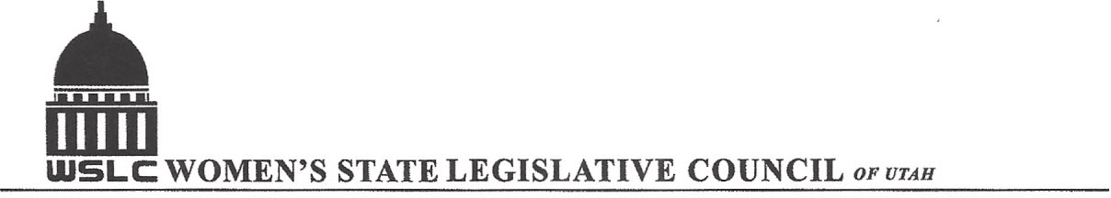
SALT LAKE CITY, UTAH

GENERAL SESSION AGENDA
WEDNESDAY, FEBRUARY 22, 2017
COPPER ROOM, CAPITOL 12:00-1:30 PM

12:00 PM CALL TO ORDER & WELCOME: PRESIDENT SHAUNA SCOTT-BELLACCOMO
PLEDGE OF ALLEGIANCE: CAROL HARLEY
MINUTES: KATIE WITT
TREASURER’S REPORT: SHANNON HUFF JACOBS
MEMBERSHIP REPORT: PRESIDENT ELECT SUZANNE MULET

PROGRAM UNDER DIRECTION OF EDUCATION: ERIN PRESTON & SERAYA AMIRTHALINGAM
12:05 -12:20 PM: SB80 School Funding Sen. Lincoln Fillmore ( R)
12:20-12:35 PM: Rep. Carol Spackman-Moss (D) speaking in opposition
12:35-12:50 PM: HB215 Reproductive Health Education and Services, Rep. Brian King (D)
12:55-1:10 PM: Opposition Speaker

1:15-1:30 PM: Bylaw Proposals

ADJOURN 1:45 PM THANKS TO ALL WHO ASSISTED WITH TODAY’S PROGRAM

ANNOUNCEMENTS: NEXT GENERAL MEETING March 1, 2017 IN THE COOPER RM

TO JOIN WOMEN’S STATE LEGISLATIVE COUNCIL, CONTACT SUZANNE MULET: treasurer@wslcofutah.org
FOR MORE INFORMATION VISIT OUR WEBSITE: www.wslcofutah.org or Facebook page

