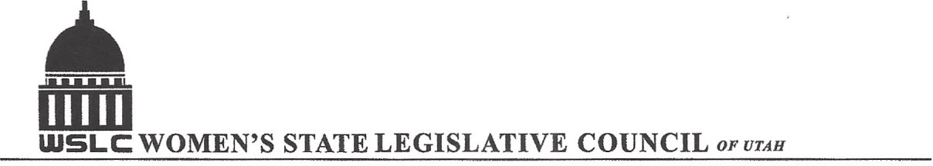
SALT LAKE CITY, UTAH

GENERAL SESSION AGENDA
WEDNESDAY, MARCH 1, 2017
COPPER ROOM, CAPITOL 12:00-1:30 PM

12:00 PM CALL TO ORDER & WELCOME: PRESIDENT SHAUNA SCOTT-BELLACCOMO
PLEDGE OF ALLEGIANCE: LORRAINE TURNER
MINUTES: KATIE WITT
TREASURER’S REPORT: SHANNON HUFF JACOBS
MEMBERSHIP REPORT: PRESIDENT ELECT SUZANNE MULET

PROGRAM BY JUDICIARY COMMITTEE: SOPHIA HAWES –TINGEY & KATHRYN GUSTAFSON
12:15-12:45 PM: HB198 Concealed Carry Amendments, Rep. Karianne Lisonbee (R)
Opposition: Dr. Ellen Brady
12:45-1:00 PM: Resolution
1:00-1:20 PM: HB 369 Sexual Offenses and Statutory Nonconsent, Rep. Justin Fawson ( R)

1:20-1:30 PM: UNFINISHED BUSINESS: BYLAW PROPOSALS /NOMINATING COMMITTEE

ADJOURN 1:45 PM THANKS TO ALL WHO ASSISTED WITH TODAY’S PROGRAM

ANNOUNCEMENTS: NEXT GENERAL MEETING March 8, 2017 IN THE COOPER RM

TO JOIN WOMEN’S STATE LEGISLATIVE COUNCIL, CONTACT SUZANNE MULET: treasurer@wslcofutah.org
FOR MORE INFORMATION VISIT OUR WEBSITE: www.wslcofutah.org or Facebook page

