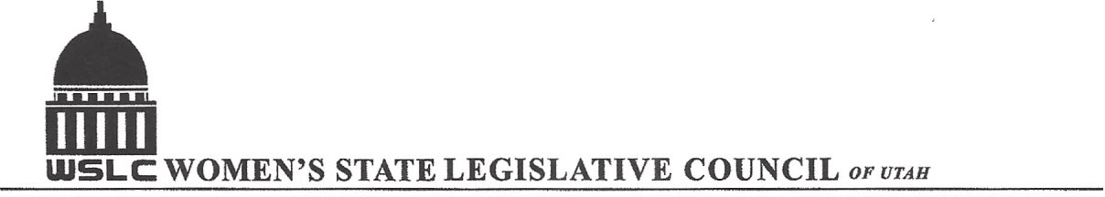
SALT LAKE CITY, UTAH

GENERAL SESSION AGENDA

WEDNESDAY, FEBRUARY 10, 2016
12PM-1:30 PM COPPER ROOM

12:00 PM CALL TO ORDER/WELCOME: PRESIDENT SHAUNA SCOTT-BELLACCOMO
PLEDGE OF ALLEGIANCE: CAROL HARLEY
INSPIRATIONAL THOUGHT: JOSIE VALDEZ
MINUTES: KATIE WITT
TREASURER’S REPORT: RENEE LOWREY
MEMBERSHIP REPORT: PRESIDENT ELECT SUZANNE MULET
UNFINISHED BUSINESS
NEW BUSINESS
PROGRAM BY BUSINESS/LABOR COMMITTEE: BRANDY FARMER & MARGOT THOMPSON
12:15-12:30 PM: HB 188 Paid Parental Leave, Rep. Angela Romero (D)
12:30-12:45 PM: Response by Sen. Todd Weiler (R)
12:45-1:00 PM: SB 59 Pregnancy Protection, Sen. Todd Weiler (R)
1:00- 1:15 PM: Response to SB 59________________________
ADJOURN 1:30 PM
ANNOUNCEMENTS: NEXT GENERAL MTG FEB 17, 2016 @COOPER ROOM 12 -1:30 PM UNDER DIRECTION OF HEALTH & HUMAN RESOUCES
THANKS TO ALL WHO ASSISTED WITH TODAY’S PROGRAM

TO JOIN WOMEN’S STATE LEGISLATIVE COUNCIL, CONTACT RENEE LOWREY: treasurer@wslcofutah.org
FOR MORE INFORMATION VISIT OUR WEBSITE: www.wslcofutah.org or Facebook page

