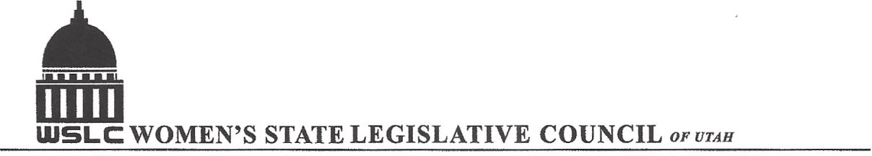
SALT LAKE CITY, UTAH
GENERAL SESSION AGENDA

WEDNESDAY, JANUARY 24, 2018
12:00-1:30 PM GOLD ROOM

12:00 PM CALL TO ORDER/WELCOME: PRESIDENT SUZANNE MULET
PLEDGE OF ALLEGIANCE: JEANNE BOWEN
INSPIRATIONAL THOUGHT: NANCY LORD
TREASURER’S REPORT: GWEN SPRINMEYER
MEMBERSHIP REPORT: PRESIDENT ELECT JOSIE VALDEZ
UNFINISHED BUSINESS:
NEW BUSINESS:
PROGRAM UNDER THE DIRECTION: SHAUNA SCOTT-BELLACCOMO AND KENDRA SEELEY
12:20 PM HONORABLE LT. GOVERNOR SPENCER J. COX
12:50 PM SPEAKER OF THE HOUSE, REPRESENTATIVE GREG H. HUGHES
1:20 PM WRAP UP
ADJOURN 1:30 PM
ANNOUNCEMENTS: NEXT MTG JUDICIARY - WEDNESDAY, JAN. 31, 2018 @COPPER ROOM 12:00 -1:30PM
THANKS TO ALL WHO ASSISTED WITH TODAY’S PROGRAM
TO JOIN WOMEN’S STATE LEGISLATIVE COUNCIL, CONTACT GWEN SPRINMEYER: treasurer@wslcofutah.org
FOR MORE INFORMATION VISIT OUR WEBSITE: www.wslcofutah.org or Facebook page

