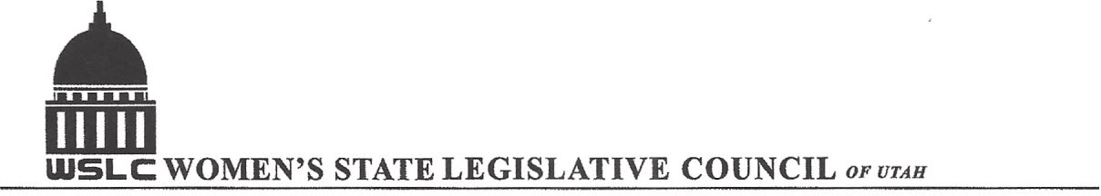
SALT LAKE CITY, UTAH

GENERAL SESSION AGENDA
WEDNESDAY, FEBRUARY 15, 2017
COPPER ROOM, CAPITOL 12:00-1:30 PM

12:00 PM CALL TO ORDER & WELCOME: PRESIDENT SHAUNA SCOTT-BELLACCOMO
PLEDGE OF ALLEGIANCE: KARI MALKOVICH
MINUTES: KATIE WITT
TREASURER’S REPORT: SHANNON HUFF JACOBS
MEMBERSHIP REPORT: PRESIDENT ELECT SUZANNE MULET

PROGRAM UNDER DIRECTION OF NATURAL RESOURCES COMMITTEE & HEALTH AND HUMAN SERVICES
12:05 -12:20 PM: SB105 Sale of State Lands Act, Sen. Gene Davis (D)
12:20-12:40 PM: HCR11 Concurrent Resolution to Rescind Bear’s Ears Monument, Rep. Greg Huges (R )
1:00- 1:15 PM: HB154 Telehealth Amendments

1:15-1:30 PM: Bylaw Proposals

ADJOURN 2 PM THANKS TO ALL WHO ASSISTED WITH TODAY’S PROGRAM

ANNOUNCEMENTS: NEXT GENERAL MEETING FEBRUARY 22, 2017 IN THE COOPER RM

TO JOIN WOMEN’S STATE LEGISLATIVE COUNCIL, CONTACT SUZANNE MULET: treasurer@wslcofutah.org
FOR MORE INFORMATION VISIT OUR WEBSITE: www.wslcofutah.org or Facebook page

