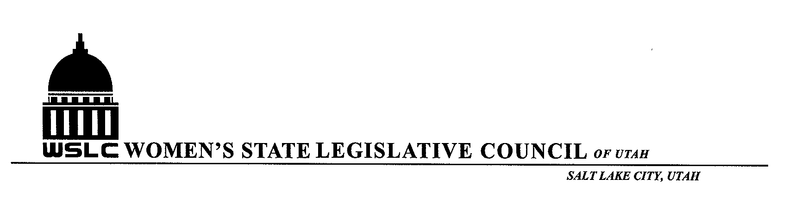

WSLC MEETING CALENDAR 2016-2017

SEPT. 21, 2016: STATE ISSUES @ COPPER ROOM, CAPITOL
OCT. 12, 2016: NATIONAL ISSUES @ ASPEN RM
DEC. 7, 2016: HOLIDAY LUNCHEON @ LITTLE AMERICA
JAN. 18, 2017: GENERAL MEETING WITH GOVERNOR @ GOLD ROOM, CAPITOL
JAN. 25, 2017: GENERAL MEETING @ COPPER RM
FEB.1, 2017 GENERAL MEETING @ COPPER RM
FEB. 8, 2017: GENERAL MEETING @ COPPER RM
FEB. 15, 2017: GENERAL MEETING @ COPPER RM
FEB. 22, 2017: GENERAL MEETING @ COPPER RM
MARCH 1, 2017: GENERAL MEETING @ COPPER RM
MARCH 8, 2017: GENERAL MEETING @ COPPER RM
MARCH 15, 2017: GENERAL MEETING @ COPPER RM
INSTALLATION LUNCHEON & TREE PLANTING CEREMONY TBA

ALL EXECUTIVE BOARD MEETINGS 10:30-11:30 IN COPPER ROOM
ALL GENERAL MEETINGS 12:00 PM-1:30 PM
UTAH STATE LEGISLATIVE SESSION: JAN. 23, 2017- MARCH 9, 2017

