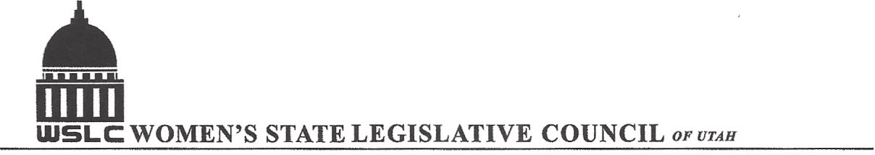
SALT LAKE CITY, UTAH

GENERAL SESSION AGENDA
WEDNESDAY, MARCH 15, 2017
COPPER ROOM, CAPITOL 12:00-2:00 PM

12:00 PM CALL TO ORDER & WELCOME: PRESIDENT SHAUNA SCOTT-BELLACCOMO
PLEDGE OF ALLEGIANCE: LORRAINE TURNER
MINUTES: KATIE WITT
TREASURER’S REPORT: SHANNON HUFF JACOBS
MEMBERSHIP REPORT: PRESIDENT ELECT SUZANNE MULET

NEW BUSINESS: ELECTIONS COMMITTEE CHAIR CAROL HARLEY
CANDIDATE SPEECHES 1 MINUTE EACH EXCEPT PRES. ELECT 3 MINS
OPEN VOTING 12:30-1:15 PM OUTSIDE ROOM

CANDIDATE SPEECHES: PRESIDENT ELECT, FIRST VICE CHAIR, CORRESPONDING
SECRETARY, TREASURER, HISTORIAN, DIRECTORS

PROGRAM BY STATE ISSUES: KARI MALKOVICH & SERAYA AMIRTHALINGAM
12:30-1:00 PM PETER CORROON, DEMOCRATIC STATE PARTY CHAIR
JAMES EVANS, REPUBLICAN STATE PARTY CHAIR

1:00-1:10 PM WSLC BIENNIUM PRESIDENT’S REPORT: SHAUNA SCOTT-BELLACCOMO
1:15 PM CLOSE BALLOTING
1:15-1:45 PM UNFINISHED BUSINESS: HOLIDAY/LUNCHEON COMMITTEE

1:45 PM ANNOUNCE ELECTION RESULTS

ADJOURN 2 PM THANKS TO ALL WHO ASSISTED WITH TODAY’S PROGRAM

ANNOUNCEMENTS: INSTALLATION LUNCHEON MARCH 29TH AT LITTLE AMERICA
TREE PLANTING CEREMONY FRIDAY, MAY 19TH 11 AM AT THIS IS THE PLACE PARK
PLEASE RSVP FOR THE ABOVE EVENTS TO SUSAN VAUGHN PH# 801-262-7757

TO JOIN WOMEN’S STATE LEGISLATIVE COUNCIL, CONTACT SUZANNE MULET: treasurer@wslcofutah.org
FOR MORE INFORMATION VISIT OUR WEBSITE: www.wslcofutah.org or Facebook page

