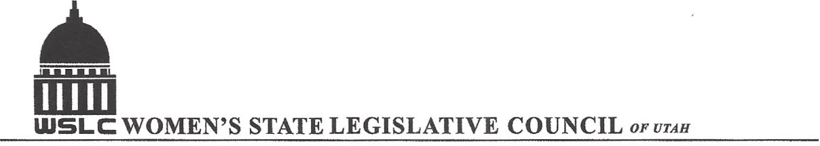
SALT LAKE CITY, UTAH
GENERAL SESSION AGENDA

WEDNESDAY, MARCH 9, 2016
12PM-2 PM COPPER ROOM

12:00 PM CALL TO ORDER/WELCOME: PRESIDENT SHAUNA SCOTT-BELLACCOMO
PLEDGE OF ALLEGIANCE: HEATHER WILLIAMSON
INSPIRATIONAL THOUGHT: SUZANNE MULET
MINUTES: KATIE WITT
TREASURER’S REPORT: RENEE LOWREY
MEMBERSHIP REPORT: PRESIDENT ELECT SUZANNE MULET
UNFINISHED BUSINESS
NEW BUSINESS
PROGRAM BY NATURAL RESOURSES & BUSINESS/LABOR COMMITTEES: KIMBER G. & BRANDY F.
12:15-12:30 PM: Utah Public Lands Initiative Act, Rep. Rob Bishop’s office
12:30-12:45 PM: David Garbett, Staff Attorney Southern Wilderness Alliance
12:45-1:00 PM: SB 235 Local District Tax Revisions, Sen. Lincoln Fillmore (R)
1:00- 1:15 PM: Con: Overstock.com
1:15- 1:30 PM: Updates on Bills
ADJOURN 2:00 PM
ANNOUNCEMENTS: NEXT MTG March 16, 2016 @COPPER ROOM 12 -1:30 PM
LEGISLATIVE WRAP UP MEETING WITH BOXED LUNCHES-PLEASE RSVP YOUR ORDER & PAY BY MARCH 9TH
TO: shjacobs@veracitynetworks.net SEE FLYER FOR MORE DETAILS
THANKS TO ALL WHO ASSISTED WITH TODAY’S PROGRAM
TO JOIN WOMEN’S STATE LEGISLATIVE COUNCIL, CONTACT RENEE LOWREY: treasurer@wslcofutah.org
FOR MORE INFORMATION VISIT OUR WEBSITE: www.wslcofutah.org or Facebook page

