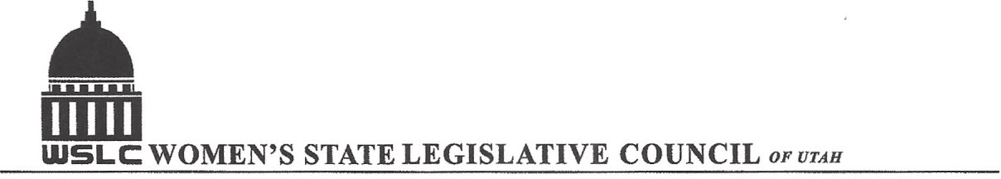
SALT LAKE CITY, UTAH
GENERAL SESSION AGENDA

WEDNESDAY, OCTOBER 18, 2017
12:00-1:30 PM COPPER ROOM

12:00 PM CALL TO ORDER/WELCOME: PRESIDENT SUZANNE MULET
PLEDGE OF ALLEGIANCE: HOLLY TREE-RICHARDSON
INSPIRATIONAL THOUGHT: CELINA MILNER
TREASURER’S REPORT: GWEN SPRINMEYER
MEMBERSHIP REPORT: PRESIDENT ELECT JOSIE VALDEZ
UNFINISHED BUSINESS
NEW BUSINESS: BOARD CHANGES AND APPOINTMENTS
PROGRAM UNDER THE DIRECTION OF NATIONAL ISSUES: SHAUNA SCOTT-BELLACCOMO AND KENDRA SEELEY
12:15-12:35PM CANDIDATES FOR 3RD CONGRESSIONAL DISTRICT
12:20 DR. KATHIE ALLEN, (D) CANDIDATE FOR 3RD CONGRESSIONAL DISTRICT
12:30 JOHN CURTIS, (R) CANDIDATE FOR 3RD CONGRESSIONAL DISTRICT (SURROGATE)
12:40-1:00PM JOHN VALENTINE, UTAH STATE TAX COMMSIONER – TAX REFORM – WHAT WE NEED TO KNOW
1:00-1:20PM CARINE CLARK, CEO BANYAN – THE STATE OF WOMEN IN HIGH TECH IN OUR STATE AND NATION
1:20-1:30PM WRAP UP
ADJOURN 1:30 PM
ANNOUNCEMENTS: NEXT MTG PRE-LEGISLATIVE ISSUES - JAN 24, 2018 @COPPER ROOM 12:00 -1:30PM
THANKS TO ALL WHO ASSISTED WITH TODAY’S PROGRAM
TO JOIN WOMEN’S STATE LEGISLATIVE COUNCIL, CONTACT GWEN SPRINMEYER: treasurer@wslcofutah.org
FOR MORE INFORMATION VISIT OUR WEBSITE: www.wslcofutah.org or Facebook page

