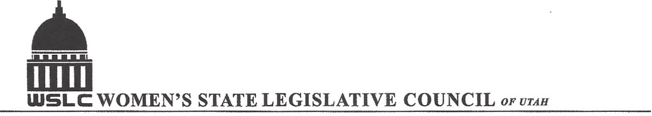
SALT LAKE CITY, UTAH

GENERAL SESSION AGENDA

WEDNESDAY, MARCH 2, 2016
12PM-2 PM COPPER ROOM

12:00 PM CALL TO ORDER/WELCOME: PRESIDENT SHAUNA SCOTT-BELLACCOMO
PLEDGE OF ALLEGIANCE: FRED ASH
INSPIRATIONAL THOUGHT: MARGOT THOMPSON
MINUTES: KATIE WITT
TREASURER’S REPORT: RENEE LOWREY
MEMBERSHIP REPORT: PRESIDENT ELECT SUZANNE MULET
UNFINISHED BUSINESS
NEW BUSINESS
PROGRAM BY EDUCATION & JUDICIARY COMMITTEES: Erin P., Seraya A, Taylor R., Catherine S.
12:15-12:30 PM: HB 365 Campus Free Expression Act, Rep. Kim Coleman (R)
12:30-12:45 PM: Con:
12:45-1:00 PM: HB 262 Campus Anti-harassment Act, Rep. Kim Coleman (R)
1:00- 1:15 PM: Con:
1:15- 1:30 PM: SB 38 School Funding Amendments, Rep. Steve Eliason (R)
1:30- 1:45 PM: Con:
ADJOURN 2:00 PM
ANNOUNCEMENTS: NEXT GENERAL MTG March 9, 2016 @COPPER ROOM 12 -1:30 PM
THANKS TO ALL WHO ASSISTED WITH TODAY’S PROGRAM
TO JOIN WOMEN’S STATE LEGISLATIVE COUNCIL, CONTACT RENEE LOWREY: treasurer@wslcofutah.org
FOR MORE INFORMATION VISIT OUR WEBSITE: www.wslcofutah.org or Facebook page

