
President Elect (D)
Josie Valdez


Josie is a cum laude graduate of Westminster College with a degree in business and economics. Her long political history includes serving as vice chair of the Utah State Democratic Party and a candidate for Lieutenant Governor and the Utah Senate. Josie is retired from the position of Assistant Director of the Utah Small Business Administration.
After retirement, Josie served as a member of the Cabinet for Mayor Rocky Anderson as Director of Diversity. Josie has served on the following boards: Utah Small Business Development Council; Future’s Commission for Salt Lake City, Co-Chair; Murray Center for the Blind; Governor's Advisory Council on Hispanic Affairs; Entrepreneurship for Single Parents, Founder; United Way; Women's Network for Entrepreneurial Training, Founder; Phoenix Institute; Utah Bi-Partisan Hispanic Legislative Task Force; Governor’s Board for Women’s Economic Development ; NAACP-Salt Lake Branch; Toastmasters International; Hispanic Chamber of Commerce; Utah Women for Building Community; Salt Lake County Hispanic Democratic Caucus; Salt Lake Community Action Program.
Honors for Josie include: Utah Business Magazine 30 Women to Watch; 20 Top Latino Business Leaders; YWCA Distinguished Woman in Business; Salt Lake Chamber of Commerce Pathfinder; NAACP Rosa Parks Award, Utah Council of La Raza Cesar Chavez Peace and Justice Award and the Life Service Award from Utah Women’s Association for Building Communities.
Sophia Haws-Tingey
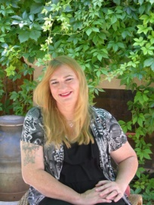
Sophia Hawes-Tingey became a member of the Women’s State Legislative Council in 2015 after having run for the Utah House of Representatives in 2014. In 2016, she accepted an appointment to the Board of Directors as Director of Judiciary. Sophia is active in her communities, having worked as an outspoken advocate for transgender women, the LGBTQ community, marginalized communities, and women’s rights. She is a fierce advocate for social justice, and for making Utah more welcoming, with concern for clean air, health care, and education. Her first experiences on the hill were lobbying for marriage equality and employment and housing protection for the LGBTQ community. As an advocate, she has built many connections with legislators and community leaders. A Navy Veteran and 24-year software engineer, she is the Vice Chair of the Community Council of Midvale City, Director of Communications for the Utah Gay & Lesbian Chamber of Commerce, and serves on the Board of Directors of the Utah Stonewall Democrats, the Board of Advisors to Restore Our Humanity, and the LGBT Advisory Board to the Democratic National Committee.In 2016 she served as a National Delegate to the Democratic National Convention in which she was able to successfully lobby for changes to the Democratic National Platform that were considered revolutionary at the time. She has also had active engagement with organizations like Equality Utah and ACLU. She is married to Danilynn Tingey, has two daughters from her first marriage, four grown stepchildren, and three step grandchildren.

First Vice President (R)
Kendra Seeley
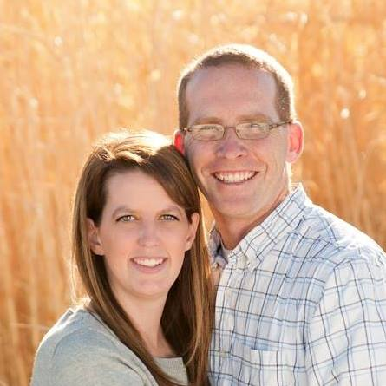
Kendra Seeley is a wife, mother, and political junkie.

She has always been a rural woman having graduated from Carbon High School and College of Eastern Utah before studying piano pedagogy at Utah State University.

She is currently the Chairwomen of the Carbon County Republican Party and serves on many various boards in Carbon County.

She drives the 4 hour round trip to the Capitol every Wednesday from Price. She currently is the co-chair of the natural resources committee. Kendra has four children and works as an event planner.

Lisa Bagley
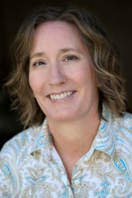

I grew up in Salt Lake City and graduated from the University of Utah with a BSdegree in Political Science. Raising four daughters, on three continents, and in five states has given me a unique perspective.
Civic involvement has always been important to me, so I strive to be informed, engaged, and active. I recently ran for Millcreek City Council. I was not successful, but I learned a great deal. Over the past couple of years:
- Appointed by Mayor Ben McAdam’s to serve on The Community Preservation Project Committee (unicorporated Salt Lake County).
- Appointed by the Salt Lake County Council to serve on the Zoo, Arts, & Parks Recreational Advisory Board June 2015-2016.
- Elected to serve as a member of The East Millcreek Community Council, 2015.
- Appointed to be Legislative Chair District 36, 2016.
- Elected Vice Chair of the Utah (VOAD) Volunteer Organizations Active in Disaster, Region 2, 2016.
- Serve as a member of the Women’s State Leadership Council (WSLC), 2016
- Involved with “Special Events Committee - Habitat for Humanity, 2017.
- Working with the “Strategic Analysis Team” - Girl Scouts of Utah, 2017.
- Serve as a member of “Community Engagement Committee” - MS Society, 2017.

To continue my education, I have recently completed the Women’s Leadership Institute (WLI) Political Development Series, 2016. I also earned an Effective Communication Certificate and the Nonprofit Academy of Excellence Certificate from the University of Utah Professional Education Program, 2015.
I am passionate about family, religious freedom for all, education, politics, disaster preparedness, response, and recovery. I enjoy skiing, hiking, and traveling.
Lorene Kamalu
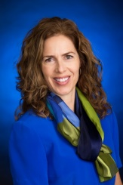

Management Consultant Ahmed Investments, Kaysville, Utah June 2014 – May 2016
- Raised capital; started monthly management meetings; worked with president to acquire CPA services
- Mentored a junior partner to improve operations at Murray e-commerce facility
- Assisted with special projects including public relations and startup of wholesale division

Other Accomplishments:
- Kaysville City Planning Commissioner; ran my own city council campaign & will next run for mayor
- Kaysville Rotary Vocational Services Chair; Kaysville-Farmington Active Transportation Committee
- Married 29 years, 5 children
- I enjoy people and make friends easily.
- Active, energetic, smiley, optimistic, influential
- Enjoy running, biking, canyoneering, entrepreneurship, making family photo books

- University of Utah; Executive MPA student with anticipated graduation in 2018; GPA 4.0 so far
- Brigham Young University; Bachelor of Science: Human Resources, Marriott School of Management. GPA 3.59

Corresponding Secretary (R)

Carol Harley
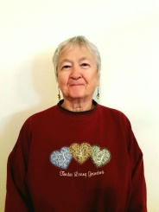

I’ve been a member of the WSLC for about 20 years. I’ve held the elected positions of 2nd VP twice, recording secretary and historian and was appointed as timekeeper for the 2009-2011 Biennium. I was president of the Weber County Legislative council for 4 years and held the position of treasurer and recording secretary as well.
I serve as treasurer on the board of St Mary’s Council of Catholic Women, and recording secretary of the Catholic Woman’s League and Church Women United of the Greater Ogden Area at the current time; I’m also on the board of the Church Women United State Steering Committee and the Diocesan Council of Catholic Women.
I’m a widow of 3 years, mother of a daughter and 3 sons, grandmother to 11 grandkids and have 19, soon to be 20 great grandchildren.
I’m a Republican and a candidate for Corresponding Secretary.
Treasurer (D)

Kathryn Gustafson

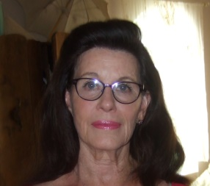

Lived in Granite, Utah District 9 since 1968
Mother of 7, 24 Grandchildren and 6 Great Grandchildren
Single Mother since 1983
Realtor since 1988
President Elect & President of Women's Council of Realtors
Women's Council of Realtors Referral & Fund Raising Chairman
Served on Realtors;
Governmental Affairs Committee,
Grievance Committee,
Professional Standards Committee &
Political Action Committee

Was a candidate for Senate in District 9 in 2014, ran against Wayne Niederhauser
Got 40% of the vote on $13,000, $7,000 was in kind, spending only about $6,000 in real money.

House, car etc is paid for with no other debts & money in the bank.

My record shows I handle money well.

Gwen Springmeyer
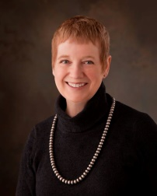
Gwen currently serves as the Grant Director for the Utah Clean Air Partnership, a position she has held since 2013. She is the former Executive Director of the Utah Nonprofits Association.
Gwen has been an active Democrat and has served on various board, panels and commissions within the Utah State Democratic Party. She is married to Bob Springmeyer who ran for Utah State Governor in 2008.
Gwen worked for the City of Salt Lake City serving as a Constituent Liaison in the Rocky Anderson Administration. She has also served as a member of the Greater Avenues Council and as a committee member of the Task Force on Racial and Ethnic Fairness.
She studied economics at the University of Utah and is a graduate of Olympus High School.
Historian (R)
Jessica Christopher
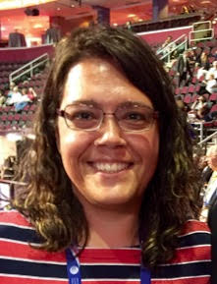
Jessica Christopher (R) graduated from Southern Utah University with degrees in Political Science and German. Her background includes work with the Utah Republican Party and various local and state-wide campaigns. She served as a senior advisor to Senator Bennett working on Social Security, health care, and housing issues. She joined Senator Lee’s staff in 2011 as his casework director where she also works on issues related to immigration, State Department, and Homeland Security. She is a Registered Parliamentarian and is currently serving as the WSLC Assistant Parliamentarian. She previously served as the WSLC Corresponding Secretary and Treasurer.

Director (D)
Margarita Satini
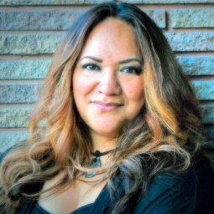
My name is Margarita Satini. I am a single mother of 4 adult children and grandmother to 3 beautiful grandchildren. I have lived in Utah since 1980 and have lived in Cottonwood Heights for nearly 7 years now. I have had a career in I.T. for 20+ years. Currently I am the Chair of the Utah Pacific Islander Civic Engagement Coalition, I am the Chair of the Salt Lake County CODA Law Enforcement Committee, and I am the Vice chair of Utah's AAPI Democratic Caucus. I do a lot of community service work and consider myself to be a political activist and advocate for my Pacific Islander Community.

Donna Murphy
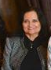
Donna has been a member of WSLC for many years and has served as previous Director of Health & Human Services as well as Education Committee and most recently as First Vice President of WSLC. She is willing to assist in whatever way she can to help the council succeed. Her profession as a Registered Nurse and is a practicing pediatric nurse at Shriner’s Hospital for Children and working as a Clinical Documentation Specialist at Intermountain Medical Center. Donna is a former Associate Professor and taught nursing for ten years. She has campaigned on presidential, gubernatorial, congressional, state senate and House representative seats. Donna would be honored to serve as director in any capacity as an ongoing effort to continue and move WSLC forward in a positive direction.
Gay Lynn Bennion
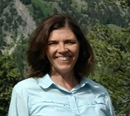
Gay Lynn Bennion was born and raised in Salt Lake City and graduated Cum Laude with a BA in English from BYU. She had an internship with the Federal Judicial Center in Washington D.C. and worked as an executive secretary for the Winston Carey Company and as an educational technician for Uniformed Services Health Sciences University. She served a church mission to Mexico. Her husband served in the Air Force for 26 years, during which time the family lived in 7 states.
She has been a co-chair, director and corresponding secretary for WSLC. She volunteers teaching English through English Skills Learning Center and was the recipient of their Bingham Literacy Legacy Award in 2016. She has been a leader of youth and women in her church and a volunteer in schools in several states. She is an avid hiker, mother of 4 adult children and will be a grandmother in May.

Director (R)
Erin Preston
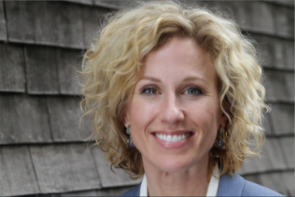
Erin Preston is an education attorney, experienced charter administrator, business woman and education advocate. Erin is currently an education attorney dedicated to providing legal services for schools, school districts, parents and students throughout Utah. In that role she often has the opportunity to work with legislators and others in helping advocate for effective legislation for Utah students.

She earned her B.A. and Law Degrees from Brigham Young University and is an attorney licensed with the Utah Bar. Her 25 year+ professional background includes work in the U.S. Senate, Securities & Exchange Commission, working as a Regional Manager for a legal publisher and then as a Founder, Builder and Administrator of a successful charter school and consultant to many other schools. Erin has worked to serve Utah students as a volunteer through the Children’s Justice Center, legislative task forces dedicated to serving the needs of kids, and as an education advocate.

Erin is the proud mother of two sons and lives in Herriman Utah.

Heather Williamson

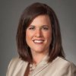

Heather is the State Deputy Director of the Utah chapter of Americans for Prosperity, the nation’s foremost network of grassroots advocates for economic freedom.

She specializes in strategic communications, community outreach, fundraising and government affairs.
She leads the effort to champion the principles of entrepreneurship and fiscal and regulatory restraint in Utah. She educates consumers, business owners, and the general public in Utah about the value and operation of an open and market-oriented economy that is free of government interference. She builds grassroots relations for the Utah state chapter of Americans for Prosperity and educates and mobilizes activists on state based policy issues and initiatives. She organizes and plans state and local education rallies and other grassroots events. And she represent the organization by attending and speaking at local events throughout Utah.

Education: Political Science and Government, BYU-I and UVU

Family: Heather is the mother of four amazing kids!

Holly Richardson
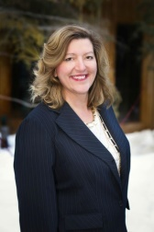
Holly Richardson is a wife, mother, small business owner and political activist, often known as "Holly on the Hill."
She is currently the Utah Women and Education Initiative Coordinator at Utah Valley University. She has served as a marketing and communications director for a state office, is a social media consultant, a popular speaker, writer and humanitarian. She is also excited to be working with women to help them create more margin in their lives so they can live a bigger story.
Holly has served in many political capacities, including State Representative, campaign manager, consultant, communication director and more.
Holly and her husband, Greg, are the parents of a large family, all but one in their teens or twenties. Holly is also delighted to be a grandma to six and a half adorable grandkids.
Between the politics and the large family, she has learned how to stay calm(ish) under intense pressure. Or maybe she's just kidding herself. Either way, she's a fan of pedicures and chocolate.....

