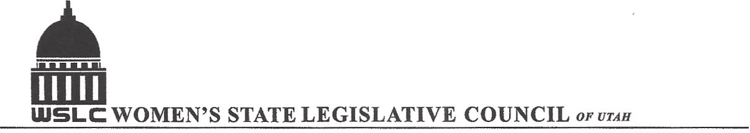
SALT LAKE CITY, UTAH

GENERAL SESSION AGENDA
WEDNESDAY, JANUARY 18, 2017
GOLD ROOM, CAPITOL 12:00-1:30 PM

12:00 PM CALL TO ORDER & WELCOME: PRESIDENT SHAUNA SCOTT-BELLACCOMO
PLEDGE OF ALLEGIANCE: LORRAINE TURNER
MINUTES: KATIE WITT
TREASURER’S REPORT: SHANNON HUFF JACOBS
MEMBERSHIP REPORT: PRESIDENT ELECT SUZANNE MULET

General Session
12:15 pm Governor Gary R. Herbert
1:00 pm Group photo with the Governor

ADJOURN 1:30 PM

ANNOUNCEMENTS: NEXT GENERAL MEETING IS IN THE COPPER ROOM ON JAN.25, 2017. WE WILL HONOR PAST PRESIDENTS KAREN THORN ON JAN. 25TH AND ANN DAHL ON FEB. 1ST BY PRESENTING THEIR FAMILIES WITH THE UTAH FLAG FLOWN AT THE CAPITOL THOSE DESIGNATED DAYS.
WE MEET EVERY WEDNESDAY DURING THE LEGISLATIVE SESSION JANUARY-MARCH 8, 2017 FOLLOWED BY A LEGISLATIVE WRAP-UP SESSION MARCH 15, 2017.

THANKS TO ALL WHO ASSISTED WITH TODAY’S PROGRAM

TO JOIN WOMEN’S STATE LEGISLATIVE COUNCIL, CONTACT SUZANNE MULET: treasurer@wslcofutah.org
FOR MORE INFORMATION VISIT OUR WEBSITE: www.wslcofutah.org or Facebook page

