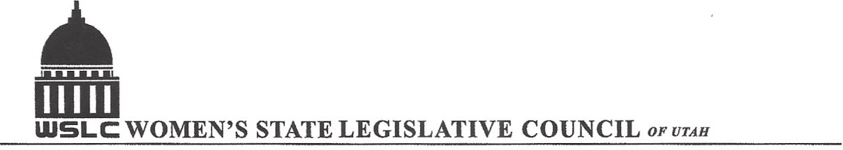
SALT LAKE CITY, UTAH

GENERAL SESSION AGENDA
WEDNESDAY, FEBRUARY 1, 2017
COPPER ROOM, CAPITOL 12:00-1:30 PM

12:00 PM CALL TO ORDER & WELCOME: PRESIDENT SHAUNA SCOTT-BELLACCOMO
PLEDGE OF ALLEGIANCE: LORRAINE TURNER
MINUTES: KATIE WITT
TREASURER’S REPORT: SHANNON HUFF JACOBS
MEMBERSHIP REPORT: PRESIDENT ELECT SUZANNE MULET

Program under direction of Judiciary/Law / Criminal Justice Committee Sophia Hawes-Tingey
12:15 -1:00 PM: SB29 Utah Marriage Commission Amendments
-Sen. Allen M Christensen, (R) Bill Sponsor

- Elaine Stehel, Licensed Minister

- Dr Alan Hawkins, Utah Marriage Commission

- Christopher Warton, Family Law, Criminal Defense, and LGBT Advocacy

1:00-1:45 PM: HB19 Civil Asset Forfeiture Reform Amendments
- Rep. Brian M Greene, (R) Bill Sponsor

- Darcy M Goddard, Chief Policy Officer, Civil Division, Salt Lake County District Attorney's Office

- Anna Broward, Public Relations, ACLU

- Will Carlson, Deputy District Attorney, Salt Lake County

ADJOURN 2 PM THANKS TO ALL WHO ASSISTED WITH TODAY’S PROGRAM

ANNOUNCEMENTS: NEXT GENERAL MEETING IS FEBRUARY 8, 2017 IN THE COOPER RM

TO JOIN WOMEN’S STATE LEGISLATIVE COUNCIL, CONTACT SUZANNE MULET: treasurer@wslcofutah.org
FOR MORE INFORMATION VISIT OUR WEBSITE: www.wslcofutah.org or Facebook page

