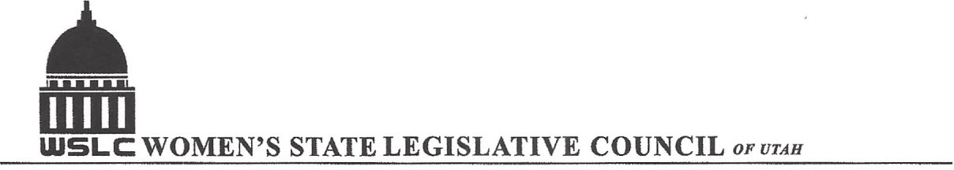
SALT LAKE CITY, UTAH

GENERAL SESSION AGENDA
WEDNESDAY, FEBRUARY 8, 2017
COPPER ROOM, CAPITOL 12:00-1:30 PM

12:00 PM CALL TO ORDER & WELCOME: PRESIDENT SHAUNA SCOTT-BELLACCOMO
PLEDGE OF ALLEGIANCE: LORRAINE TURNER
MINUTES: KATIE WITT
TREASURER’S REPORT: SHANNON HUFF JACOBS
MEMBERSHIP REPORT: PRESIDENT ELECT SUZANNE MULET

PROGRAM UNDER DIRECTION OF BUSINESS & LABOR COMMITTEE BRANDY FARMER
12:15 -12:30 PM: HB147 Living Wage Amendments, Rep. Lynn Hemingway (D)
12:30-12:45 PM: SB109S01 Small Employer Retirement Program, Rep. Todd Weiler (R)
12:45-1:15 PM: HB242 Family Medical Leave Amendments, Rep. Dixon Pitcher (R)
HB242 Stephanie Pitcher, Attorney
1:15-1:30 PM: Bylaw Proposals

ADJOURN 2 PM THANKS TO ALL WHO ASSISTED WITH TODAY’S PROGRAM

ANNOUNCEMENTS: NEXT GENERAL MEETING FEBRUARY 15, 2017 IN THE COOPER RM

TO JOIN WOMEN’S STATE LEGISLATIVE COUNCIL, CONTACT SUZANNE MULET: treasurer@wslcofutah.org
FOR MORE INFORMATION VISIT OUR WEBSITE: www.wslcofutah.org or Facebook page

