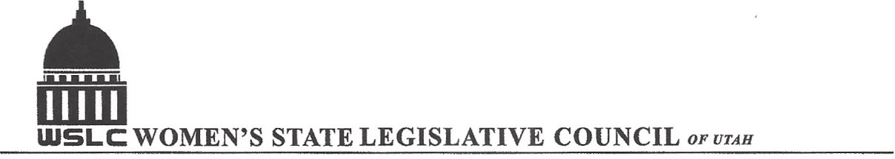
SALT LAKE CITY, UTAH
GENERAL SESSION AGENDA

WEDNESDAY, SEPTEMBER 21, 2017
12:00-2:00 PM COPPER ROOM

12:00 PM CALL TO ORDER/WELCOME: PRESIDENT SHAUNA SCOTT-BELLACCOMO
PLEDGE OF ALLEGIANCE: LORRAINE TURNER
MINUTES: KATIE WITT
TREASURER’S REPORT: RENEE LOWREY
MEMBERSHIP REPORT: PRESIDENT ELECT SUZANNE MULET
UNFINISHED BUSINESS
NEW BUSINESS: KITTY KAPLAN MEMORIAL
PROGRAM UNDER THE DIRECTION OF STATE ISSUES: KARI MALKOVICH & SERAYA AMIRTHALINGAM
12:15-12:27 PM: Lt. Governor Spencer Cox (Gov. Gary Herbert, R)
12:28-12:40 PM: Mike Weinholtz (D) Governor Candidate
12:40-12:52 PM: Jon Harper(D) Attorney General
12:52- 1:04 PM: Attorney General Sean Reyes (R)
1:04- 1:16 PM: State Auditor John Dugall (R)
1:16- 1:28 PM: Mike Mitchell (D) State Auditor
1:28- 1:40 PM: State Treasurer David Damschen (R)
1:40- 1:52 PM: Neil Hansen (D) State Treasurer
ADJOURN 2:00 PM
ANNOUNCEMENTS: NEXT MTG NATIONAL ISSUES- OCT 12, 2016 @ASPEN ROOM 12 -1:30 PM
THANKS TO ALL WHO ASSISTED WITH TODAY’S PROGRAM
TO JOIN WOMEN’S STATE LEGISLATIVE COUNCIL, CONTACT RENEE LOWREY: treasurer@wslcofutah.org
FOR MORE INFORMATION VISIT OUR WEBSITE: www.wslcofutah.org or Facebook page

