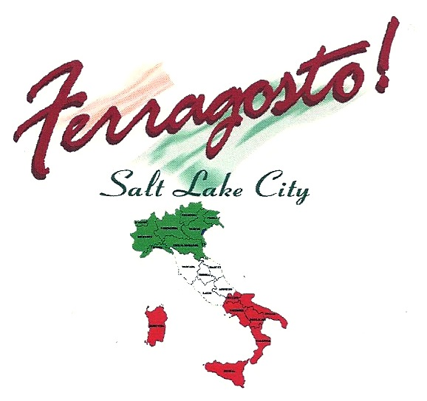
St. Ambrose Parish Italian Festival
August 24-25, 2012
Family Oriented Event
1929 South 2300 East, Salt Lake City, UT

Friday, August 24 Saturday, August 25
5:00 to 9:00pm 10:30am to 9:00 pm

Live Entertainment
Italian Food & Craft Booths
Italian Wine & Beer
Italian - American Karaoke
Bocce Tournament
Saturday August 25, 2012
Call Jim Webster, 801 949-7291
Be a Festival Volunteer or get a booth
Call Bruce Baron 801-583-7222
Jinger Call 801-979-1997
Volunteers provide an invaluable service to the operation of Festival
To Benefit the St. Ambrose Parish

