
“Lite”
hbarnett@fiber.net

Vol. 37, Issue 1 – June 26, 2018

DNA and TYLCBA

Every wonder what DNA stands for? Here is a quick refresher course.

DNA is an abbreviation for the very thing that makes up strands of DNA: deoxyribonucleic acid. It can help solve decades old crimes. Hopefully it can also solve BYU’s quarterback dilemma.

I submitted spit earlier this year to check out my ancestry and DNA. They kept sending notices that there was a problem, and would I please expectorate again, but not with a mouthful of sunflower seeds.

When we finally got our spit together, it turns out that I am part Scottish and English, with a smidge of Iberian thrown in. However, my DNA also proved I am mainly and mostly a pure blooded Cougarian, with just a touch of Contrarian thrown in.

An LDS mission, old age, and dwindling driving skills can mask my genetic markers but can’t change them. I am what I have been, am and always will be. I have BYU blood coursing through my veins.

As for TYLCBA, that stands for Two-Year-Layoff-Come-Back-Attempt. We’ll see how that goes. Consequently, I am….

Introducing Cougar Sportsline Lite

After a two-year sports sabbatical, I am cranking up the newsletter again. Well, that isn’t exactly true. I am going to begin publishing Cougar Sportsline Lite. What you are reading today is Issue 1. I don’t know when Issue 2, 3, 4, 5 etc. will be sent out. I might send out a couple of issues a week or I might skip a couple of weeks. Heck, I might send the same issue multiple times on the same day. Did I mention that senility and sabbatical sometimes go hand-in-hand?

The letter may be a couple of paragraphs, or 10 pages long. It depends on what is happening and if I want to say anything about it. There will be no pressure to publish. I am already close enough to being dead to be reminded of it with a weekly deadline each Monday morning.

I know this is not a very good business plan, especially the part where I am not charging for the letter (see details below).

If I have your name and current email address, you will receive the Lite Letter. I currently have no website but if you want to sign up or drop out just drop me an email and I will add or delete accordingly.

With my spit in a tube history proving I’m a fan, it’s probably time to give my spit-hitting-the-fan take on the DNA, Ancestry and genealogy of BYU as it pertains to this coming football season.

Here is my Ancestral Analysis of BYU football for 2018

If you check the pedigree charts of BYU football when they were scoring points and winning most of their games, they always had a quarterback who was Dynamic, Natural (Think Robert Redford and “Wonderboy”, and Always capable of making a play when it counted, and the game or season was on the line.

Here’s another acronym needed for BYU to win games. NFL ability. Okay, not first round, or even late round NFL QB genes, but at least Free Agent ability.

BYU was not a very talented team last season when they went 4-9. They had the same kind of talent the year before except for Taysom Hill and Jamaal Williams. Those 2 NFL guys made the difference between 9-4 and 4-9.

Let’s start with Hill. His last season at BYU was a 9-4 mark. He could make the plays that needed to be made. It is no secret that BYU is only good when they have a good quarterback running the show.

We know Hill’s history at BYU. He had sp“It”. He also is currently in the NFL. The previous sp“It” guy was John Beck. He also had a stint in the “League”. Then there was Brandon Doman. He got an NFL sniff with the 49ers. Steve Sarkisian wasn’t NFL material, but he could throw the ball with accuracy. He holds the single game pass efficiency record for the Cougars with a 91.2 percent completion rate against Fresno State.

Ty Detmer didn’t have a very long run as a coach at BYU, but he could sling it well enough to stick in the NFL 14 years.

I don’t have to say anything about Steve Young, Jim McMahon, Marc Wilson and Gifford Nielsen. Their NFL credentials speak for themselves. I will say something about Robbie Bosco. He didn’t sniff the NFL, but he could put the ball in the end zone when it was needed.

All these former greats had different personalities. Some were fiery, some were ultra-competitive, some soft spoken and some like McMahon were outspoken. Despite the variance in personalities and arm strength, they all had two things in common. They won games and they completed passes. Lots of passes. Here are the historical passing records of BYU football quarterbacks.

Career Passing Yards

All Time Ranking | Yards | Name | Seasons
1. | 15,031 | Ty Detmer | 1988-91
2. | 11,365 | Max Hall | 2007-09
3. | 11,021 | John Beck | 2003-06
4. | 9,536 | Jim McMahon | 1977-78, 80-81
5. | 8,817 | Steve Young | 1981-83
6. | 8,400 | Robbie Bosco | 1983-85
7. | 8,390 | John Walsh | 1991-94
8. | 8,065 | Kevin Feterik | 1996-99
9. | 7,637 | Marc Wilson | 1977-79
10. | 7,464 | Steve Sarkisian | 1995-96

Season Pass Completion Percentage - minimum of 350 attempts

All Time Ranking | Percentage | Name | Year | Record
1. | 73.3% | Steve Young | 1983 | 11-1
2. | 69.3% | John Beck | 2006 | 11-2
3. | 69.2% | Max Hall | 2008 | 10-3
4. | 68.8% | Steve Sarkisian | 1996 | 14-1
5. | 67.2% | Max Hall | 2009 | 11-2
6. | 66.1% | Robbie Bosco | 1985 | 11-3
7. | 64.9% | Steve Sarkisian | 1995 | 7-4
8. | 64.5% | John Beck | 2005 | 6-6
9. | 64.3% | Ty Detmer | 1989 | 10-3
10. | 64.3% | Jim McMahon | 1981 | 11-2

According to my recollections of BYU football, which now go back some 40 plus years, when BYU was good and winning lots of games, they had quarterbacks who could consistently throw the ball on time to a receiver who could consistently catch it and regularly get the ball into the end zone.

That’s why we should keep our eyes on BYU’s quarterbacks during the upcoming fall camp. There are positions where BYU will have more depth and talent than they did last season. There will be players on both sides of the ball that surprise fans and coaches.

Who cares? It is all about the quarterback. Unless BYU finds one that can complete passes consistently, this will not be the turnaround season Cougar faithful are hoping for.

Don’t take my word for it. Here’s what new offensive coordinator Jeff Grimes told Dick Harmon of the Deseret News back in January when Harmon asked him what he was looking for in a starting quarterback.

Grimes said there are 4 things he looks for in a quarterback. 1. Competitive Spirit. 2. Accuracy. 3. Toughness. 4.Cerebral Capacity (Smarts).

Now go back to the lists above of the quarterbacks BYU had when they were winning games. They all had a competitive spirit, they were all tough and they all had the mental ability and toughness to play the game.

What set them apart was their accuracy as a passer.

Now look at the list below of Cougar candidates from which Grimes and new QB coach Aaron Roderick will select their first BYU starting quarterback. Just like CNN, I will certify my political neutrality in this process by listing them alphabetically.

Joe Critchfield
Jaren Hall
Beau Hoge
Tanner Mangum
Zach Wilson

But, like all the other networks, with only 31 percent of the precincts and prospects reporting and only 38 percent of their passes completed, and without a single pass being throw when camp opens in August, I will call this race even before the first week of fall camp. That’s because you can expect the competition to be quickly trimmed after one week to just two quarterbacks, with a third thrown in as a precaution against an QB injury, later in the camp.

Keeping with the alphabetic atmosphere, I expect the two top contenders emerging after the first week of camp to be Beau Hoge and Tanner Mangum. This is assuming both are totally healthy and ready to go.

Wilson and Hall are too talented to burn any eligibility in this race (except for a few cameo appearances against maybe McNeese State, Hawaii, UMass and NM State. (More on that later.) The coaches will keep them interested for the first week of fall camp with some reps, but despite some impressive raw talent, this is a huge step up from Corner Canyon HS for Wilson and Maple Mountain High School and a mission for Hall.

The QB future may look good at quarterback for BYU, but what about the present when viewed through the lens of passing accuracy?

Here are the passing stats from last season:

 | GP-GS | efficiency | Comp-att-int | Pct | Yards | TD”s | Avg/g
Mangum | 8 - 8 | 110.80 | 147-257-9 | 57.2 | 1540 | 8 | 192.5
Critchlow | 6-3 | 109.73 | 55-101-4 | 54.5 | 642 | 3 | 107.0
Hoge | 3-2 | 105.61 | 19-39-3 | 48.7 | 257 | 2 | 84.7
Detmer | 2-0 | 43.22 | 7-20-3 | 35.0 | 91 | 0 | 45.5
Wilson HS | 10-10 | 107.4 | 170-297-8 | 57.2 | 2986 | 24 | 298.6
Hall HS 2015 | 8-8 | 82.89 | 97-183-8 | 53.0 | 1336 | 13 | 167.0

So, if all the candidates are basically the same when it comes to brains, toughness (physically and mentally) and accuracy really does matter, whom do you choose?

Yeah, my money is also on Mangum with just this one caveat for him and the rest of the field. If BYU’s starting quarterback again throws more interceptions than touchdowns this season, you can look for a repeat and redo of the 4-9 record.

Amplifying Accuracy

Here is more of Grimes take on accuracy from his Harmon interview in January.

“All the arm strength, intelligence, mobility, charisma, charm, recruiting attention and leadership in the world count for nothing if a QB can’t deliver the ball on time to a target”, said Grimes.

“A guy that can throw the ball to the right place and throw a catchable ball repeatedly is the most important physical attribute you need with a guy playing that position. I want a guy with arm strength, but arm strength comes a little bit down the list. I’ve been around guys with very strong arms who aren’t very good,” added the first-year BYU OC.

“With accuracy, there are a number of things that lead to that, but to recognize it, you have to see a guy and watch him for a very long time and see him in person,” added Grimes. “A very deceiving thing in recruiting anyone, especially a quarterback, is looking at highlight videos. A highlight film is just that, a collection of his best throws, put together in a highlight,” continued Grimes.

“Anybody can take their 50 best throws and put it on film, but I want to see 50 throws in a row in the course of a game or two games and more and see how many of those are thrown to the right place, are thrown on time and thrown in a place where the receiver has a chance to make a play on the ball,” concluded Grimes (aka KSJSB). Kalani Sitake’s Job Security Bet.

Waiver Wire Watching

We all know the story of Taysom Hill and his NFL waiver wire saga that saw him waived by Green Bay last year. The Packers hoped he would clear waivers, so they could sign him to their practice squad.

New Orleans had other ideas and claimed him off the wire and have fallen in love with him. He will be the backup to Drew Brees this season and is seen by many as the heir apparent to replace the 39-year old Brees upon his retirement.

As Saints coaches are fond of saying when asked who they will get to replace Brees, their standard answer is now, “He is already in the building”.

Now with new transfer rules put into place and announced June 12 by the NCAA, the question for college coaches now when it comes to players is “How long will he stay in the building”.

Basically, the new transfer rule, which goes into effect in October, allows all Division I student athletes the ability to transfer to a different school and receive a scholarship without asking their current school for permission.

The new model creates a new “notification-of-transfer” model. The system allows a student to inform his or her current school of a desire to transfer, then requires that school to enter the student’s name into a national transfer database within two business days. Once the student-athlete’s name is in the data base, other coaches are free to contact that individual.

Two things come to mind. Schools already scout high schools and junior colleges for athletes. Now they can scout current rosters of other schools in case any of those scouted players decide to transfer.

You can expect schools to add a Waiver Wire Watcher position to their payrolls shortly.

The other item that comes to mind is the case of Peyton Dastrup. Is this new rule retroactive?

In case you missed it, Dastrup announced a few weeks ago that he was transferring from the BYU basketball program to complete his eligibility at another school. It was reported locally that Dave Rose and BYU wished him well, but also blocked him from transferring to any other D-I school in Utah or in the WCC. He announced yesterday he is headed to Oregon State.

Speaking of leagues, as of October, players may transfer to any school of their choice that shows an interest but look for all leagues to make their own league rule about transferring between conference schools and not allow it.

Revenue Streams

Any time there are changes made you can usually find a way to make money off it. So here is a suggestion for the BYU athletic brass.

Forget the ESPN contract, contact Netflix and Amazon and see if they have an interest in producing an original series called Confidential Coach Conversations with Disgruntled Players who want to transfer.

Make it unedited and include conversations with the player’s family. I guarantee this would be a riveting series. Those actual unedited conversations would be worth the price of season tickets, even at Alabama.

I’m not sure yet how this new transfer rule will impact players who have conduct and honor code issues at BYU. My understanding is that for a player to transfer to another school, he must be in good standing with the university from which he is leaving.

I assume that will still be the case with the new policy so don’t look for a boatload of suspended or disciplined players lined up at Kalani Sitake’s door.

Next Level Intrigue on Defense

It’s was no secret that BYU was not very good defensively last season.

That has me and all other Cougar faithful looking for any kind of hope for improvement this season. We will see what happens, but what BYU did this spring and will do this fall offers a hint of hope.

In case you missed it, they moved both starting corners from last season to safeties. That would be Troy Warner and Dayan Ghanwoloku. You don’t do that unless you think you have something better to replace them with.

Ilaisa Tuiaki, BYU’s defensive coordinator, thinks he has. Watch this video. It’s interesting but beginning at the 3:50 mark hear him talk about defensive prospects and use the “next level” label with cornerback Chris Wilcox. He also talks about the “physicality of this year’s defense. Watching Tuiaki talk about defensive improvements should provide plenty of spit and saliva for even the most disgruntled fan base of Cougars to either choke on or cheer on.

Consider the restart of Cougar Sportsline Lite as my free lunch to all BYU fans. I hope you enjoy it.

As stated previously, there is no cost for your subscription.

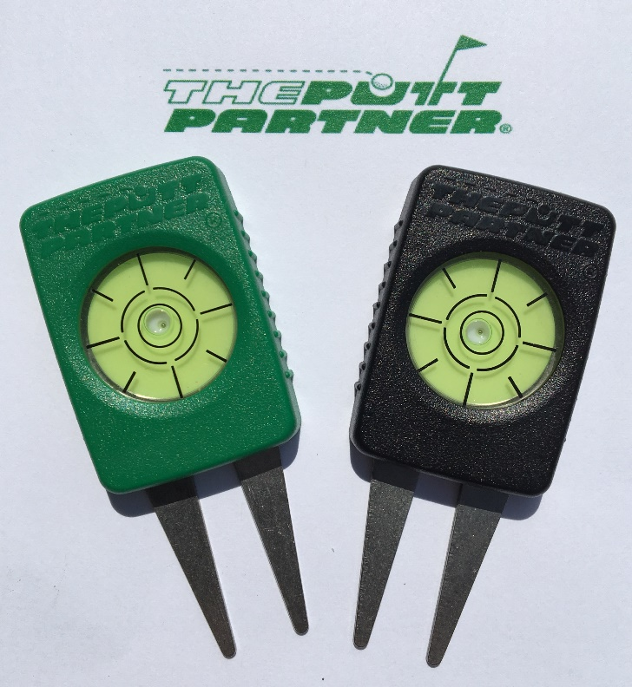

Speaking of lunch and launching,
I have developed a new golf product that is
now available on Amazon.com.

All proceeds from sales of this product go directly to me, HB Arnett, and will help provide the “free lunch meat” for continued publication of Cougar Sportsline Lite!

If you are a golfer, know a golfer, or just are curious or magnanimous, the more sales and reviews I get on Amazon will greatly influence the continuation of the newsletter. Even if you aren’t a golfer but know golfers, I’m hoping you will send your friends and family to my Amazon page. You can access it by
Clicking Here.

Thanks, your pal and putt partner, HB

