HB Arnett’s

“Lite”
hbarnett@fiber.net
801 372 0819

Vol. 38, Issue 24, - January 7, 2019

Which is Better?
Eyes Closed or Eyes Open?

Are musical artists better when they perform with their eyes closed or eyes open?



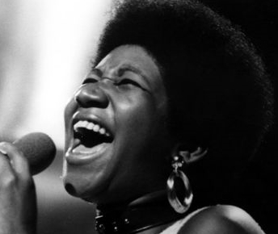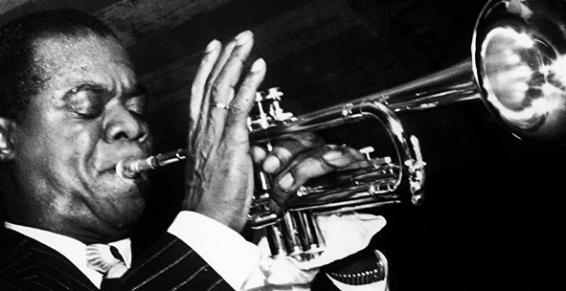

Which got me to wondering. I am definitely more arse than artist, but could I improve the newsletter if I wrote it with my eyes closed?

You be the judge. Here goes: Nyu zbayppfball kist abitger fsmr. Thyis tije t was to saubt nart[sm tge ‘gaeos st86id byud a gritti ti ‘bty.

What I meant to say but couldn’t because my eyes were closed is this: BYU lost another game. This time it was to Saint Mary’s. SMC should build a grotto for BYU. The Cougars have become a patron saint and patsy for the Gaels.

By now, all eyes should be wide open to the fact that this is not a good BYU basketball team. They aren’t good enough to contend for an NCAA berth. They aren’t good enough to beat anybody who happens to be good. They are frustrating, maybe even poorly coached, but here it is. Eyes open or closed, they are still entertaining. If not, explain to me why I keep watching them play. Even better, why do you keep watching them.

They are just good enough to be annoying and anticipatory. Even when they are getting blown out, you can close your eyes and still dream of them making a dramatic comeback for the win.

This team has offensive talent. This team has no defensive talent. That should be our clue as to when to keep our eyes open and then keep them shut.

If you need this explained on a grander scale, remember Jimmer Fredette. Here are two eyes
open/eyes closed videos that expand on the point.

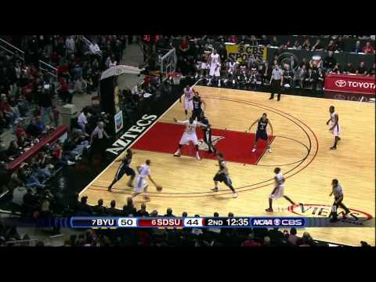
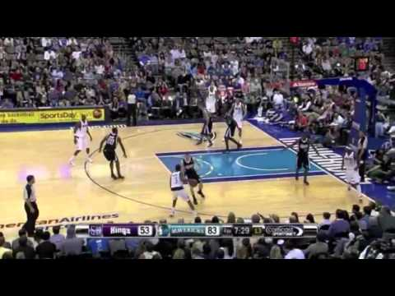

Open or Closed?

When Tom Holmoe announced a two-year contract extension for Dave Rose before this basketball season started, did he do it with eyes open or eyes closed?



Regardless, open or closed, it now appears he did it wearing “Rose” Colored glasses. Based on the performances of this season, even “Rose” colored glasses are now shattered.

So why do we care and why do we keep watching BYU basketball this year and BYU football two years ago?

For the same reason we visit our children in jail. They are still our team and our children. No matter the situation, both are still our children and our team. Yes, in case you are wondering, visiting a child in jail is an “eye opening” experience.

Heck, if all we wanted was winners, we would all be Alabama and Clemson football fans and Duke and Kansas basketball fans.

Things aren’t always rosey and aren’t always wonderful. Hey, there might be some sort of doctrine in that declaration. Sometimes things are bright and other times they are dark.

That is why they invented these for life and sports fans. You can wear them up or down, depending on your team and how they are doing in times of brightness or in times of darkness.

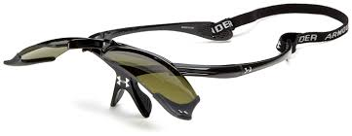

BYU basketball might be facing a total eclipse of darkness after coming off a month long road trip. It should be glasses down this coming week as the Cougars will see a little more sunshine and less talent than they did this past week/month.

Television Timetable

BYU vs. Portland (M Basketball)
Thursday, January 10 at Provo
Tipoff: 7:00 pm MST
TV: BYUtv
BYU vs. Santa Clara (M Basketball)
Saturday, January 12 at Provo
Tipoff: 7:00 pm MST
TV: BYUtv

Glasses Up…Glasses Down! You Decide

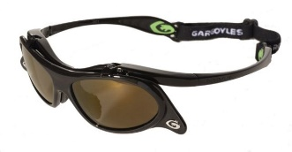

Here are some recently released stories about BYU sports. Click and read them and then decide if they are glasses up for you because of darkness or glasses down because of brightness.

Zach Wilson and Jaren Hall…..Glasses down because of brightness.

Big Time QB transfers to Ohio State….Glasses up because of darkness.

Realignment and BYU?... Glasses Down. I still see BYU as a player because of their own network.

BYU Circles its Stadium and Wagons…Glasses Down. Now you can spit off the concourse anywhere in LaVell Edwards Stadium. It’s a bright day for Spitters and BYU Football.

