HB Arnett’s

“Lite”
hbarnett@fiber.net
801 372 0819

Vol. 38, Issue 35 – March 25, 2019

Legal Definition of Bigamy:

Bigamy: Is the condition of having two wives or husbands at the same time.

Which begs the question: Will BYU Football be practicing monogamy or bigamy at quarterback this fall?

We know plenty about Zach Wilson, BYU’s current starting quarterback, who is not participating in spring drills because of recent shoulder surgery.

His credentials and credibility as the first wife and starting BYU quarterback were documented and detailed during the last part of last season. He was special. He is talented and a playmaker.

But…and this is an even bigger butt (rump roast) in the Cougar coaches’ room after spring football. Is Wilson, as special as he has shown he is, still the best quarterback on the roster?

That became an issue after Jaren Hall threw his hat into the ring of best quarterback by leading BYU to 4 touchdowns in his 4 possession during the spring scrimmage last week. All he did was go 12 of 14 for 203 yards and two touchdowns. He also rushed 5 times for 59 yards and had a 65-yard touchdown run negated by a holding call way down field.

It was readily apparent to those who saw the display that Hall is extremely talented. Our best compliment is that he looked “Wilson Like”.
Here, however is an opinion that counts. Jeff Grimes, BYU’s current offensive coordinator, when asked what Hall showed him, had this response. “The same thing he shows every day in practice – a lot of poise, a lot of confidence and, really a pretty amazing combination of a guy that can run and throw,” said Grimes. “Not surprised at all because we see it every day in practice.”

For those who take the letter, this also should be no surprise.

Below are snippets of what was written by me beginning last July.

July 27, 2018

The future at quarterback for BYU will be either Zach Wilson or Jaren Hall. BYU coaches are not stupid. They are not going to jeopardize that future by throwing Wilson to the wolves early against Arizona, California, Wisconsin and Washington. (Just off a mission, Hall won’t be ready to play, but he and Wilson will play at least four games later in the season. That is the competition we should be anxious to see.)

August 13, 2018

Now for Some Serious Succession Talk
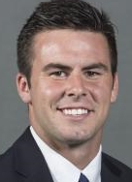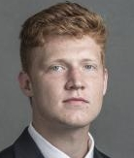
Mangum Wilson Critchlow
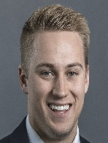
Hall Romney Conover McKee

We will see. The British have their monarchy and set succession, but BYU will need diplomacy. If Wilson is the heir apparent, how are they going to keep Jaren Hall happy and in the program? Stay tuned.

August 20, 2018
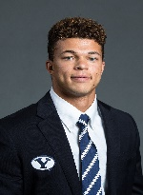
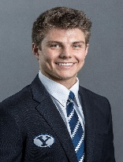
BYU offensive coaches know that Zach Wilson, on the right, is good. He will more than likely start the Arizona game. Yes, he is that good. So is Jaren Hall, on the left. He is as talented as Wilson. He just didn’t get all the spring reps and practice that Wilson did because he was finishing up his LDS (oops, my bad) The Church of Jesus Christ
of Latter-day Saints mission in California. There is a reason Hall is getting plenty of reps and is the 3rd QB in camp in front of Joe Critchlow. There is a reason that he will see the field this season.

October 29, 2018

They didn’t see the field, but just a friendly reminder that both true freshmen quarterbacks, Zach Wilson and Jaren Hall were both dressed and ready to go if needed. They will be needed next year and maybe this year if Mangum doesn’t stay healthy.

After Saturday against Hawaii, the current 2018 BYU QB controversy will either be resolved or exacerbated until next March and the start of spring football.

I’m talking the Zack Wilson vs. Jaren Hall debate on tap for 2019. A season opening schedule of Utah, Tennessee, USC and Washington guarantees a QB controversy between them.

Wilson will have the head start and could have a lock on the job depending on how he performs during the remainder of this season. But don’t discount Hall, the returned missionary from Mapleton.

So, let’s get started early because it is coming.

Zack Wilson…Jaren Hall
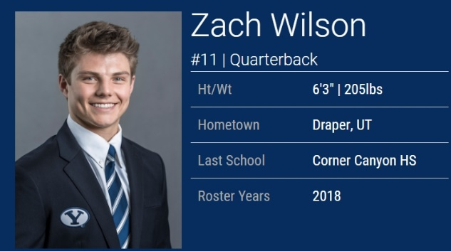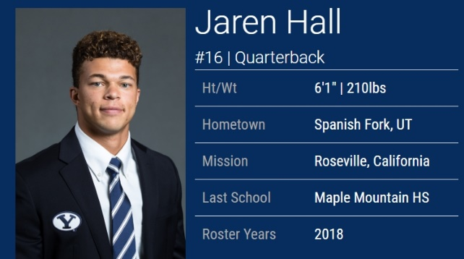

Click to Watch Wilson Click to Watch Hall

The good news is it appears we now have a playmaking and game changing quarterback in Zack Wilson. Even better news, we have Jaren Hall, the redshirt freshman, who has all the same skills Wilson has.

For the next four years, we are good to go at quarterback even if there is an injury issue. Since the probability of getting a quality running back and a game changing receiver are slim to none, it might be time to get the quarterback in shotgun formation and let him air it out and when that doesn’t happen, make a play with his legs.

January 7, 2019

Glasses Up…Glasses Down! You Decide

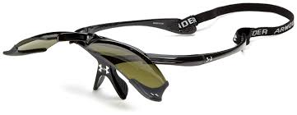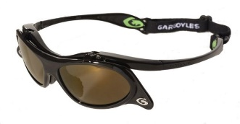

Here are some recently released stories about BYU sports. Click and read them and then decide if they are glasses up for you because of darkness or glasses down because of brightness.

Zach Wilson and Jaren Hall…..Glasses down because of brightness.

January 18, 2019

Spring Ball…So Good, yet So Ordinary (Now)

I have always been a big fan of Jaren Hall. He is the redshirt freshman quarterback that is lighting it up in Spring football drills for BYU this month. For those worrrying about the shoulder surgery recover of Zach Wilson, don’t.

Wilson, as he has already proven, is a big time quarterback, but for whatever reason, if he doesn’t fully recover or is late in recovering, BYU has a quarterback on the roster already (Jaren Hall) shining this spring that is as talented as Wilson in football.

So far, I can’t say the same about Hall in baseball. Of course his attention is devoted to football, but he is skilled also as a baseball player. He is only hitting .105 currently for Mike Littlewood and the Cougars in baseball. That should pickup when spring drills in football are over.

That was what I wrote in the past. Here is what I am writing in the present, beginning with today.

March 25, 2019.

One of these 2 quarterbacks, Wilson or Hall, will not still be on the BYU roster in 2020

I have no inside scoop or information. I just keep tabs on college football…particularly schools like Georgia, Oklahoma, Ohio State, Clemson, Alabama, Utah, and Texas.

To make my point, history is on my side. Click here to see why.

To further emphasize the QB transfer point, Click here.

Did I mention that the last two Heisman winners were both quarterbacks from Oklahoma in Baker Mayfield and Kyler Murray? Both were transfers to OU. Mayfield started as a walk-on at Texas Tech and Murray, enrolled originally at Texas A&M.

Once again, I have no inside information, but a lot of time the past is certainly indicative of the future. That is why I don’t see Jaren Hall or Zach Wilson being on the same BYU roster either in 2020 or at the latest 2021. The wild card in this scenario would be a season or career ending injury to either of these two big-time talented quarterbacks.

Again, just my opinion, but if, and I emphasize the word “if”, Hall or Wilson were to transfer, the most like spot would be Utah. It is still very close to both player’s family and both were recruited by the Utes.

In Montana, where neither Hall or Wilson would transfer to play for the Grizzlies, like former BYU QB Drew Miller did, they like to say, “Don’t Borrow a Jack”.

A traveler had a flat tire while driving in the country and discovered he didn't have a jack. Spotting a farmhouse, a mile off, he started walking toward it, so he could borrow a jack and change his tire. But as he walked, he convinced himself that the farmer wouldn't trust him, would think he was a con man and would refuse his request. By the time the traveler got to the house, he was so offended that when the farmer came to the door, he shouted at him, "You can keep your dang jack!" and stomped off.

Speaking of Montana and Jack, I married a girl from The Big Sky State and she still tells me occasionally, “You don’t know “Jack”, which is short for “Jack Squat” who sat in front of me at Palo Verde High School my senior year in a civics class and lived up to his name. He really didn’t know “Jack Squat”. In his defense, however, he did own and drive a 1966 Ford Mustang that was “Jacked up” which proves he obviously did know something. So did I. That is why I sat behind him so I could ask him for a ride home after school.

Consequently, I freely admit I also don’t know “Jack” and I’m probably borrowing a “Jack”, but history has a way of repeating itself, especially when it comes to elite football programs and elite quarterbacks. BYU is not an elite program yet, but they do have two “extremely elite” quarterbacks on their roster. If we don’t have to borrow a “Jack”, it should “Jack” up the Cougar fans base for what is to come for BYU offensively in the future.

Yeah, But BYU is Different

Just a reminder, two of the best BYU quarterbacks ever were transfers from other schools. Do the names Max Hall (ASU) and Taysom Hill (Stanford) ring any bells? Yes, I know Hill never enrolled at Stanford, but he did sign with the “Trees” out of high school.

Click Here to read about the top 10 college QB transfers, which lists Max Hall among them.

SPEAKING OF STANFORD…

That is who the BYU Women’s basketball team will be playing tonight in the second round of the NCAA tournament. TV: 9 pm MDT, ESPN2

That game will be hosted by Stanford on their home court.

By now you should know that BYU took care of their opening round business with a 73-64 win over Auburn. You may not know what Steve Young told the team after the game in the locker room.

Click here to see for yourself.

