HB Arnett’s

“Lite”
hbarnett@fiber.net
801 372 0819

Vol. 38, Issue 28, - February 4, 2019

Yes and No Answers to Gonzaga’s 93-63 Thrashing of BYU

Yes, Gonzaga is really that good!

Yes, The Zags have 4 and possibly 5 legitimate NBA prospects on their roster.

No, BYU has zero NBA prospects on its current roster. (They may have a couple of Euro prospects in Childs and Haws and it’s still too early to tell with Baxter, but he is trending up.

Yes, The coaching apples don’t fall far from the Dave Rose tree. Quincy Lewis played for Rose at Dixie JC. Lee Cummard played for Dave Rose at BYU. Tim Lacomb didn’t play for anybody.

Here is the offical BYU resume of Lewis, Lacomb and Cummard.

Tim Lacomb - Coaching Experience
- BYU Assistant Head Coach (2017-present)
- BYU Associate Head Coach (2015-17)
- BYU Assistant Coach (2010-15)
- BYU Director of Operations (2007-10)
- Utah Video Coordinator (2005-07)
- American Fork Assistant Coach (2002-05)
- Lone Peak Assistant Coach (1999-02)
- Utah Team Manager (1994-96)
Quincy Lewis – Coaching Experience
- BYU Assistant Coach (2015-present)
- Lone Peak High School Head Coach (2003-15)
- Southern Utah Assistant Coach (2002-03)
- Utah Valley State College Assistant Coach (1997-02)
- BYU-Hawaii Assistant Coach (1995-97)
Lee Cummard – Coaching Experience
- BYU Assistant Coach (2018-present)
- BYU Graduate Assistant (2016-2018)
Yes, the coaching apples also don’t fall far from Gonzaga’s Mark Few’s tree.
Donnie Daniels – Coaching Experience
- Gonzaga Assistant Coach (2010 - 2019)
- UCLA Assistant Coach (2004 - 2009
- Cal State Fullerton Head Coach (2001-2003)
- Utah Assistant Coach (1990-2010)
Tommy Lloyd – Coaching Experience
- Gonzaga Assistant Coach (2001-2019) Responsible for Foreign Recruiting
- Gonzaga Administrative Assistant (1999-2000)
Brian Michaelson – Coaching Experience
- Gonzaga Assistant Coach 2013-2019)
- Assistant director of basketball operations (2010-2012)
- Gonzaga administrative assistant (2008-2009)
- Walk-on for Mark Few at Gonzaga (2001-2002)
So, what’s the difference between the coaching staffs at BYU and Gonzaga and the superior success of the Zags over the Cougars and the rest of the WCC?
This guy – His name is Tommy Lloyd

Click Here to see what he has done for Gonzaga.
Sheepish of Sheepskin?

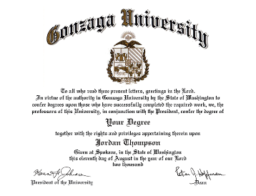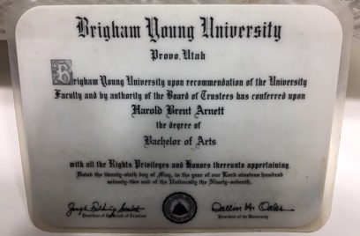

Ask any Gonzaga graduate or current student if they think their degree is diminished or tarnished by their school admitting 4-5 foreign students with limited English proficiency annually to play basketball. How do you think they would respond? How would you respond?

Ask any BYU graduate or current student if they think their degree is diminished or tarnished if their school admits 2-3 foreign students annually to play basketball? How do you think they would respond? How would you respond?

Since I have a degree from BYU as evidenced by the above photo, let me respond personally. I would gladly give up 3-10% of my BYU birthright and diploma bragging rights
for an annual berth in the NCAA tournament. What’s a little mess of pottage on my part to clean up the current messes of recruiting for BYU football and basketball.

Here is Gonzaga’s diplomatic diploma response below.

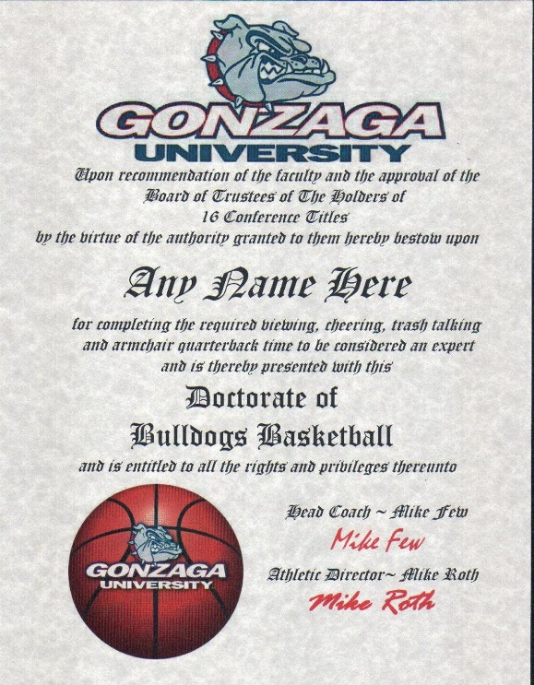
Here’s my personal response. I will gladly take a 5% depreciation on my BYU degree if the Cougars can beat Utah, Tennessee, USC, Washington and Boise State in football and can at least split with Gonzaga. And I don’t care if they do it with little to no English grammar skills as long as they have “game”.

The only other alternative for BYU in basketball is this:

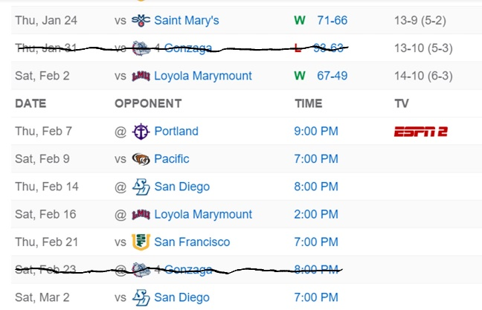
Refuse to play Gonzaga and plead and play the xenophobia card.

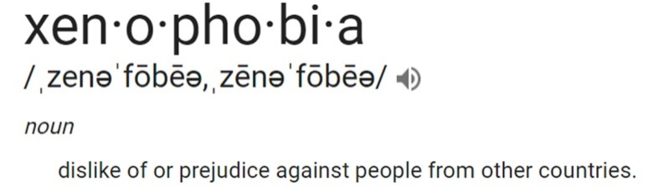

BYU 67 LMU 49
It Was Baxter to the Maxter

Take it to the max is an expression of achievement. Try this on for achievement in your first start as a BYU basketball player. I’m referring of course to Gavin Baxter’s line in BYU’s 67-49 win over LMU last Saturday night in Provo.

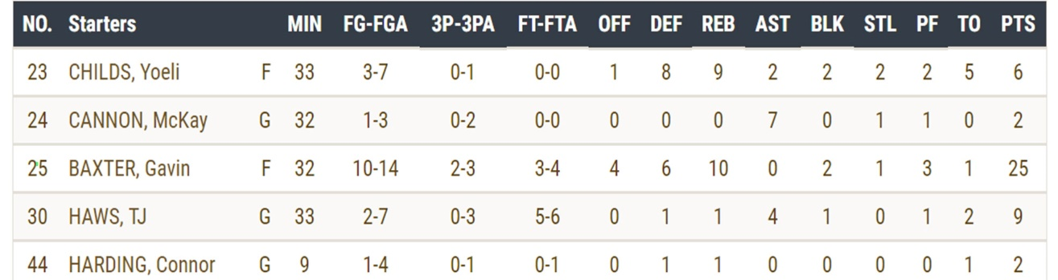

Granted, they are only numbers, but are numbers that are usually reserved for Yoeli Childs and TJ Haws. What does it mean? Baxter can play…at least against LMU in his first career start.

Nick Emery used to know how to play and then he forgot after a two-year layoff. The temporary bout of amnesia is apparently gone based on Emery’s stats against LMU.

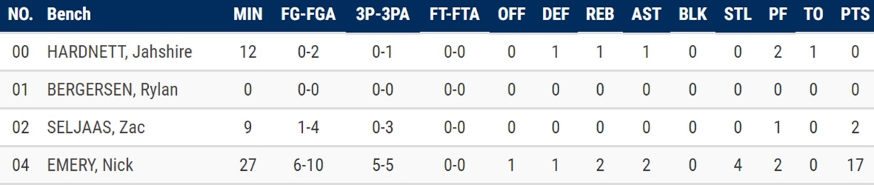

All box scores are not equated equal. For that reason, don’t go looking at the BYU boxes with Gonzaga, Mississippi State and San Francisco.

The BYU women also had a couple of box bummers this last week on the road as they lost to both LMU and Pepperdine.

Here are the current WCC standings for men and women.

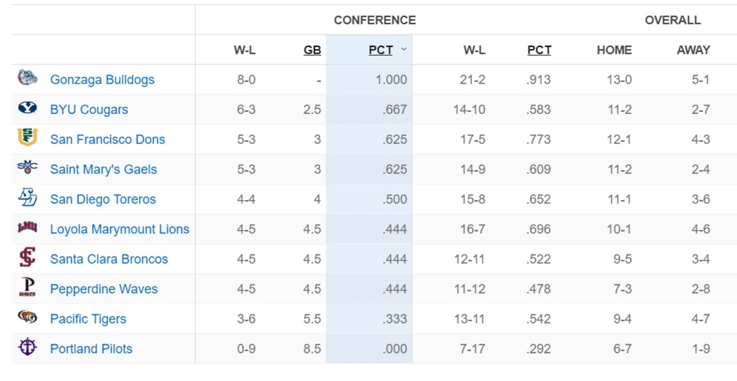

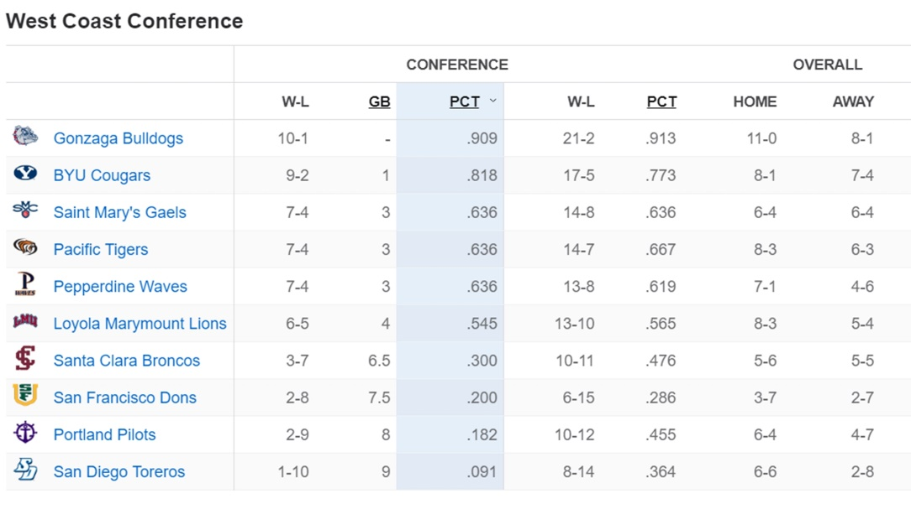

Television Timetable

BYU vs. Portland (M Basketball)
Thursday February 7 at Portland
Tipoff: 9:00 pm MST
TV: ESPN2
BYU vs. Pacific (M Basketball)
Saturday, February 9 at Provo
Tipoff: 7:00 pm MST
TV: BYUtv
BYU vs. Saint Mary’s (W Basketball)
Thursday, February 7 at Provo
Tipoff: 11:00 am MST
TV: BYUtv
BYU vs. Pacific (W Basketball)
Saturday, February 9 at Provo
Tipoff: 2:00 pm MST
TV: BYUtv

I’ll be back later tonight, but probably tomorrow, with some previews of national letter-of-intent day for football.

