HB Arnett’s

“Lite”
hbarnett@fiber.net
801 372 0819

Vol. 37, Issue 2-A – July 6, 2018

MUCHO MACHO MAN!
Here are my top three Mucho Macho Man videos of all time. Hope it helps you get through July and into August. That’s when we will discover if there are any Mucho Macho Men ready to play football for the Cougars with the start of fall camp.
-  Click Here Mucho Macho Man I

-  Click Here Mucho Macho Man II

-  Click Here Mucho Macho Man III

Honorable Mention Mucho Macho Man

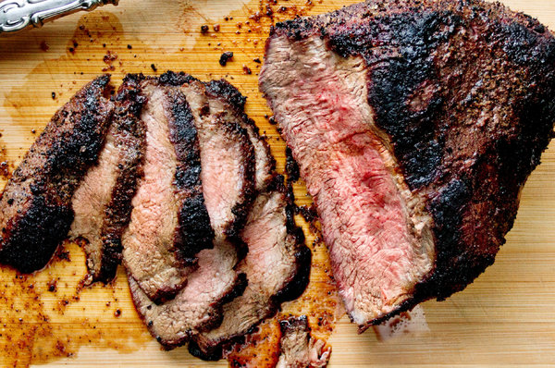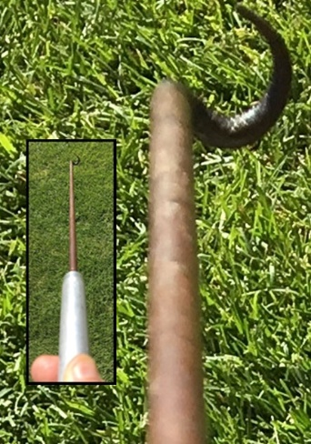
I still cook my Tri Tip the original Santa Maria (and James Bond way). Grilled not shaken or smoked. I went Mendoza (see last issue) with the meat and hit for the cycle (4 for 4) on July 4. Still use the same recipe I learned 35 years ago from my uncle, a real Santa Marian. Two parts salt, one-part pepper and rub it on liberally.
Get a loaf of French bread to sop up the au jus. Throw in some homemade salsa (large can of diced tomatoes, 1 tomatillo, 1 each of every kind of every pepper you find at the store). Throw in a little onion and if you don’t speak Spanish, you soon will.
For best results, sear both sides, then find a comfortable chaise lounge and lay down with eyes closed for ten minutes. Then get up and turn meat over. Repeat every ten minutes for 45 minutes if you like it rare. Let it cook another 15 minutes if you are a well-done type of carnivore.
Speaking of turning the meat over, you can tell the rookies from the Santa Maria veterans by what they use to execute the turn. I call mine “Hook ‘em Horns”. It was handmade by my Santa Maria uncle and gifted to me because he said I had “the touch”. It is the only thing in my meager mucho macho estate that my kids will fight over.
We capped off the 4th with our usual fireworks “lite” show in the street in front of the house. My grand kids’ favorite also was my favorite. Just thought I would share. My progeny called it doggone good.

What It Is?
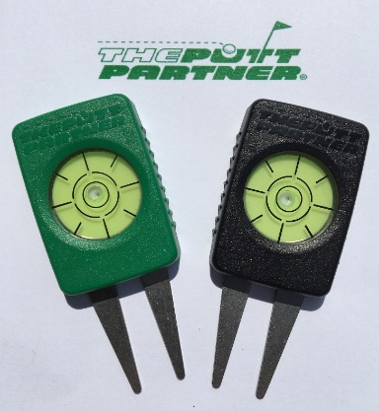

How it Works

Click here to see how it works for old guys!

Click here to see how it works for young guys!

Yes, the CS Lite free lunch (and subscription) is still on the table. I’m providing the meat and subscription free, but to make this a tasty meal for all of us, I need you to provide the condiments.

Click here for the condiments I need!

Thanks, your pal, publisher and putt partner, HB

