HB Arnett’s

“Lite”
hbarnett@fiber.net
801 372 0819

Vol. 38, Issue 33 – March 11, 2019

San Diego Toreros Gore BYU 57-80…and it wasn’t that close
Pictorial Perusal of What Happened to BYU Basketball

BYU’s six-year downward spiral in basketball has been examined, dissected, discussed, defended and should be the subject of several doctoral dissertations over the coming years.

For those unfamiliar with a dissertation, here is one definition. A thesis or dissertation is a document submitted in support of candidature for an academic degree or professional qualification presenting the author's research and findings.

I can’t wait a couple of years to discover what happened to BYU Basketball. And even though I already have a Ph.D, (Pharmaceutically Helped Daily) with Metformin, Lisinopril and Botox (to keep my BYU smile in place), here is a more mundane attempt at explaining BYU basketball pictorially and with previous tried and true dissertations.

It was Chick Hearn, the legendary LA Lakers announcer who coined and said continually when a team was shooting terribly. “They can’t even throw a pea in the ocean.” BYU was 1 of 17 from beyond the arc against San Diego.

Here is the BYU box score in pictures.


Note there are no peas in the ocean.

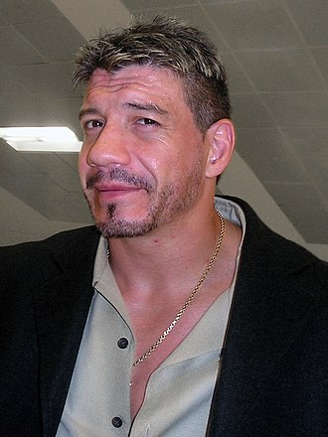

Eddie Guerrero was a professional wrestler who coined the phrase, “If you’re not cheating, you’re not trying. Notice there are no peas floating in his sea either.

Here is a video that backs up Guerrero’s mantra and a good reason BYU has slid backward in basketball.

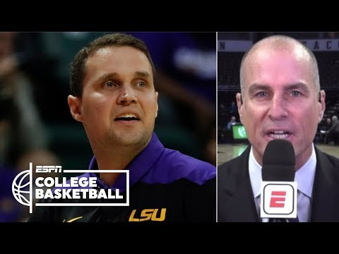

When it comes to “Strong Ass” offers at BYU in recruiting, that would be the ultimate oxymoron, but if there were such a thing as “Strong Donkey” offers at BYU, here is my pictorial perspective of what it would look like.



Actually, years ago a BYU head coach did lose his job for offering a “strong donkey” offer to an athlete who had no transportation in Provo.

Here is what he provided and was fired for.

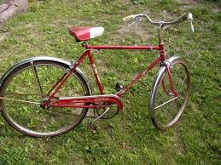

Bicycles and Bottom Line in BYU Basketball

BYU will only be as good as the Church of Jesus Christ of Latter-Day Saints pipeline provides.

It hasn’t been a strong pipeline for several years now. Let me quickly explain that there is a difference between the regular pipeline of players of the sponsoring institution’s faith and elite players of the same faith.

Church players with NBA potential don’t sign with BYU but go with programs who while they may not be offering “Strong Backside” offers financially, they are offering one-way tickets to the NBA.

The elite Church prospects don’t sign with BYU. Good Church products to, but they aren’t good enough to compete with those prospects that warrant “strong donkey” offers from elite schools.

There are no elite Church prospects in the pipeline. There are some decent to good prospects, but none of the big boys with the big bucks will be offering any big-time money to these players.

The last strong donkey player at BYU that stuck in the NBA was Danny Ainge and that was decades ago. Mike Smith was a strong asset player, but he just got a cup of Postum in the league.

Kyle Collinsworth was the last big hope, but he is on the fringe in the “G” league. Nobody on this current team is NBA material and nobody has been NBA material for the last 6 years. If they were that is where they would be playing. Sorry, but that applies to Jimmer Fredette. If he was NBA material, he would be in the NBA.

Maybe better coaching and a different program culture would make a difference but watch the upcoming NCAA tournament and then tell me you honestly believe that. Do you honestly believe that when you watch players that are considered “Strong Asset Offered Players” that BYU can honestly compete without that caliber of players? Me either.
I will still watch BYU football and basketball. They are still my teams, but the bottom line the way big time college sports is set up is that if you want the thoroughbreds in your stable, you have to attend the auctions in Lexington where they are sold and be a competitive bidder.

Here is another viewpoint when it comes to BYU football and basketball from one of my favorite subscribers. I present it for your perusal or refusal.

Men's basketball is just one sport, and we knew it was a lost cause. Forget about it (especially tonight) and look at the rest of the athletic department.

What a turnaround, in one year, for track-and-field. Last year BYU choked. The 2018 men's team, in particular, had been highly ranked going into the NCAAs. Once there, it failed mightily.

This year, things were different. Both men's and women's track-and-field did BYU proud, performing better than expected. The men had been ranked 16th in the latest USTFCCCA poll, but they finished 13th at the NCAAs.

The girls were even better. The last poll (March 4) had them in the 22nd spot, but they finished 14th in the finals.

Those two finishes will translate into a lot of Directors' Cup points.

This is exactly what BYU should be doing. The bureaucrats who run BYU aren't ruthless or creative enough to compete with the corrupt, religion-hating mass-culture when it comes to the money sports, football and men's basketball. But BYU can compete elsewhere. The Cougars should be an OVERALL sports power, like Stanford, Notre Dame, Penn State, UCLA.

Let LSU make the "strong-ass offers" to sleazy front men for ghetto players. BYU doesn't need to get into that sewer.

https://ftw.usatoday.com/2019/03/lsu-will-wade

Beyond track and field, BYU has a top-twenty women's gymnastics team, for the first time in a long time. Baseball is off to a hot start. BYU men's tennis is actually ranked in some poll somewhere. This is all good news for the school, and it's the proper way to run a university and to keep BYU's name in the headlines.

Most NCAA athletes play these "other" sports, and many of them are also good students. They generally hang around for all four years of college. They're high-quality representatives of the school while they're attending, and later they become high-quality alumni.

More of that, please.

A Subscriber

Just a Little Surprised
In an interview last week, a BYU football coach was asked which was harder to get in school at BYU when it came to football players. He said jucos were the easiest and grad transfers were almost impossible.

Again it appears that BYU is playing by different rules. That is probably good for the academic integrity of the school, so I will leave it at that.

But I do find it interesting that Big Ten schools with their Big Ten Academic Alliance seems to have no problem with grad transfers playing football and basketball at their prestigious institutions.

Here is how the Big Ten Academic Alliance describes itself: Headquartered in the Midwest, the Big Ten Academic Alliance is the nation’s preeminent model for effective collaboration among research universities. For more than half a century, these world-class institutions have advanced their academic missions, generated unique opportunities for students and faculty, and served the common good by sharing expertise, leveraging campus resources, and collaborating on innovative programs. Governed and funded by the Provosts of the member universities, Big Ten Academic Alliance mandates are coordinated by a staff from its Champaign, Illinois headquarters.

The grad transfer that rings my bell is Russell Wilson who went from North Carolina State to Wisconsin to the NFL, without any admittance hitches. Here is the latest I have gleaned from the current Transfer portal when it comes to quarterbacks transferring to the Big Ten seamlessly.

Justin Fields is going from Georgia to Ohio State.
Josh Jackson is going from Virginia Tech to Maryland.
John Langan is going from Boston College to Rutgers.

When it comes to grad transfers to BYU, Ty’son Williams the grad transfer from South Carolina was on the Provo campus this past weekend. He would be a major upgrade to the Cougar’s offense.

Unfortunately, during his visit, it was snowing profusely, and also when it comes to being admitted as a grad student at BYU, that snow turns into an almost unpassable avalance blocking almost any and all grad transfers. It is possible, however, because Dylan Collie was admitted last season as a grad transfer.

We will see how this plays out.

Here is the latest BYU spring football roster as put out by the Cougars.

