HB Arnett’s

“Lite”
hbarnett@fiber.net

Vol. 37, Issue 1-A – June 29, 2018

I DON’T TWEET, BUT I HAVE BEEN CALLED A TWIT (click to view) SO HERE’S TODAY’S TWIT TAKE* (*You can expect a lot of Cougar Clicking today)

Chris Wilcox: Got a little push back (actually Ilaisa Tuiaki received the push back for his rave review of Chris Wilcox at BYU media day as possibly playing at the next level.) Most of that push back was from those of us that saw his play on the field last season.

One guy who actually has NFL credentials and is employed by BYU said Wilcox reminded him of Michael Davis. They both have length and speed. Nobody thought Davis was NFL material based on his play at BYU, but he is the one cashing the Los Angeles Chargers’ checks.

Any Connection between BYU QB’s Yards-per-catch stats and BYU’s win/loss column?

One of my long-time subscribers from the Midwest is a very astute observer of society and sports, especially as it pertains to BYU. He certainly thinks there is a correlation.

Trust me, he is one smart dude, but he’s not perfect…as evidenced by his being an avid observer of the annual Salmon run up the Mississippi (No YouTube video yet).

Let’s see if the stats he asserts can make those assumptions spawn and stick. If so, there could be a salmon run in the fall on the Mississippi and a run of wins for the Cougars.

Season | Starting QB | Yards per Catch | Season Record
2017 | Mangum | 10.47 | 4-9
2016 | Hill | 10.46 | 9-4
2015 | Mangum | 12.64 | 9-4
2014 | Hill, Stewart | 11.08, 13.17 | 8-5
2013 | Hill | 12.45 | 8-5
2012 | Nelson | 11.11 | 8-5
2011 | Heaps, Nelson | 10.08, 14.8 | 10-3
2010 | Heaps | 10.57 | 7-6
2009 | Hall | 12.95 | 11-2
2008 | Hall | 11.99 | 10-3
2007 | Hall | 12.91 | 11-2
2006 | Beck | 13.44 | 11-2
Fast | Backward | To Random | Seasons
2003 | Berry | 6.14 | 4-8
2001 | Doman | 13.55 | 12-2
1996 | Sarkisian | 14.23 | 14-1
1995 | Sarkisian | 13.8 | 7-4
1994 | Walsh | 13.1 | 10-3
1993 | Walsh | 14.6 | 6-6
1990 | Detmer | 14.4 | 10-3
1986 | Lindsley | 13.4 | 8-5
1984 | Bosco | 13.6 | 13-0
1983 | Young | 12.9 | 11-1
1982 | Young | 13.3 | 8-4
1980 | McMahon | 15.7 | 12-1
1979 | Wilson | 14.7 | 11-1
Top 5 QB’s | Selected in | 1st Rd 2018 | NFL Draft
1st Pick Browns | OU’s Mayfield | 16.24 | 12-2
2nd Pick Jets | USC’s Darnold | 13.67 | 11-3
3rd Pick Bills | Wyo’s Allen | 11.76 | 8-4
4th Pick Cardinals | UCLA’s Rosen | 13.18 | 6-6
5th Pick Ravens | Louisville’s Jackson | 14.48 | 8-5

Speaking of Salmon and a Miracle Comeback season for BYU, here are a couple of videos to peruse. (Click to view) If they can catch Salmon in Yemen,
then (Click to View) Anything is possible.

Could BYU Football Be on the Upswing?
Coming off a 4-9 season, fans, including myself, are looking for any glimmer of hope we can get. I think I found that glimmer photogenically.

Don’t know if the Cougars can play, but they sure looked much better coiffed than last season.

Things look like they are on the “upswing” based on the “Do’s” several players were sporting during the recent media day. Be your own judge. When fall rolls around, then we’ll have proof instead of “photo proofs”.

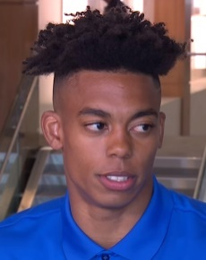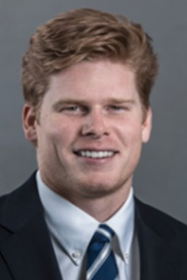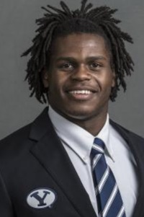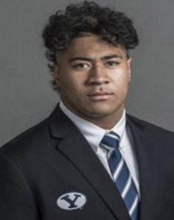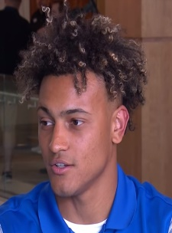
Micah Simon Matt Bushman Riley Burt Alden Tofa Troy Warner

We are all hoping for an upswing in BYU quarterback play. The same rule applies. Based on their upswing or not so upswing hairdos, who’s your pick below for starting QB?

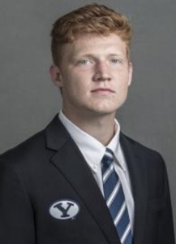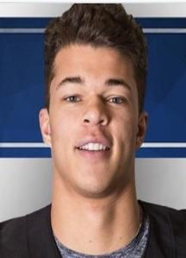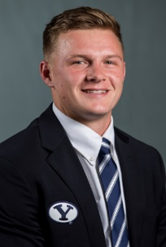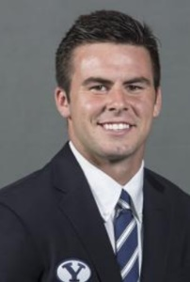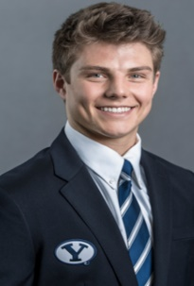

Joe Critchfield Jaren Hall Beau Hoge Tanner Mangum Zach Wilson

If your quarterback answer is none of the above, you can choose your hair and heir apparent from the long and loose look of Kenny Stabler, the Crimson Tide teen or the Goldilocks of Gridiron, Tom Brady.
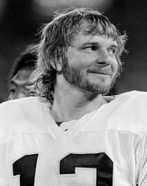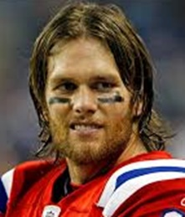

-----------------------------------------------------------------------------------

More Upside or is it Uphill?

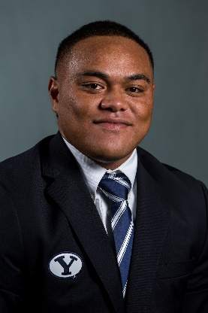

There is no upsweep to this hairdo but maybe still a little upside for Ula Tolutau. The word I get is that he is still working out with the team during informal summer drills, but not expected to rejoin the squad until Spring at the earliest. BYU has had a run on these “good fish, bad (fit) school” occurrences lately. Don’t bait your hook or breath waiting for this to resolve itself soon.

Homecoming and Height?

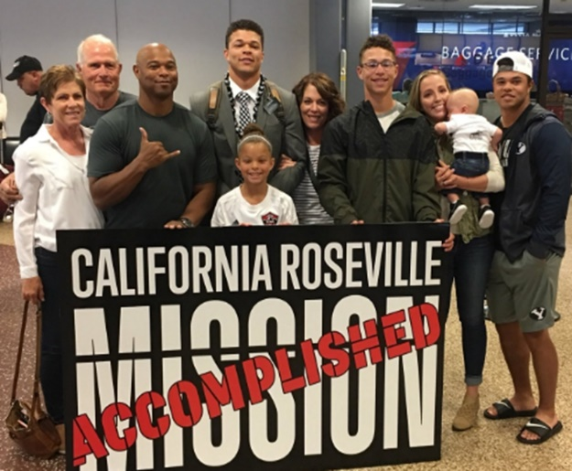

According to the current BYU roster, KJ Hall (far right), Cougar running back and brother of recently returned missionary/QB Jaren Hall (center) is listed at 5’9”. Here’s how Kalin Hall (3rd from left), the former BYU running back from Las Vegas and father of Jaren and KJ, was listed in the BYU press book a few decades ago (1992 - 93):
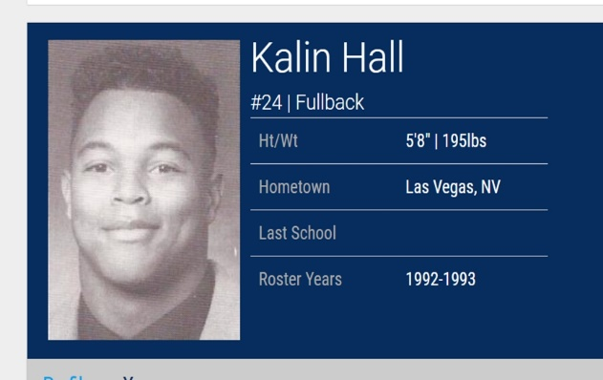

BYU lists Jaren on their roster at 6-1, 195 after returning recently from his LDS mission.
I have a California public school upbringing in that educational bastion of Blythe, California. That includes Ruth Brown Elementary, Blythe Jr. High, Palo Verde HS and one semester at Palo Verde CC.
I remember in mathematics, that the Pythagorean theorem, also known as Pythagoras' theorem, is a fundamental relation in Euclidean geometry among the three sides of a right triangle as evidenced in the above in the Hall family photo.
It states that the square of the hypotenuse (the side opposite the right angle) is equal to the sum of the squares of the other two sides. The theorem can be written as an equation relating the lengths of the sides a, b and c, often called the "Pythagorean equation".
Consequently, I have the cute girl at the front of the Hall homecoming photo pegged at 4’1”.
I might also mention that the Pythagorean theorem also came in handy in Blythe while I worked in the cantaloupe packing sheds, hoed cotton, cut, raked, baled and stacked hay, and castrated cattle. Another 4-7 season and I might offer my skills to Kalani Sitake in case he wants to emulate Jackie Sherrill when he was coaching at Mississippi State.
Click here to cut to the chase. Is Texas on the future schedule? Educational and Motivational? It worked: 28-10 win!

There actually is a connection between my golf product and BYU football. Click here for details.

So…

Consider the restart of Cougar Sportsline Lite as my free lunch to all BYU fans. I hope you enjoy it.

As stated previously, there is no cost for your subscription.

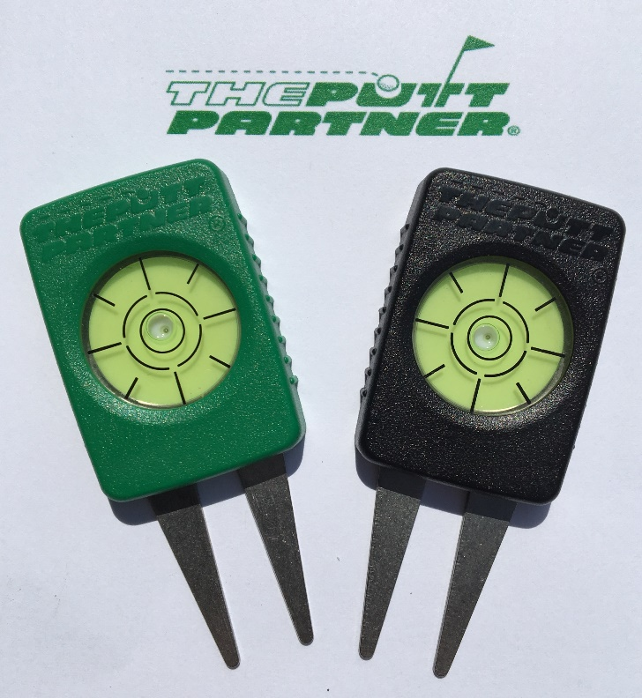

Speaking of lunch and launching,
I have developed a new golf product that is
now available on Amazon.com.

All proceeds from sales of this product go directly to me, HB Arnett, and will help provide the “free lunch meat” for continued publication of Cougar Sportsline Lite!

There is no charge for the newsletter, but The Putt Partner sells for $14.95. Consider it a back-door campaign contribution without having to report it to the Federal Election Commission and without worry of being investigated or indicted by a Grand Jury. Investigation by your wife, however, might be another matter.

If you are a golfer, know a golfer, or just are curious or magnanimous, the more sales and reviews I get on Amazon will greatly influence the continuation of the newsletter. I am especially in need of reviews, positive if possible.
Even if you aren’t a golfer but know golfers, I’m hoping you will send your friends and family to my Amazon page. You can access it and order by
Clicking Here.

Thanks, your pal and putt partner, HB

