HB Arnett’s

“Lite”
hbarnett@fiber.net

Vol. 37, Issue 1-B the last of week – June 30, 2018

MEA Culpa Scoreboard

Thanks to “Lite” recipients who keep track of my spelling errors, grammar errors, egregious errors and my advancing age errors. Here is my first scoreboard update from “Memory Lane, or lack of it”.

“Lite in the Lobe” 

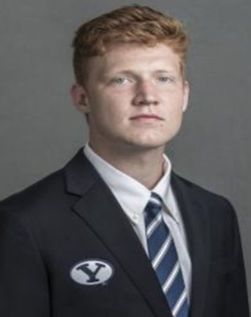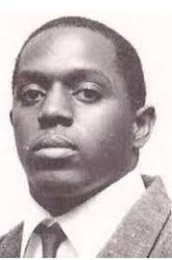

I called Joe Critchlow Joe Critchfield because I was thinking Crutchfield, as in Tony, the BYU Cougar cornerback out of Pasadena’s Muir High School a couple of decades ago. Here he is then and now.

“Late in Life Lapse”

This was totally a fishing faux pas. The stats should have been for yards per pass attempts (Casting). Yesterday I detailed yards per completion (Catches). Here is the correct conversion.

Season | Starting QB | Yards per Attempt | Season Record
2017 | Mangum | 10.47 | 4-9
2016 | Hill | 10.46 | 9-4
2015 | Mangum | 12.64 | 9-4
2014 | Hill, Stewart | 11.08, 13.17 | 8-5
2013 | Hill | 12.45 | 8-5
2012 | Nelson | 11.11 | 8-5
2011 | Heaps, Nelson | 5.76, 8.50 | 10-3
2010 | Heaps | 6.05 | 7-6
2009 | Hall | 8.70 | 11-2
2008 | Hall | 8.20 | 10-3
2007 | Hall | 7.76 | 11-2
2006 | Beck | 9.3 | 11-2
Fast | Backward | To Random | Seasons
2003 | Berry | 6.10 | 4-8
2001 | Doman | 8.7 | 12-2
1996 | Sarkisian | 10.0 | 14-1
1995 | Sarkisian | 8.9 | 7-4
1994 | Walsh | 8.0 | 10-3
1993 | Walsh | 9.4 | 6-6
1990 | Detmer | 9.2 | 10-3
1986 | Lindsley | 7.8 | 8-5
1984 | Bosco | 8.5 | 13-0
1983 | Young | 9.1 | 11-1
1982 | Young | 8.4 | 8-4
1980 | McMahon | 10.3 | 12-1
1979 | Wilson | 8.7 | 11-1
2018 NFL Draft | Top 5 QB Picks | Yards per attempt | Season Record
1st Pick Browns | OU’s Mayfield | 11.76 | 12-2
2nd Pick Jets | USC’s Darnold | 8.7 | 11-3
3rd Pick Bills | Wyo’s Allen | 6.61 | 8-4
4th Pick Cardinals | UCLA’s Rosen | 8.24 | 6-6
5th Pick Ravens | Louisville’s Jackson | 8.74 | 8-5

Here’s my take. For BYU to have a much-improved season record this year, The Cougar Quarterback, whoever it is, needs to be in the 8.0 and above yards per attempts range. Taysom Hill produced good records, in the 6.5 ypa area, but that seems skewed because of his prolific rushing talents.

BYU’s most recent run of football success was 2006 (Beck): 11-2, 2007 (Hall): 10-3, 2008 (Hall):11-2 and 2009 (Hall 11-2. The Cougars went 43-9 in that 4-year span and the average passing yards per attempt per season was 8.49.

When it comes to BYU football this year, 8 seems to be the magic number. Steve Young isn’t making a Cougar comeback, but 8 yards per passing attempt or better needs to if jobs are retained and a fan base soothed.

Just for fun, Jeff Grimes is the official offensive coordinator, but his specialty while working at LSU, Virginia Tech, Auburn and Colorado was as a running game coordinator.

He and Sitake has hired Aaron Roderick, the former BYU receiver and long-time Utah coach to be the passing game coordinator. Thought it might be interesting to look at Roderick’s record as an offensive coordinator using the same parameters above.

Season | Quarterback | Yards per Attempts | Season Record
2003 SUU | OC Zimmerman | 5.43 | 4-7
2004 SUU | OC Reher | 7.57 | 6-5
2010 Utah | Co-OC Wynn | 7.81 | 10-2
2015 Utah | Co-OC Wilson | 6.67 | 10-3
2016 Utah | Co-OC Williams | 7.07 | 9-4

Consider the restart of Cougar Sportsline Lite as my free lunch to all BYU fans. I hope you enjoy it.

As stated previously, there is no cost for your subscription.

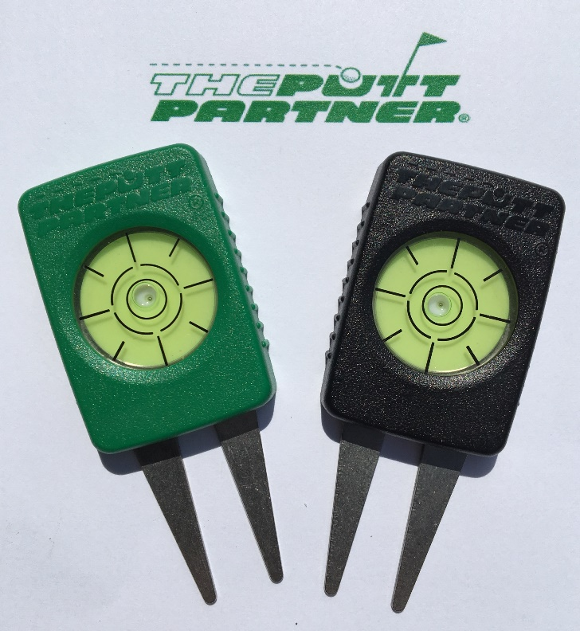

Speaking of lunch and launching,
I have developed a new golf product that is
now available on Amazon.com.

All proceeds from sales of this product go directly to me, HB Arnett, and will help provide the “free lunch meat” for continued publication of Cougar Sportsline Lite!

There is no charge for the newsletter, but The Putt Partner sells for $14.95. Consider it a back-door campaign contribution without having to report it to the Federal Election Commission and without worry of being investigated or indicted by a Grand Jury. Investigation by your wife, however, might be another matter.

If you are a golfer, know a golfer, or just are curious or magnanimous, the more sales and reviews I get on Amazon will greatly influence the continuation of the newsletter. I am especially in need of reviews, positive if possible.
Even if you aren’t a golfer but know golfers, I’m hoping you will send your friends and family to my Amazon page. You can access it and order by
Clicking Here.

Thanks, your pal and putt partner, HB

