HB Arnett’s

“Lite”
hbarnett@fiber.net
801 372 0819

Vol. 38, Issue 29, - February 11, 2019

pre·sump·tu·ous

adjective
- (of a person or their behavior) failing to observe the limits of what is permitted or appropriate.
"I hope I won't be considered presumptuous if I offer some advice"

Synonyms:

brazen, overconfident, arrogant, egotistical, overbold, bold, audacious, pert, forward, familiar,
impertinent, fresh, free, insolent, impudent, cocksure;

In the spirit of presumptuousness, I will announce my choice of lunch for today at 1 pm MST. I have invited all local media to attend for the announcement. I am still working on streaming arrangements for those of you living out of state, so you won’t miss this momentous meal occasion. I want to thank all those fast food chains that have made this opportunity possible. They all offer great selections, but I will choose the one best for me and my future.

Here is how it will work. I will be sitting at a table with several different hats and options from which to choose.

I want to thank all those fast food franchises for giving me this great opportunity, but I have narrowed it down to the following caps and cuisine.





All offer me a chance to pursue my intake of saturated fats, but only one will allow me to pursue my life-long dream of becoming a sous chef when my football career is over. Consequently, I choose Wendy’s.

That in a nutshell, is my presumptuous perspective on football recruiting…at BYU and all other schools. There is enough hype, hope and hats to go around, but can you name me five recruits BYU signed two years ago? Didn’t think so. Can you name me five football recruits Utah signed? Didn’t think so.

Want an even more in-depth analysis of college football recruiting. Check out the current transfer portal and see how many 4- and 5-star recruits from a few years back are transferring for more playing time.

Yes, I’m the same guy that has said repeatedly that it is all about players and not coaching. So recruiting is important, but it can’t truly be evaluated, especially at BYU, until 2 or 3 years down the line.

Who really knows how BYU did in football recruiting this year? We will absolutely know how the Cougars did 2,3 and 4 years ago coming this August when the face the likes of Utah, Tennessee, USC and Washington. Hang onto your hats for that schedule and a real evaluation of BYU recruiting.

SPEAKING OF RECRUITING AND THE FUTURE

I offer this interesting informative and eye-opening article about high school football, and even the NFL. It is from Atlantic Magazine. It is long, but I think well worth the read. Football and the NFL are Facing White Flight – The Atlantic

Who Finished Second?
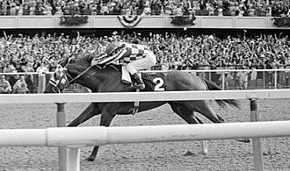
The 1973 Belmont Stakes was the 105th running at Belmont Park in Elmont, New York June 9, 1973. Facing a field of five horses, Secretariat won by 31 lengths, the largest margin of victory in Belmont history, in front of a crowd of 69,138 spectators. His winning time of 2 minutes and 24 seconds still stands as the American record for a mile and a half on dirt. The event was televised and broadcast over the radio. In the five-horse field, Twice a Prince showed while My Gallant placed (second and third).

I had to look up who finished second to Secretariat, but I have a really good idea who will finish either second or third to Gonzaga this year in the WCC basketball standings. That would BYU. The only thing to be determined is by how many lengths the Cougars will be behind the Zags.

That will be determined in the next two weeks as Dave Rose and his troops hit the road this week for games at San Diego and a rematch with LMU. The following week BYU returns to Provo to face San Francisco and then faces Gonzaga again in Spokane.

Here are the current WCC Standings.

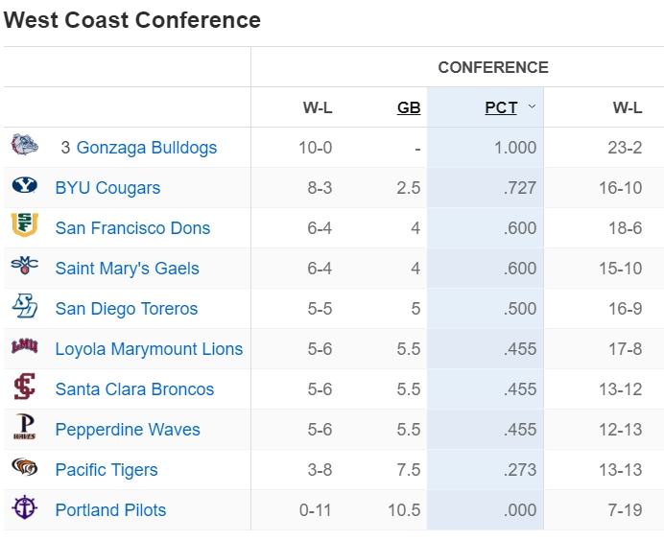

Television Timetable

BYU vs. San Diego (M Basketball)
Thursday February 14 at San Diego
Tipoff: 7:00 pm MST
TV: TheW.tv
BYU vs. LMU (M Basketball)
Saturday, February 16 at Los Angeles
Tipoff: 2:00 pm MST
TV: TheW.tv
BYU vs. San Francisco (M Basketball)
Thursday, February 21 at Provo
Tipoff: 7:00 pm MST
TV: BYUtv
BYU vs. Gonzaga (M Basketball)
Saturday, February 23 at Spokane
Tipoff: 8:00 pm MST
TV: ESPN or ESPN2

