HB Arnett’s

“Lite”
hbarnett@fiber.net
801 372 0819

Vol. 37, Issue 3-A – July 14, 2018

Cougar Clicks

After my 1 ½ year stint as a missionary in Michigan and 7 months of adjusting to the “old” Arnett ways, it’s all starting to come back to me. Seems that besides publishing a newsletter, Cougar Sportsline, I used to have hair and liked Bruce Willis movies. Apparently, I also sent out “Cougar Clicks”. That would be links of anything BYU sports related that I came across on line and wanted to share.

So, in the spirit of old movie stars without hair, almost adjusted, and the Arnett Way, I will also begin sending out Cougar Clicks to those who signed on for receiving CS Lite. Both are free. Just click on the names below and read the pertinent articles. All I ask is that you consider buying one of my Putt Partners. See below for details.

Taysom Hill | Joe Critchlow | Jeff Grimes | Dave Rose
Pejorative pining for the MWC | Jesse Wade | Alexa Gray | Jesse Wade Again
Long walk for Pennsylvania walk-on | Conover Coming in 2020 | Fesi Sitake | Tejan Koroma
----------------------------------------------------------------
It’s Simple
Above the line is Free!
Below the line keeps it free when you purchase

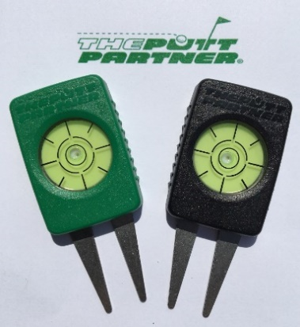

Keep it Free!
Click here to make it so!

Thanks, your pal, publisher and putt partner, HB

