HB Arnett’s

“Lite”
hbarnett@fiber.net
801 372 0819

Vol. 37, Issue 4 – July 16, 2018

Tetons Tell 5-year History of BYU Football…Plus Record for This Season

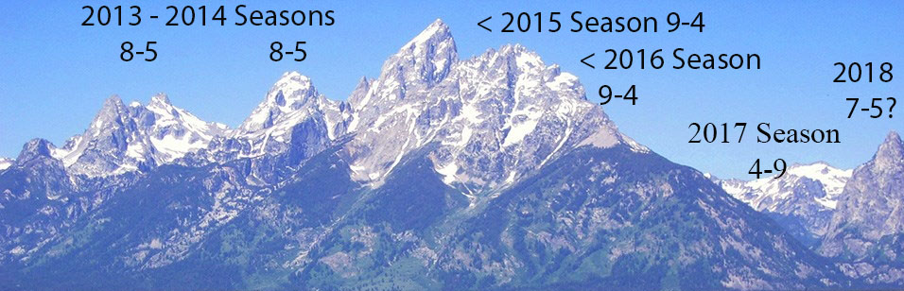

I’ve never climbed the Tetons, but I do know what pitons are. I use them on my salad all the time. Speaking of the Tetons, I looked on line to see what the going rate was for a hotel in Jackson with which I’m familiar and have stayed at many times.

The on-line rate of $394 per night, plus tax and fees ($419) made sleeping in my car enticing. It didn’t entice my wife, however. She strongly encouraged me to find other accommodations and arrangements.

Divide $419 by 24 (hours) and it would have me paying $17.45 per hour for a one-day stay at a 2-star hotel (according to the internet). Since I am meddling in math, here is another calculation to consider.

Decent BYU sideline football tickets last year cost about $350. That worked out to be $58.33 per game. The average game time for the six contests was 3 hours and 5 minutes. That works out to paying $19.45 per hour to watch a 2-star football team go 2-4 in Provo. The wins were against Portland State and San Jose State. If you are looking to put a price on wins, the BYU season ticket holder ended up paying $113 per hour for those two wins over Portland State and SJSU.

I’d take the Tetons over a BYU 2-win-at-home season every year. Maybe that’s why the Tetons and my brain are telling me that BYU can win 7 games this season.

For that to happen, I take you to another mountain range just a state away from Wyoming.

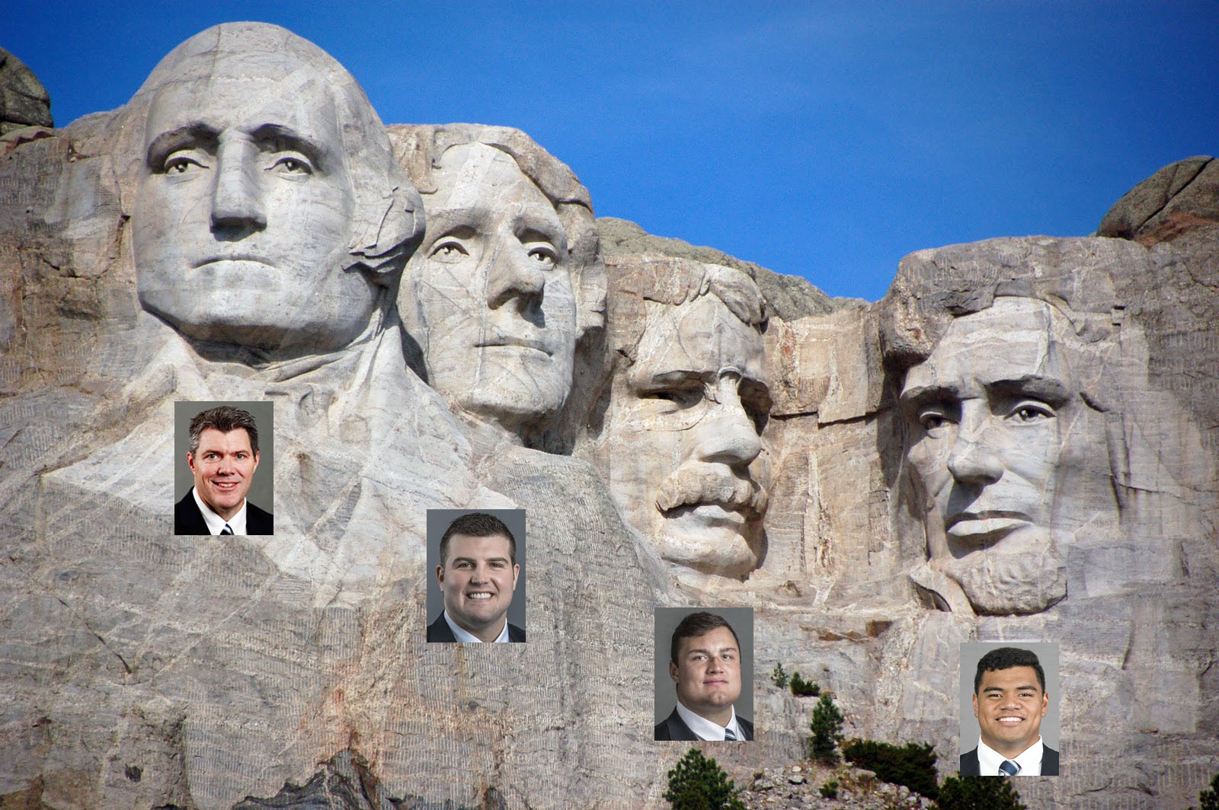

BYU Is Going to “RushMore” and Succeed at It!

When you can rush the ball consistently, you are going to win 7 games, even against a fierce and fiery schedule.

BYU won’t have another Jamaal Williams on the roster this season. Quite frankly, in my opinion, the BYU running back roster is very ordinary. No matter, the running game for BYU will be greatly improved because of the four BYU Mount Rushmore heads above.

Starting at the left in the photo, you have new offensive coordinator, Jeff Grimes, offensive line coach, Ryan Pugh, Tristen Hoge, the Notre Dame transfer, and Ului Lapuaho, finally back after 2 years of injury rehab.

A good ground game starts with a little football genealogy. Grimes and Pugh come with SEC football pedigrees. In the SEC there are 5 options for offense. 1. Run the ball. 2. Run the ball. 3. Run the ball. 4. Punt. 5. Think about passing on third down, run instead and then punt.

This is not rocket science. If you run the ball effectively in the SEC, you are always going to be knocking on the door of a National Championship. It’s obvious that Grimes and Pugh, with Kalani Sitake’s consent, are going to see if running the ball consistently will take them from 4-9 to 9-4.

To run the ball in the SEC, it is a given that you are going to have NFL caliber running backs. You also are going to find NFL caliber offensive linemen.

That’s the rationale for posting pictures with a Mount Rushmore background of Hoge and Lapuaho. Hoge, is a Fighting Irish transfer and after winning an NCAA appeal will be a sophomore this season. He saw action at Notre Dame and was in the mix for starting his sophomore season at South Bend before transferring to Provo. He has a legitimate shot at playing at the next level.

Bronco Mendenhall (remember him) said a few years back when Lapuaho was playing for the Cougars and healthy, that the Hunter HS product had potential to play in the NFL.

With the new offensive hires, BYU has firmed up its formula for winning games. Here’s the formula expressed visually.


Never Bring a Knife to a Gun Fight!

Harrison Ford represents what 9 teams did to BYU last season. The sword wielding villain represents BYU’s lack of running game last year.

My opinion for this season is that the Cougar offense will be packing much more “heat or guns” when it comes to their running game. It will come in handy if the BYU passing game still looks shaky and unsettled. If the quarterback and passing game goes from unsettled to just decent, I will up my win total to 8 games this coming season and throw away the “tombstone talk” for BYU football’s program.

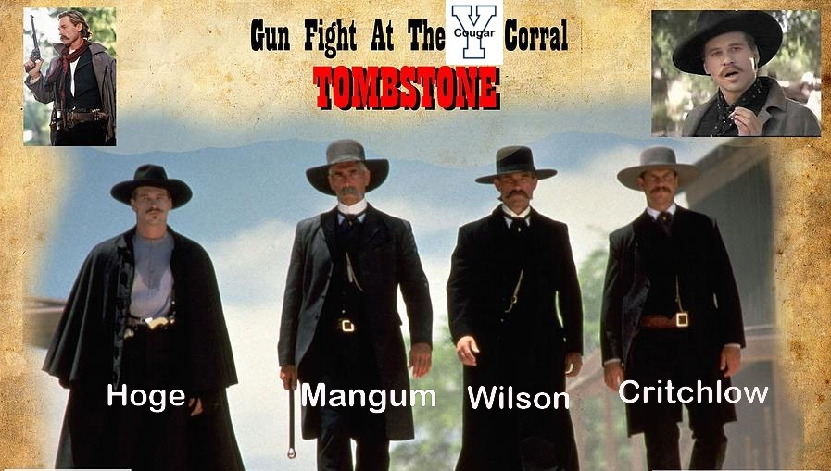

If there is some serendipitous surprise at quarterback this fall camp and there is a BYU “throwback” at the helm of this offense, then I’ll re-up for another stay in the Tetons and you can re-up your BYU football ticket purchases.

Cougar Clicks
Cougar Clicks are links to anything BYU sports related that I come across on line and think are interesting enough to share. Just click below and see for yourself. Yes, it is still free.

Nate Austin | Elijah Bryant | Ty (Detmer) Today | Tejan/Algernon/KC
Alexa Again (Gray) | BYU recruiting…A familiar story | Tanner Mangum | Moroni 18:17  (Pututau)

----------------------------------------------------------------
It’s Simple.
Above the line is Free!
Below the line keeps it free when you purchase



Keep it Free!
Click here to make it happen!

Thanks, your pal, publisher and putt partner in golf and BYU Sports,
HB

