HB Arnett’s

“Lite”
hbarnett@fiber.net
801 372 0819

Vol. 38, Issue 31/32 – March 5, 2019

Lung Rhymes with Dung Which Describes How I Have Felt the Last 10 Days

I apologize for not publishing the newsletter the last couple of weeks.

I think I have a good excuse. I wouldn’t exactly call it a near-death experience, but I did see the light and found myself going towards it.

Turns out it was just a Flying “J” Truck Stop in Boise. That’s where I spent more than a week in bed at my daughter’s home with a cough that wouldn’t go away while hacking and hoping my lungs would outlast my limited supply of Diet Mountain Dew.

I tried all my go-to Shaquille O’Neal and Wal Mart remedies. I used Icy Hot, Mucinex, Minestrone, Mike and Ike red hots, but nothing was working.

That’s when I compromised my medical standards and went main-stream. I saw a doctor. No, she wasn’t seeing patients at the Flying “J” but did diagnose me with a case of “Gonzageria”.

It’s not that rare of a disease these days. The primary symptom is that your blood pressure and the BYU-Gonzaga score are the same: 102/68.

She prescribed me something called Benzonatate. The pills looked a lot like Mike and Ike’s, but didn’t taste as good.

Then she threw in a freebie prescription and it has worked wonders.
She prescribed watching the following video 3 times a day to cure all long-term effects of Gonzageria. It worked for me.

Click to Watch and for the cure

WCC Tourney Prescription
Benzonatate for BYU?

What is Benzonatate used to treat? This medication is used to treat coughs caused by the common cold and other breathing problems (e.g., pneumonia, bronchitis, emphysema, asthma). It works by reducing the reflex in the lungs that causes the urge to cough.

There is no specific description on the effectiveness of this drug when it comes to choking. In case you forgot, BYU will now be playing either Santa Clara, San Diego or Portland Saturday night in Las Vegas in WCC tourney action. Game time is set for 10:00 pm Mountain Time and will be telecast live on ESPN2.

They coughed or choked away, depending on your BYU Benzonatate perspective, the No. 2 seed by losing at home to San Francisco.

The BYU women have earned the No. 2 seed and are scheduled to play in the semifinals on Monday, March 11, at 2 p.m. PDT. The Cougars will play the winner of No. 3 seed Pepperdine vs. No. 6 seed Pacific, No. 7 seed Santa Clara or No. 10 seed San Diego.

The game tips off at 3 pm Mountain Time and will be broadcast live by BYUtv.

Three of a Kind
Spring Football Poker

I’m not a poker player. I had to look up poker hands from highest to lowest.

Here is what I found:

Poker Hands From highest to lowest.
- Royal Flush. The best possible hand in Texas hold'em is the combination of ten, jack, queen, king, ace, all of the same suit.
- Straight Flush. Five cards of the same suit in sequential order.
- Four of a kind. ...
- Full house. ...
- Flush. ...
- Straight. ...
- Three of a kind. ...
- Two pair.

Again, my expertise is not poker hands, but it doesn’t take much of a read to tell that this fall could be anywhere from a Royal Flush, Straight Flush or just Flush with the likes of Utah, Tennessee, USC, Washington and Boise State on the schedule.

What BYU does have in its favor is four of a kind at quarterback and a full house on the offensive line.

They are also working on a three of a kind recruiting hand.

There is a reason that Baylor Romney will see reps this spring. First and foremost, he has some qb skills, he also is the older brother to current Cougar teammate Gunner Romney and BYU’s top high school prospect for the coming year. That would be Tate Romney, a 6-2, 210 pound linebacker from Chandler HS in Arizona.

Romney, the qb, prepped in El Paso and not at Chandler. He does have game. Gunner Romney also has game, we just haven’t been allowed to see it with a new offense and injuries that plagued him all season long.

The younger Romney may be the most talented of all the Romney’s. His recruiting offers have gone through the ceiling. His current offers include scholarships from Utah, Colorado, Vanderbilt, Washington State, Yale, Iowa State, Cal, Northwestern, Arizona and BYU.

Here’s Grimes Take on First Day of Spring Practice

Click to Watch

Spring Ball Stats
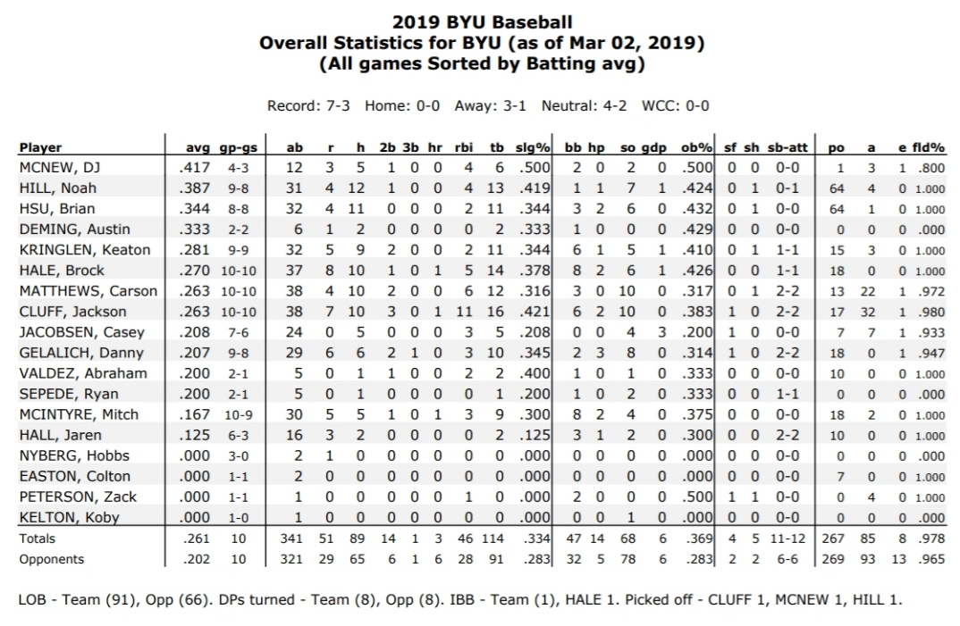

For those wondering if dung lung is an actual diagnosis, I have included the following photo of my sick self and the doctor checking me out with an under the hood examination in Boise.
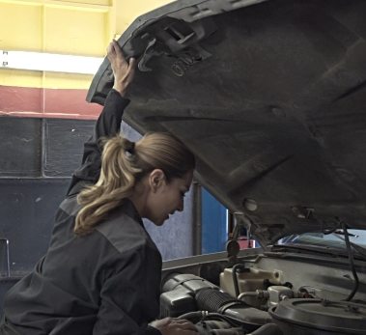

I also am providing medical proof from the University of Utah that dung lung is real and so is the UofU. Click here for proof. Cold fusion photos to follow.

