HB Arnett’s

“Lite”
hbarnett@fiber.net
801 372 0819

Vol. 38, Issue 26, - January 21, 2019

I’m Coming out of the Closet!

Trust me, I am feeling trepidation and anxiety in making this personal announcement, but after 38 years of hiding it, now is my time for truth.

I attended my first women’s basketball game last Thursday. I am not ashamed.

I have been on the fringe of female basketball for a couple of decades. With the advent of BYUtv, I have seen snippets of games, but never experienced an actual game in person…until last Thursday.

Please, don’t judge me. Let me explain.

My wife is very supportive of my disclosure. As a couple, we have probably the best Church calling we have ever held. We are part of a North Orem 7-Stake SNAP program serving as advisors and counselors. SNAP is an acronym for Special Needs Adult Program. It’s the closest I’ve been to heaven.

A couple of months ago, the BYU women’s basketball team visited us and put on a clinic for these extra-special individuals. These women effused personality, poise and were engaging and enthusiastic and very charitable with their time and talents.

As part of their presence and presentation, they gave us as a group free tickets to one of their games. Turns out it was last Thursday’s barn burner against WCC powerhouse Gonzaga. BYU won 70-68.

What I saw was intensity, talent, will to win and some darn good basketball when viewed in the lenses of perspective and delineation of gender limitations when it comes to dunking, jumping and quick twitch muscles. There was no limitation, however, in shooting, rebounding and ball handling.

It was good enough and intense enough, that I actually stood up and yelled at the referees. That’s when my wife turned to me and said, “You are really into this game, aren’t you?”

Yes, I was. I thoroughly enjoyed myself. There! I said it. I have actually come out of the closet and will say something I have never said before. I enjoyed myself and could actually see myself taking in another game in person again. (If the tickets are free!) Did I mention that one of the ancillary benefits of this game is that there were no lines at the concession stand?

I was intrigued enough to check out on TV Saturday’s game against Portland. It didn’t get intriguing until BYU overcame a massive deficit and finally defeated the Pilots with a 16-0 run late in the fourth quarter. The final: BYU 79 Portland 71.

Recap of the Gonzaga and Portland games

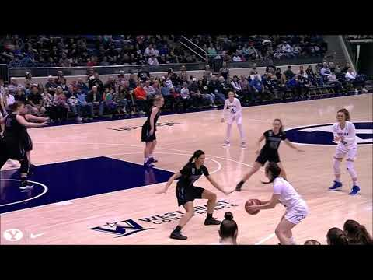

Going Back in the Coaching Closet

Last week I wrote that coaches are overrated, and the success of BYU basketball and football are determined by the talent level of the players on those rosters.

I was immediately subpoenaed to the stand for cross examination by two subscriber attorneys, both of whom are trained to be analytical, rational and thoughtful. I have always respected their opinions.

Here is what I said in last week’s newsletter:

Cougar football is not about coaching. It is also about Church players. The more and better members of the Church you can get and recruit, the better your team will be out of necessity because you aren’t going to ever sign big time non-Church recruits.

Here is what they said in response.

HB: I agree with most of what you write except that against good teams in close games, Coaching makes a huge difference. There were several football games over the last three years that BYU lost because of poor field decisions, play calling and defensive alignments. Moreover, coaching makes a big difference in teaching the fundamentals, conditioning and game preparation. Neither Sitake nor Rose shine as above average (even mediocre) in all of these areas.

HB: Jim McMahon was not LDS. Steve Sarkisian was not LDS. Ty Detmer was not LDS. LaVell's great teams were loaded with players and coaches who were not LDS. BYU football would still be a steaming pile of dung if not for the NON-MORMON players and coaches who put the team on the map.

A great coach is mostly a manager. He figures out how to get good players. He figures out how to get good coaches. He figures out how to win and how to sustain a successful program.

Nick Saban is not a football genius. He's a great manager, and Alabama is the most accommodating venue possible for someone like that. When Saban had to win based just on his "coaching," in the NFL, he was a flop. (That was also true of Lou Holtz, another great manager but not a brilliant football mind.)

When you argue (as you do) that it's all about players, and that they have to be LDS, and that there aren't enough of them around, you're apologizing for mediocrity. You've become part of the problem.

If I were in charge, I'd fire Tom Holmoe and I'd fire Dave Rose. I'd extend Kalani Sitake. He's got the right attitude; he hates losing; and he's willing to do the things necessary to win. He deserves total support from the administration and from the school's trustees, and he deserves at least five years to show what he can do. Saddling him with an untested Ty Detmer was not the right thing to do. I'd make it clear to Sitake that he will get full support, but that he's expected to make the team better, at least a little bit every year.

Too often in the Provo/LDS environment, people say that so-and-so is a "good person" and that consequently they're entitled to a job. Dave Rose is without question a good person. But he can't win championships. He's had the greatest access to Mormon talent in the history of the school, and he's squandered it. He has to go. I'm angry just thinking about what Rose has done with all those great players. Nothing--that's what he's done.

BYU fans have to stop apologizing for failure. The rest of the world ignores us. There's this illusion that we're still doing OK. No. We're invisible. We don't matter anymore. Do we have the stuff to do something about it, or do we not?

What do you think? BYU beat Pepperdine on the road last week 87-76. Was it great coaching or a great night by TJ Haws’ 34 points?

Two days later, still on the road, San Francisco handled BYU with ease 63-82. Was it poor coaching or poor play? Yoeli Childs did have 25 points, however.

If you are still undecided, more evidence to back up your point of view will be on display this week at the Marriott Center. Saint Mary’s and Gonzaga will both be coming to town with the Gaels set for a Thursday appearance and the Zags in on Saturday.

Television Timetable

BYU vs. Saint Mary’s (M Basketball)
Thursday, January 24 at Provo
Tipoff: 9:00 pm MST
TV: ESPN2
BYU vs. Gonzaga (M Basketball)
Saturday, January 26 at Provo
Tipoff: 9:00 pm MST
TV: ESPN2

A Picture is Worth 1000 Words, But What About 1000 Yards Rushing?

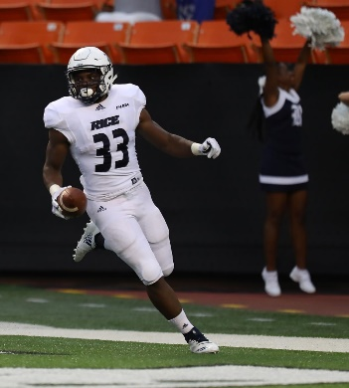
BYU is recruiting Emmanuel Esukpa, a graduate transfer from Rice. He was recruited to Rice by current BYU running back coach, AJ Steward. Esukpa is 5-11, 230 pounds. Here is his bio from Rice’s 2018 Press Book.

2018
Second on the team with a career-high 461 yards and 51.2 per game... Topped 100 yards for the second time in the first three games, finishing with 104 on 17 carries at Hawai’i... First Owl to top 100 twice in the first three games since Charles Ross in 2013... Scored on a 51-yard run vs. Hawai’i, his second straight game with a carry of over 50 yards.... Set up the Owls first score vs. Houston with a career-best, 52-yard run... Smashed his career bests with 32 carries and 173 yards vs. Prairie View... Rushing total was the most for an Owl in an opener since Trevor Cobb opened a season that would end as the winner of the Doak Walker Award by rushing for 197 yards at Northwestern to open the 1991 season... Total was the most for an Owl since Sam McGuffie ran for 178 at Tulsa in 2010... Start vs. Prairie View was the second of his career.
2017
Rushed for 261 yards on 57 carries and scored one touchdown while playing in 10 games (1 start)… Made his starting debut in the opener vs. Stanford in Sydney, Australia… Top effort for the season was a 56 yard output (six carries) and a touchdown vs. Army… Yardage total established a single-game best… Ripped off a 29-yard run at UTEP for his longest run from scrimmage in his career... Rushed for 165 yards and a touchdown and added a 5 yard TD reception in the Blue-Gray Spring Game to cap off a standout 2018 spring camp.
2016
Scored a pair of rushing touchdowns this year while battling injuries... Rushed for a career-high 24 yards at USM, including a career-long carry of 15... Saw his first action in the backfield against Baylor, rushing for 16 yards on six carries and scoring his first career touchdown... Scored in his second consecutive game with a one-yard run at North Texas.
2015
Redshirted.... 2016 C-USA Commissioner's Honor Roll.
Mansfield High School
First team All-District 8-6A as a senior at Mansfield for coach Jeff Hulme ... Ran for 743 yards on 125 attempts (5.9 per carry) and scored 10 touchdowns... Added a 61-yard TD on his lone pass reception...Two-year starter... Also participated in track... Member of state qualifying 4x200 relay as a sophomore.
Personal
Full name: Emmanuel Ukelabuchi Esukpa... Born: Nov. 28 at Dallas... Parents: Stanley and Millicent Esukpa (one brother, one sister)...Rice Major: Sport Management...
Ancillary Amusement…at least for me

BYU’s Ballard Center Apologized for Allegedly Insensitive ‘Taco Tuesday’ Instagram Post

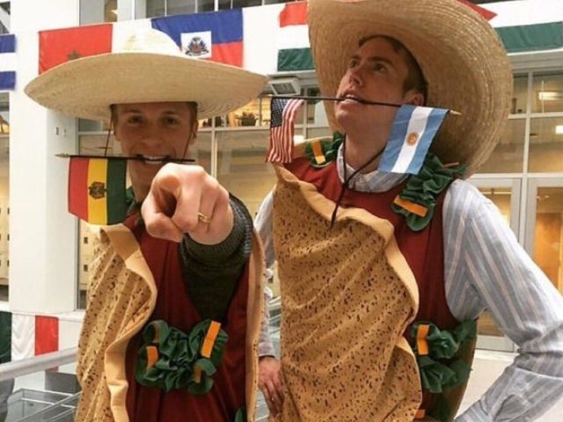

Click Here to read story.

And while I’m at it, let me retroactively apologize for BYU students and their tradition of throwing taco shells on the LaVell Edwards Stadium football field after touchdowns. That happened a few decades ago and was a traditional way of celebration until administrators put a stop to it.

Not because it was racist and insensitive but because it took too much time and effort to pick up the taco shells so the game could continue. In those days it was an issue because BYU was scoring 5-9 touchdowns per game.

And what about the University of Arizona? I remember sitting in the McHale Center a decade or so ago for my daughter’s graduation. The tradition then and still is, that graduates throw tortillas at the podium and all over the arena to celebrate their academic achievements.

Since I have come out of the closet and confessed about women’s basketball, I should also confess to the following costumes that I would like to wear that are insensitive, racist and non-politically correct.

I hereby pre-apologize in advance to China, The Navajo Nation, Brazil, France, Switzerland, Poland, Chile and Germany.

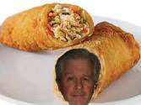
Chinese Egg Roll


Navajo Fry Bread

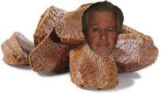
Brazil Nut

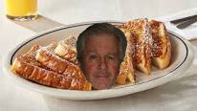
French Toast

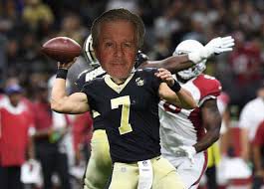
Swiss Army Knife

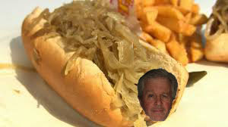
Polish Dog

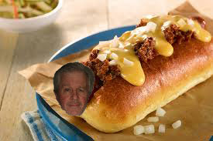
Chili Cheese Dog (Where I served
a mission, we pronounced it Chile Cheese Dog)

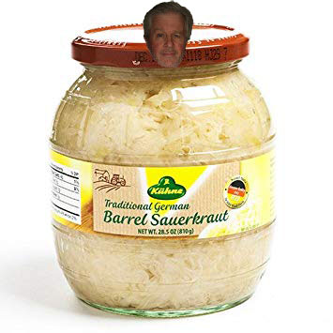
Germany

