HB Arnett’s

“Lite”
hbarnett@fiber.net
801 372 0819

Vol. 38, Issue 30, - February 18, 2019

Cougars Sweep SoCal Road Games

BYU Playing Tonya Harding Basketball

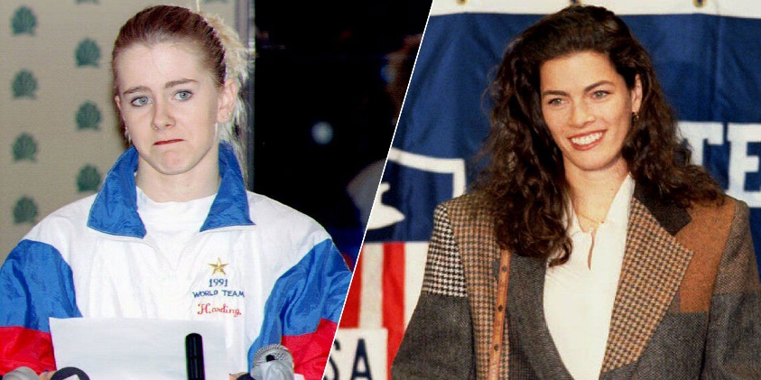

Tonya Harding and Nancy Kerrigan

Here’s Wikipedia’s description of Harding:
Tonya Maxene Harding; born November 12, 1970 is a retired American figure skater.
A native of Portland, Oregon, Harding was raised primarily by her mother, who enrolled her in ice skating lessons beginning at age four. Harding would spend much of her early life training, eventually dropping out of high school to devote her time to the sport. After climbing the ranks in the U.S. Figure Skating Championships between 1986 and 1989, Harding won the 1989 Skate America competition. She was the 1991 and 1994 U.S. champion before being stripped of her 1994 title, and 1991 World silver medal. In 1991, she earned distinction as being the first American woman to successfully land a Triple Axel in competition. She also was a two-time Olympian and a two-time Skate America Champion.
In January 1994, Harding became embroiled in controversy when her ex-husband, Jeff Gillooly, orchestrated an attack on her fellow U.S. skating rival Nancy Kerrigan. Despite the controversy, both women were selected to compete at the Winter Games in Lillehammer, where Kerrigan won the silver medal and Harding finished eighth. After the Games ended, Harding was not charged in the attack but pleaded guilty to hindering the prosecution and was banned for life on June 30, 1994 from the U.S. Figure Skating Association.
My Take

Ok, here’s my take on Tonya Harding and BYU Basketball. Harding had a lot of baggage that she carried around during her career, but the bottom line is that despite the drama and damage of her off the ice escapades, she was an extraordinary athletic skater. She proved that by becoming the first woman to land a Triple Axel in competition.

For most of this season, BYU basketball has been emulating Harding, on the court. There have been plenty of beatdowns and baggage during the current 18-10 season.

There has been a revolving door in the rotation and starting five. There have been games when there was little to no defense played. Dave Rose has been accused of being over the hill and over-signed to a two-year extension. Nick Emery came late to the party, Josh Seljaas came late to the shooting party. Throw in the transfer/non transfer of Jashire Hardnett and the only thing BYU hasn’t done this season is take a baton and beat the kneecaps off Gonzaga. The next kneecap opportunity will be this Saturday in Spokane.

The Zags are still the Nancy Kerrigan and King of the WCC. But despite the distractions of Harding’s off-the-ice dramas, she was a fantastic skater. Could it be that after all the in-season distractions, dramas and mind boggling losses, BYU could actually be a very good basketball team?

This is the week we find out.

San Francisco is first up on the docket as the Don’s face BYU in Provo on Thursday. Then, as mentioned, it is on to Spokane for a second chance at Gonzaga on Saturday.

Television Timetable

BYU vs. San Francisco (M Basketball)
Thursday, February 21 at Provo
Tipoff: 7:00 pm MST
TV: BYUtv
BYU vs. Gonzaga (M Basketball)
Saturday, February 23 at Spokane
Tipoff: 8:00 pm MST
TV: ESPN or ESPN2

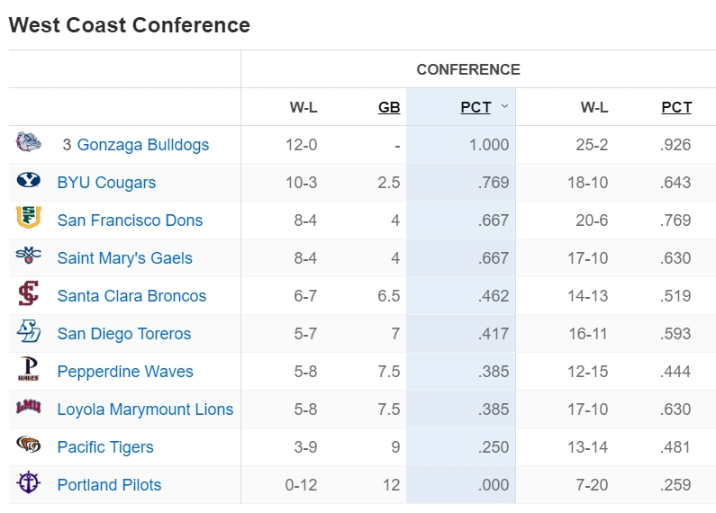


Harding and Baxter showing their spin moves on ice and hardwood

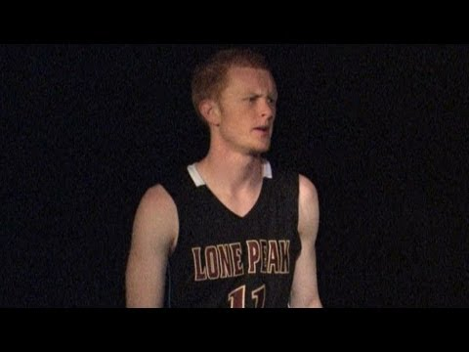

No Harding, but Harden (as in James of the NBA) for TJ Haws as he puts up 35 on San Diego. Couldn’t find any video highlights of TJ Haws putting 35 points on San Diego, but this high school video will give you an idea of how he played against the Toreros. Warning, Haws play is spectacular, but the audio is much less so. Turn it down.

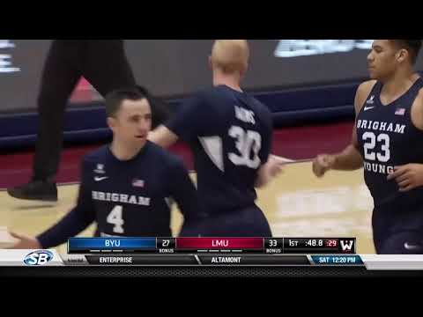

BYU Beats San Diego

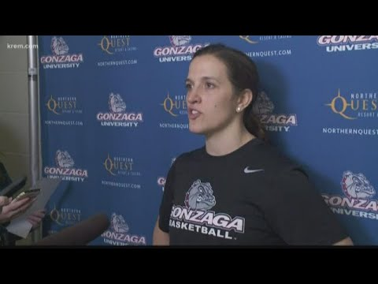

BYU Women Showing their Moves in WCC Standings Against Gonzaga with 66-64 Win

Going, Going, Gone? Coming, Coming, Here?

BYU is still looking for a running back to bolster that position for the fall.

The latest name to surface is Ty’Son Williams from South Carolina.

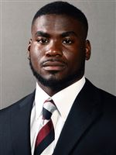
Click Here to get more info on Williams. And Click Here for even more information.

Get the latest on national transfers and graduate transfers by Clicking Here for the TRANSFER PORTAL

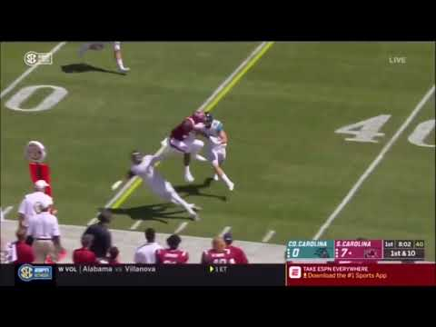

Click arrow above for video of Williams at South Carolina

