HB Arnett’s

“Lite”
hbarnett@fiber.net

Vol. 37, Issue 2 – July 3, 2018

Happy 4th of July!

Now would be an appropriate time to re-read the Preamble to the Constitution as we celebrate the birth of our nation tomorrow.

Speaking of preambles, July is also the month leading up to all the hype of a BYU fall football camp beginning in August. There hasn’t ever been a fall camp in Provo where the tenor and talk hasn’t been about how improved BYU is, how they will be nationally ranked and the surprise team of the nation. It is just the nature of the beast.

Every coach in America is going to honk and hype his team. That’s how tickets are sold. There is always an exception, however. Bronco Mendenhall may be an exceptional coach, but he is also sometimes the ultimate exception.

So, I have 30 days before I start honking and hyping the BYU football horn and mushing and gushing along with all the other media types about the three T’s of BYU football. That would be Testosterone, Tackling and Talent.

Of the Big Three, an improvement in talent will be what we should be looking for.

Meanwhile, it is still July, so I want to talk about the 3M’s.

MERIDIAN, MIRANDA AND MENDOZA

Meridian…I’ll be in Meridian, Idaho with all my immediate family gathered from many states to celebrate my birthday July 22. I won’t tell you how old I will be, but I can give you the 3M hints.

I’m younger than Mitt. I’m older than Madonna and the same age as Mathers. Think Leave it to Beaver and let’s leave it at that. If I take a step up in the alphabet and talent, I’m also going to be the same age as one of the greatest rock singers of all time. Stevie Nicks. Don’t know if fall football camp will get my blood pumping, but this Nicks’ classic with Tom Petty always does.

As Anne Shirley of Green Gables says, Nicks and I are kindred spirits. We were both born in Arizona and both have lived in Utah during our lives. We both have profited from singing. She gets paid to do it and I get paid to not do it.

Miranda…as in Miranda Rights. “You have the right to remain silent. Anything you say can and will be used against you in a court of law. You have the right to an attorney. If you cannot afford an attorney, one will be provided for you. Do you understand the rights I have just read to you? With these rights in mind, do you wish to speak to me?”

These are my rights as publisher of CS Lite. I can write what I want unless I, or you the reader, find it objectionable (think the 3P’s, prurient, pornographic or Pro Ute).

As for the definition of objectionable or “Pro Ute”, I refer you to Supreme Court Justice Potter Stewart who said in the Jacobellis case in 1964 involving obscenity “I shall not today attempt further to define the kinds of material I understand to be embraced within that shorthand description; and perhaps I could never succeed in intelligibly doing so. But I know it when I see it”.

Me, too! I know “Pro Ute Propaganda” when I see it and you won’t see it in this letter.

As for your rights, since you are receiving the letter for free, you don’t have any, other than to quit reading. (I am happy, however, to receive feedback and contributions, both positive and negative.)

Mendoza…as in The Mendoza Line… The Mendoza Line is an expression in baseball in the United States, deriving from the name of shortstop Mario Mendoza, whose poor batting average is taken to define the threshold of incompetent hitting. The cutoff point is most often said to be .200 (although Mendoza's career average was .215) and, when a position player’s batting average falls below that level, the player is said to be "below the Mendoza Line". This is often thought of as the offensive threshold below which a player's presence on a Major League Baseball team cannot be justified, regardless of his defensive abilities. The term is used in other contexts when one is so incompetent in one key skill that other skills cannot compensate for that deficiency.

So, what’s the current Mendoza Line for Kalani Sitake and Dave Rose? Both are nice guys and good guys, but how many wins will it take this year and possibly next to justify their continued employment as head coaches at the revenue sports of BYU. And what is the Mendoza Line for Tom Holmoe? Does he have one? Should he have one?
Both Sitake and Rose have exercised their own Mendoza Methods for their staffs. Especially Sitake. He has “Mendozed” most of his original staff out the door.
Here it is in chart form.
Position | 2016 (Then) | 2018 (Now)
Head Coach | Kalani Sitake | Kalani Sitake
Offensive Coordinator | Ty Detmer | Jeff Grimes
Defensive Coordinator | Ilaisa Tuiaki | Ilaisa Tuiaki
Quarterback Coach | Ty Detmer | Aaron Roderick
Running Back Coach | Reno Mahe | AJ Steward
Offensive Line Coach | Mike Empey | Ryan Pugh
Tight End Coach | Steve Clark | Steve Clark
Wide Receiver Coach | Ben Cahoon | Fesi Sitake
Defensive Line | Steve Kaufusi | Ilaisa Tuiaki
Linebackers | Ilaisa Tuiaki | Ed Lamb
Safeties | Ed Lamb | Preston Hadley
Cornerbacks | Jenaro Gilford | Jenaro Gilford
Director of FB Operations | Russel Tialevea | Jon Swift
Strength and Conditioning | Tafisi Nu’u, AJ Middleton | Tafisi Nu’u, AJ Middleton, Justin McClure
Director of Athletic Relations | Jasen Ah You | Position Closed
Support Services Coordinator | Position Didn’t Exist | Jasen Ah You
Director of Recruiting Operations | Tevita Ofahengaue | Position Closed
Development & On-Campus Recruiting Coordinator | Position Didn’t Exist | Tasha Player
Director of Player Personnel | Jack Damuni | Alema Fitisemanu
Community Relations Director | New Position Created | Jack Damuni
Director of Player Development | Sione Kinikini | Position Closed

Here and Gone: Here is a list of those employed by Sitake and BYU in 2016 that are no longer employed by BYU Football: Ty Detmer, Reno Mahe, Ben Cahoon, Mike Empey, Steve Kaufusi, Russell Tialevea, Sione Kinikini, Tevita Ofahengaue.

Now for the Mendoza Line for Rose. How many Mendoza makeovers and do overs does he get before he wins a regular season or tournament WCC Basketball title? For those counting, it is now 6 seasons and counting without a title.

For Holmoe, the Mendoza line is trending up and down, with down the latest result, when it comes to the Learfield Director’s Cup. The Cup indicates the overall strength of an athletic program by ranking all programs.

This year the Cougars finished No. 45 in the Director’s Cup. That’s the Cougars worst ranking since 2009 when they came in at 47. Here are the last ten rankings for the Cougars. 2009 – 49; 2010 – 36; 2011 – 37; 2012 – 43; 2013 – 43; 2014 – 42; 2015 – 38; 2016 – 30; 2017 – 31; 2018 – 45.

*Religious Relapse...I’m still not too far removed from Michigan missionary service, so I can still say this, believe this and you can even quote me on this.
.
“I’m grateful there is no Mendoza Line in the Plan of Salvation”. Click for reference and read 23-30

JACK SQUAT AND JACK MORMON
I’ve been told many times over the years that I don’t know Jack Squat, but I’m pretty sure I dated his sister in high school. Enough personal teenage trivia, however.
You might know Jack Mormon. Pretty sure he coached somewhere in Utah in the early 50’s. In case you are a little fuzzy on his coaching tree and te line, here is what I discovered about him.
But can he coach at BYU? Non-members can play at BYU and non-members can coach at BYU, but what about a Jack-member or Jack Mormon?
If a JM wants an athletic employment authorization and an OK, he will need an EE. That means ecclesiastical endorsement. That will entail a PPI where they will ask about your math skills. They will ask you if you know what 10 percent of your income is.
So, a Jehovah’s Witness, JW, and technically a Hari Krishna, HK, can coach at BYU, but not at the highest (HC) level, but a Jack Mormon, JM, can’t.
So that puts an end to the always thought of MLM. No, not Multi-Level-Marketing, but Mike Leach Maybe?
Just a thought, but a passing one. Yes, pun intended. And yes, I’ve always wondered what happened to Jack Squat’s sister.

Free Lite Lunch and Football National Championship for BYU!
Ok, the free sandwich is true (aka free CS Lite Subscription), but you’re a sucker if you fall for the Cougar football fable.
Just trying to get more readers to read the fine print below and pay attention to the financing of the free lunches (subscriptions).

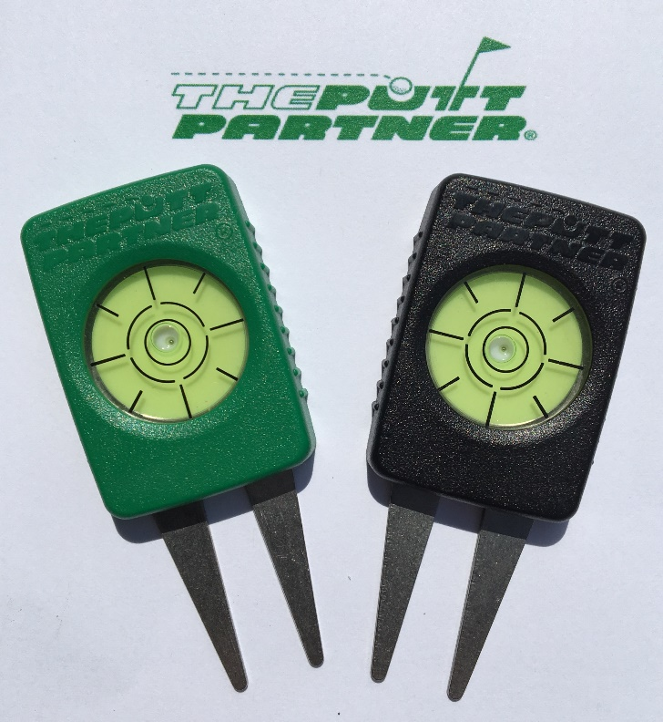

I have developed a new golf product that is
now available on Amazon.com.

All proceeds from sales of this product go directly to me, HB Arnett, and will help provide the Free CS Lite Lunch you are currently reading!

Today’s Cougar Blue Plate Special is (s)Quid Pro Quo!

There is no charge for the newsletter, All the tentacles and strings are removed from your free Cougar Sportsline Lite subscription, but any help in my marketing of The Putt Partner on Amazon is greatly appreciated.

If you are a golfer, know a golfer, or just are curious or magnanimous, the more sales and reviews I get on Amazon will greatly influence the continuation of the newsletter. I am especially in need of reviews, positive if possible.
Even if you aren’t a golfer but know golfers, I’m hoping you will send your friends and family to my Amazon detail page. You can access it and order by
Clicking Here.

Thanks, your pal and putt partner, HB

