HB Arnett’s

“Lite”
hbarnett@fiber.net
801 372 0819

Vol. 37, Issue 7 – August 1, 2018

Shoes and Dues is Encouraging for BYU Football

Like everyone else, when BYU opens football practice this week, my eyes will be on the quarterbacks and receivers. Like everyone else, we will be looking at the wrong thing.

If BYU hopes to revive its football program, it will start with the offensive and defensive lines. Just my opinion, but of all the new coaches hired, they key guy will be Ryan Pugh, the new offensive line mentor.

BYU will go as he and his group go.

From what I can see, Pugh is a guy that knows what he wants and gets it. Check out this video for an illustration of his intensity.

Now check out this photo to see a couple of offensive line names that may be unfamiliar.

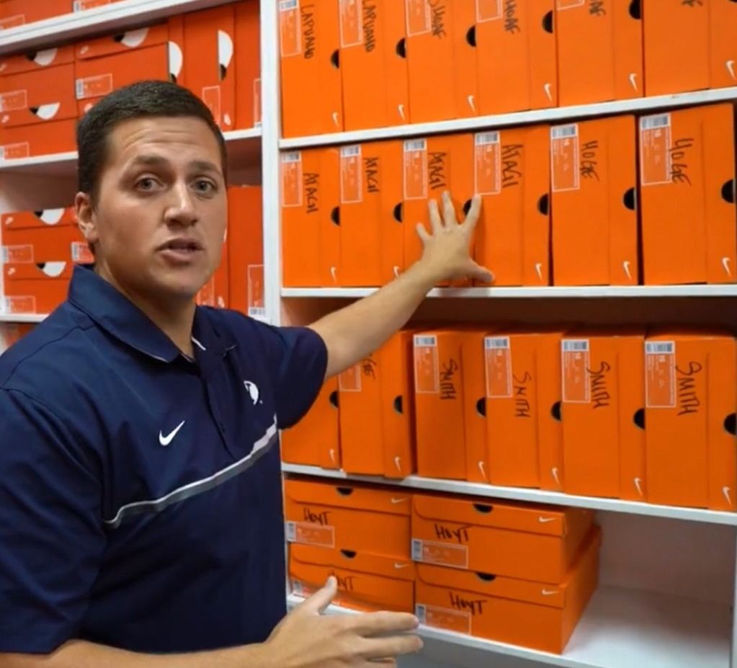

Names you should recognize are Lapuaho, Shoaf, Hoge and Hoyt. Names that you may not be familiar are Atagi and Smith. If they are getting shoes, they are in camp.

Here’s the BYU bio on Atagi. Here’s some scoop on Smith.

This guy is not in camp, but he will be on campus September 8 for the game against Cal. His name is Darrin Smith.

Saints Can’t Tailor for Taysom….Yet!

Interesting read on Taysom Hill and his development at New Orleans and how it is a coaching conundrum.

If Mangum wins the starting QB job and plays well, do BYU coaches have the same problem getting the next guy ready for next season?

In Recruiting International Basketball Players at BYU, is There a Gender Bias?

There was a time when BYU men’s basketball recruited foreign basketball players. There might be some hope that it may resume. We will see. Some while back, I read an interesting take on BYU basketball and foreign recruiting. You might also find it interesting.

Meanwhile, men’s volleyball, and this year, women’s basketball, has a boatload of foreigners. Here’s the roster for the BYU women this year.

The real kicker for foreign recruits at BYU is the language proficiency deal.

Am I the only Mormon that finds extreme irony in the fact that a block away from the Marriott Center is one of the finest, if not the finest, language training facilities in the world, but BYU basketball or any other campus sport can’t be involved in any language training?

It might be time for the Ah Choo compromise. If you can sneeze in English and can make a three-point shot, BYU admission administrators should show some leniency.

As a basketball recruiting postscript, they speak English in American Fork.



I’m no longer marketing the Putt Partner on CS Lite. I’m still selling on Amazon. I appreciate all those who were supportive of the product.

The bottom line of this announcement is that I’m going to sell subscriptions to the letter. I will honor all those whose previous subscriptions were in place before the mission and make good on all those putt partners that were bought.

Not sure what the price platform will be, but it will be reasonable, if not downright cheap. I should have the website up and running sometime later this week, but will advise and advertise when subscriptions kick in.

hb

