HB Arnett’s

“Lite”
hbarnett@fiber.net
801 372 0819

Vol. 38, Issue 1, August 3, 2018

Walmart Weighs in on Every State’s top Seller (Click to see yours)
This is important for BYU fans from Utah planning on traveling and attending away games.

I Weigh in on BYU’s Top Players for Every Position
*These are not Walmart’s opinions, but mine based on three days of fall practice without pads or pressure on player’s performance. I will have an updated opinion after the Arizona game when BYU will play against another team with real talent, real coaches and real intent to bash in the head of BYU.

**Top Player may not necessarily mean that player will start or see action this season, but just my opinion. My opinion could be devalued somewhat because I’m hearing that I might be currently under consideration to become a new cabinet member that will soon be announced: Secretary of Prostate. For those not familiar with the location of this male gland, it is located just in front of the rectum. Politically and anatomically, I should fit right in.

Quarterback: Zach Wilson. This guy is the real deal. Size, mobility, big arm and confidence. His real test will be when he faces a real team intent on bashing in his head. On paper and in practice, this guy can play. Still don’t think he will start the season for the Cougars.

Running Back: Multiple Choice. A. Squally Canada B. Beau Hoge C. Zach Katoa D. All the above. Not much to choose from here. This part of offensive production will be very pedestrian again. If I’m wrong I will give this group a chance to get even with me. I will walk across University avenue (not in the crosswalk) and they can take their shots at me.

Receiver: The Collie brothers. That would be Dylan Collie and, if healthy, Gunner Romney, an Austin Collie clone. One more WR who has taken three years to get there but I still like, is Talon Shumway.

Offensive Lineman: Jacob Martinez isn’t a household name, but he will hold down the house of the offensive line. Will be the starter at center and be major surprise for those who haven’t been paying attention.

Tight End: A Matt Bushman in hand is worth three in the bush. Fortunately for BYU, there are others in the bush waiting to play. They will have to be good to unseat Bushman from this spot. Put these names in your burning bush and smoke for future reference. Moroni Pututau, Dallin Holker and Hank Tuipulotu.

Defensive Line: Uriah Leiataua. If he as hard to block as his name is to pronounce he should be good. Otherwise, I’m staying politically correct with Corbin Kaufusi. Speaking of politics in Provo, his mother is the current mayor of the city.

Linebacker: Hands down: Sione Takitaki. A playmaker with an NFL future.

Defensive Back: Anybody that could make the two-deep at Utah. Best guess would be Jenaro Gilford, in his prime. I need a name here, so I will go with Troy Warner.

Special Teams: It’s been a while since anybody has stood out, but I give the nod to this guy for this play last season. Brayden El-Bakri

Coach: Kalani Sitake. He has had more shake up on his staff and roster than Trump, but he still smiles and is still personable. Now we will see if the roster and staff changes can put a smile on BYU fan’s faces. That answer should come in September.

BYU MVP: Still to be determined, but my early vote goes to Jack Tuttle, the freshman QB at Utah. If he hadn’t committed early to the Utes, Zach Wilson would be practicing in Salt Lake and not Provo this past week.

Christian McCaffrey Lite?

Remember the 5-11, 205 all-purpose running back from Stanford? He was drafted in the first round of the 2017 NFL draft by Carolina. He was a phenomenal player in college and a go-the-distance-type threat every time he touched the ball.

Beau Hoge is a very long way from being a McCaffrey clone, but he is the closest thing to it BYU has. He also is currently listed on the Cougar roster at 6-1, 220. He is also listed as an RB/QB.

BYU coaches are hoping Hoge can put some much-needed juice in the BYU running game this season. He may be the answer to an anemic running game projection, despite a much improved and productive offensive line.

We shall see how this goes. If you want to see video of McCaffrey in college and Hoge in high school watch here and watch here. Ok, I’d settle for McCaffrey Extra, Extra Lite for Hoge.

Top 5 High Schools in Basketball Success Nationally for the last 5 years as rated by MaxPrep.com

Academies…1. Monteverde Academy, FL; 2. Oak Hill Academy, VA; 3. Findlay Prep, NV; 4. La Lumiere, IN; 5. St. Benedict’s Prep, NJ

Public Schools…1. Garfied, WA; 2. Apple Valley, MN; 3. Shadow Mountain, AZ; 4. Memphis East, TN; 5. Simeon, IL

Private Schools…1. Bishop Montgomery, CA; 2. Mater Dei, CA; 3. DeMatha, MD; 4. Neumann-Goretti, PA; T5. Greensboro Day, NC; T5. Bishop Gorman, NV

Top 5 High Schools where BYU has recruited and signed players for the current roster of 2018-2019 as reported in byucougars.com.

Public Schools…T1. Timpview, Utah County; T1. Lone Peak, Utah County; 3. Provo, Utah County; 4. American Fork, Utah County; T5. Bountiful, UT, T5 Bingham, UT, T5 Shelly, ID, T5 Orem, UT, T5 Highland, ID, T5 Rocky Mountain, ID, T5 Borah, ID

Top 5 College Coach Frequent Flier Miles used for Recruiting as speculated by oldmancougar.com and documented by frequent runs in NCAA post season tournaments

1.Kentucky, John Calipari, 2. Arizona, Sean Miller, 3. Kansas, Bill Self, 4. Duke, Mike Krzyzewski, 5. Gonzaga, Mark Few. T107. Jeff Neubauer, Fordham, T107. Dave Rose, BYU.

Cost per Mile

If I was the sarcastic and curmudgeonly type, I might write the following: According to Google Maps, the distance between the Marriott Center and Timpview HS in Provo is 2.1 miles. Assuming the cars donated to BYU coaches by local dealerships average about 18-20 miles per gallon and assuming Cougar coaches make at least 15 trips to the school while recruiting prospects. That works out to be about 32 miles.

Based on those numbers and the current $2.92 per gallon cost of gas locally, BYU spent $3.50 per recruit for the 3 Timpview players that will be on the roster together in 2021.

Waste not, want not and (maybe, win not).

But, being the soft-hearted observer of BYU sports that I am, I will say emphatically, that BYU basketball coaches appear to be good stewards of their recruiting budgets.

When you remember that Rose and staff went 2500 miles to get Jimmer Fredette, then the cost per recruit rises to $11.53 per player. In case you forgot about him, he resurfaced last month in The Basketball Tournament. If that doesn’t ring a bell, maybe this video of Jimmer ringing Gonzaga’s bell might help.

Speaking of Timpview, Nate Hansen, a 6-3 guard from THS committed to BYU and will sign with them later this year. He joins Hunter Erickson, another 6-3 guard from Timpview who signed last year with the Cougars. He will serve an LDS mission first. I assume the same for Hansen.

The cream of the Timpview crop is recently returned missionary Gavin Baxter. The 6-9 athletic forward has a future not only at BYU but beyond. Think a taller and more athletic Yoeli Childs.

No sarcasm here. He is the real deal.

Not a Killer Schedule…A Mueller-Mauler Schedule

If Robert Mueller is a special prosecutor, then so is Tom Holmoe. The BYU football schedule for September is prosecutorial, persecutorial and just plain painful if you are Kalani Sitake and his staff.

Two top ten teams within three weeks on the road, is brutal. Two Pac 12 teams to open the season will set the tone for how this year plays out. One is at home, the other on the road. Here’s hoping BYU is not the Washington Generals to this Harlem Globetrotters schedule where wins will be very, very hard to come by. The Generals generate hope for BYU this season. I still call the Cougars to get a minimum of 7 wins this year and to appear in a bowl game. Read this for a Generals update and hope for BYU against its Mueller and Mauling schedule.

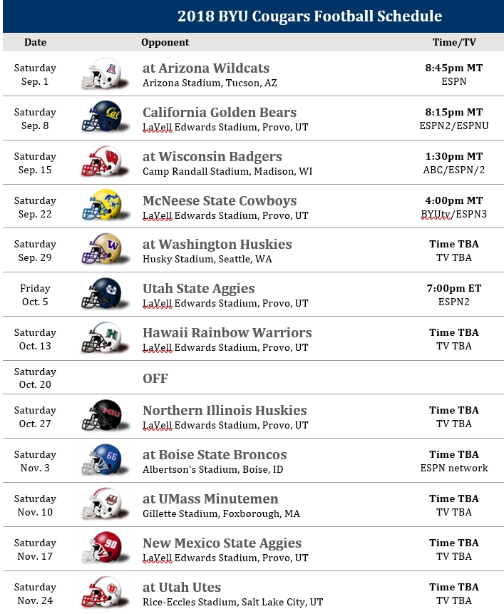

Never Too Early to Talk Arizona and Season Opener…Let Kevin Sumlin do the Talking

It was interesting and entertaining to hear Arizona first year coach Kevin Sumlin address the Tucson media Friday after the Wildcats first practice. A lot of what he said applies to all coaches preparing for a season opener and that includes Kalani Sitake and BYU. He sounds like Sitake, just wearing a different shirt and hat.

Here’s what Sumlin said on first day.

Here is what Sitake said on first day. His second day.

Arizona opened as a -15 point favorite, but the line is now down to -13.5. I don’t gamble, but my best friend in high school was the head oddsmaker at the Stardust for a couple of years before he started publishing his own tout sheet. Before he died a few years back from brain cancer, he used to call me to get my take on BYU and the spreads.

If he was alive today and called, I would tell him to take the Cougars and the points. If he was alive and called today wanting to know my opinion about the LDS Church versus the world, he’d get the same answer. Take the Church and the points as an underdog.

