HB Arnett’s

“Lite”
hbarnett@fiber.net
801 372 0819

Vol. 38, Issue 18, - November 26, 2018

(Alexander)Pope Pipes in on BYU Losing Streak to Utah

Alexander Pope (1688 – 1744) was an 18th-century English poet. He is best known for his satirical verse. He is the second-most frequently quoted writer in The Oxford Dictionary of Quotations after Shakespeare. Inspector Lewis comes in third.

He never covered BYU football or basketball for the Salt Lake Tribune, Daily Herald or Deseret News, but if Pope did, what he wrote centuries ago would be very appropriate when he penned the following without even knowing he was panning the Cougars.

“Vice (aka losing to Utah in football) is a monster of so frightful mien
As to be hated needs but to be seen;
Yet seen too oft, familiar with her face,
We first endure, then pity then embrace.”

Three in a row was hard to endure. Five in a row was pitiful. Eight in a row and counting is now expected and embraced.

Did you really think BYU could beat Utah last week? Me neither.
Did you really think Auburn could beat Alabama in Tuscaloosa last week? Me neither.
Did you really think Michigan would beat Ohio State in Columbus last week? Me neither.
Did you really think Washington State would beat Washington? Me neither.
Did you really think Bronco and UVA would beat VA Tech in Blacksburg? Me neither.
Did you really think Utah State would be Boise State in Boise? Me neither.
Did you really think BYU’s coaching staff would out game plan and out coach Utah’s staff?
Me neither. But they did just that for the first half of the eventual 35-27 loss.
Did you think BYU coaches made some questionable decisions in the second half? Me too.
Did you think those questionable decisions cost the Cougars the game? I didn’t.

Most football decisions are decided by personnel. BYU ran out of personnel.

Next Man Up!

Utah’s head coach is famous for saying “Next Man Up” when an injury occurs on his team. He is made out to be a great and gutty coach for that saying. He can say it and mean it because he actually has a depth chart. He has players that are not that far in distance and depth in quality and talent from the players who start.

BYU can say the same thing, but it doesn’t mean the same thing. That’s because BYU doesn’t currently have a depth chart. They have a player chart. Suiting up doesn’t mean you can play and contribute. There is a big, big difference, in my opinion, and it showed in the second half of last Saturday night.

I’m not letting coaches off the hook, but they know what they have on their rosters, and sometimes coach to protect those rosters from being exposed and exploited by coaches on the other side of the field.

Here are the players that saw the field for the Cougars against Utah as starters.

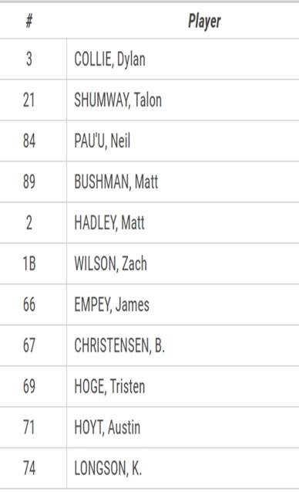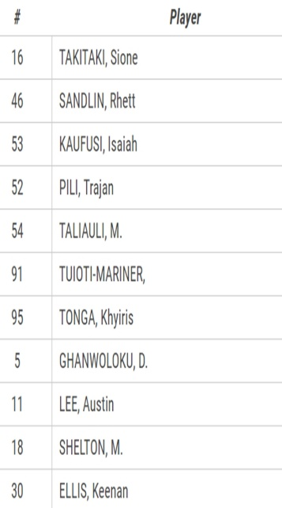

Here are the rest of the roster that saw the field

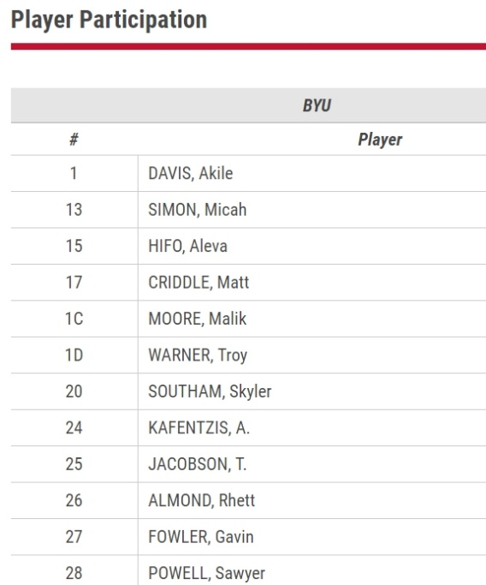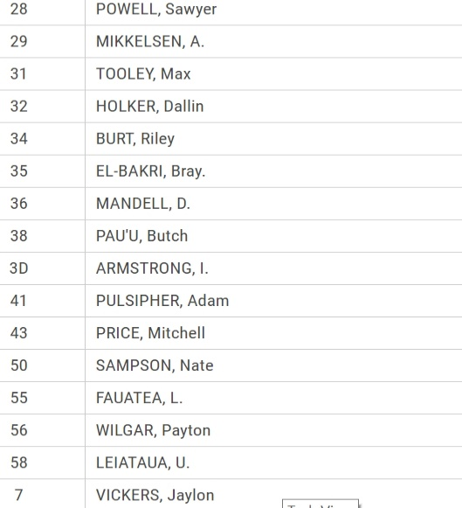

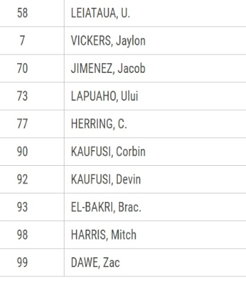

Dunce or Depth?

I understand the current debate about BYU’s football coaching staff. Are they just inexperienced? Are they just not the the sharpest Converse in the closet, the brightest Adidas in the attic or does Nike Apparel stop at the neck at BYU?

I get it. Some coaches seem to be brighter than others. If coaching requires geniuses, then Tom Holmoe is looking in the wrong places for candidates. Start checking out think tanks, not talent ranks. There have been a few coaches who left the profession and were elected to Congress. See, that proves my point. It’s not rocket science.

It’s players. The more you have that have talent and skill, the better your chances at winning.

I know my intellectual limits because I also know my IQ and belt size. Both are two digits and can comfortably cover my current waist line, but it is close.

Speaking of close, BYU coaches are very close to having the parts they need to participate competitively at the highest levels of college football.

They have a quarterback in Zach Wilson. If free agency existed in NCAA football, BYU would have to put the Franchise tag on him to avoid him making Bryce Harper or Manny Machado money this coming offseason.

He has also single handedly put the Franchise tag on Kalani Sitake and staff for one more season. His potential and talent are good enough for one more year for this staff. After that, they are on their own.

BYU has a very young and talented offensive line that put up very good numbers on the ground against a Utah defense that leads the Pac 12 in rushing yards allowed.

They have tight ends. They have serviceable receivers. What they don’t have is a deep threat that has to be respected.

But their biggest need is a legitimate Division I tailback. Get one of those and put him in the same backfield as Wilson and the football IQ of BYU’s offensive staff will balloon quickly. Heck, they might even run for Congress if they can come up with a 1000 plus yard rusher. It’s not rocket science. It’s the science of creating a crease and having the talent to see the crease, get through it and then have enough speed to make those rocket scientists on the other sideline wish they were smart enough to recruit you. When BYU admission administrators can figure that out, then BYU coaches can work their rocket science magic.

They are currently trying to work that recruiting magic with Las Vegas running backs. That is where BYU’s No. 1 juco recruit is from. Rhamondre Stevensen is his name and BYU wants him. The Cougars are also recruiting Ikaika Ragsdale, a 6-0, 195 pound running back out of Bishop Gorman. He is a junior and can’t sign until 2020. His parents are LDS. Not sure about his religious affiliation.

Here’s Some Suggestions for Solutions

When Nebraska football was good, it was because they had boatloads and hay balers full of walk-ons. BYU needs more walk-ons. The more you have the more chances you have to discover a real talent that wasn’t recruited. There are exceptions, but in most cases, a BYU football walk-on has to compete with the rest of the world for admittance to the Provo school. Hey, I’m all for academic integrity, but with an enrollment of 33,000 plus, can’t BYU find room for 25 LDS football walk-ons per year. That works out to be .00075 of the student body.


The sponsoring institution and Church of BYU is known for providing educational opportunities to its members. What about the Perpetual Education Fund? One of the more poignant, if not the most poignant experience of our missionary experience in Michigan was serving as Pathway Missionaries. We saw it change lives, including ours. The Church realizes the value of making education available to all. Why not for a few more football players? It would help BYU football and basketball, which would in turn helps BYUtv have a major source of free programing. Speaking of that, how about creating a major in TV programming. If North Carolina and other academic big shots can get away with fabricating special majors for athletes which allowed them to never go to class, the least BYU could do is offer TV Programming where only a “Studio C” grade point average is expected.

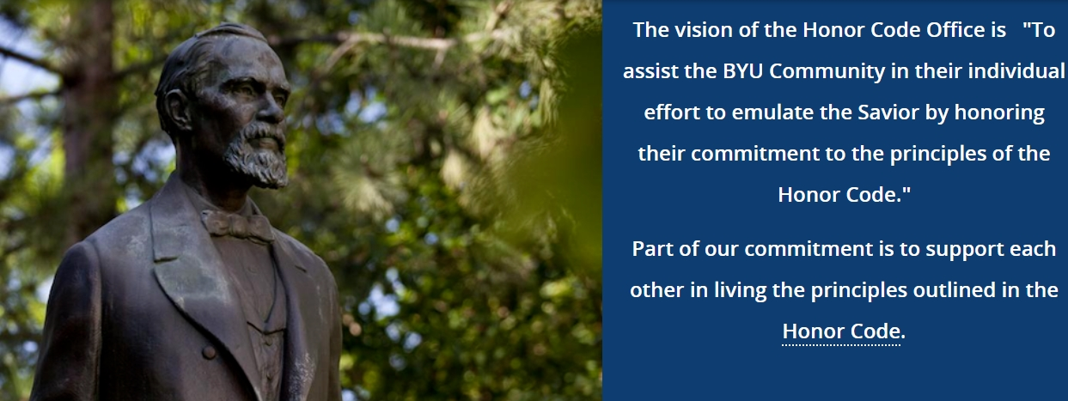

I am fully 100 percent in support of the Honor Code at BYU. It is the same Honor Code I have and have had in all The Church of Jesus Christ of Latter-Day Saints wards and branches in which I have resided during my lifetime. If I’m not mistaken, my personal Honor Code administrator is my Bishop, who has been called, sustained and set apart for his voluntary service. There might be exceptions, but it is my understanding that most Honor Code administrators at BYU receive an annual W-2 form. My Bishop doesn’t. The irony of the administration of the Honor Code is that BYU students already have a personal Honor Code advisor in the hundreds of Bishops already called, sustained and set apart for the calling that BYU apparently feels is redundant. Just my opinion, but it should be the Bishops, not the Honor Code Office, who decides who stays and goes.

Volleyball is a Game of Bump and Serve. The following is a game of Cut and Paste directly from BYU

PROVO, Utah – The BYU women’s volleyball program received the No. 4 overall seed in the 2018 NCAA Division I Volleyball Championships and will host the first and second rounds of the tournament Friday and Saturday.
Click here to view the 2018 NCAA Tournament bracket
The West Coast Conference champion Cougars (27-1) will face America East champions Stony Brook (21-8) at 7 p.m. MT in the Smith Fieldhouse on Friday while Pac-12 at-large Utah (18-13) and Summit League regular season champion Denver (27-2) will compete in the first match of the day at 4 p.m. The winner of each match will advance to the second round slated for 7 p.m. on Saturday.
Tickets for the matches go on sale starting Monday, Nov. 26, at 9 a.m. For complete ticket information, please click here.
BYU has been ranked No. 1 in 11 of this season’s 14 AVCA coaches’ polls thanks to a 27-match win streak that included victories over 10 of the 64 teams in this year’s tournament, including No. 1 seed Stanford, No. 14 seed Marquette, Duke, Loyola Marymount, Pepperdine, Saint Mary’s, San Diego, Syracuse, Utah and USC.
“We’re excited to head into the tournament as the No. 4 seed,” BYU head coach Heather Olmstead said. “We’re looking forward to another opportunity to play in the Smith Fieldhouse in front of our awesome fans.”
This year marks seventh-straight NCAA tournament appearance for BYU and the 31st overall, seventh-most in Division I volleyball history.
Teams winning both matches this weekend will move on to regional play December 7-8. The regional winners will advance to the national semifinals and championship final hosted by Minnesota on December 13 and 15 at the Target Center in Minneapolis, Minnesota. The national semifinal matches will broadcast on ESPN and the championship match will broadcast on ESPN2.

If You Get Caught with Your Hand in the Cookie Jar, Hopefully You Come Away with a Big Cookie

Let’s hope the Cookie Jar wait for Nick Emery is worth it.

It is now painfully obvious that BYU basketball isn’t good enough or improved enough to make any serious waves in WCC play or NCAA post season appearances.

After the most recent 76-62 loss to Houston on the Marriott Center floor last Saturday, this team still lacks enough talent and athleticism to be a player on the national stage.

Unless, Nick Emery is the answer. The question is: Is he NBA caliber. The answer is no, and neither is anybody else on this BYU basketball team.

That doesn’t mean they won’t be entertaining to watch and cheer for. It just means what it means for Kalani Sitake. Dave Rose doesn’t have enough truly talented players.

At 5-2, they are certainly entertaining. Two more games against Illinois State and Weber State and we will find out if Emery will just be more entertainment or actual engagement and encouragement.

Television Timetable

BYU vs. Illinois State (M Basketball)
Wednesday, November 28 at Normal, IL
Tipoff: 6:00 pm MST
TV: The Valley on ESPN
BYU vs. Weber State (M Basketball)
Saturday, December 1 at Ogden
Tipoff: 7:00 pm MST
TV: Kjzz and WatchBigSky.com

Ask your Wife if it is Too Early for a Christmas Stocking Stuffer Idea!



Check out my Christmas gift or stocking stuffer ideas by clicking here:
theputtpartner.com

Thanks, HB

