HB Arnett’s

“Lite”
hbarnett@fiber.net
801 372 0819

Vol. 38, Issue 1- A, August 6, 2018

Size over Sense

Just read a nice piece in the Deseret News about Britain Covey, the returned missionary from Chile Rancagua, (been there done that) who will be back on the Utah roster this fall.

I followed this kid when he was at Timpview HS in Provo. He had it all, except size. He was quick, smart and slippery. He also was a sure-fire legacy recruit for BYU. Legacy lost in this recruiting battle. As you know, Covey became a Ute.

In hindsight, Utah’s sense overcame Covey’s lack of size. Size does matter when you are looking for a durable running back or a QB who can heave it down field, but athleticism is athleticism and works well on the field if that athleticism is utilized wisely by coaches. Utah was wise, BYU wasn’t.

No sour grapes from me. I will cheer for this kid because we are both former Chilean missionaries. Huasos and Abrazos are in our blood.

Head’s up, however. There may be another size versus sense saga coming down the BYU recruiting stream again. Write this one down: Braedon Wissler. The kid is utilized currently as a running back at Bingham HS. He won’t play there in college. He opened some eyes in Las Vegas this summer and apparently BYU’s eyes were also opened. They at least are now interested. We will see how this size vs. sense saga plays out.

Better Late Than Never

I had a thing a few weeks back that detailed the current salaries of former BYU Cougars in the NFL. I forgot to include the current highest paid Cougar. Here it is in $’s and ¢’s. Ziggy Ansah.

I was still in Michigan doing the mission thing when former Cougar and current NE Patriot, Harvey Langi and his wife were involved in a car crash. Here is a more recent update.

Not late. This happened to Tejan Koroma yesterday.

My Take on First Two Days of Post Practice Questions for Kalani Sitake

No question that Kalani is a people person and easy going with the media. What if he wasn’t? What if he went Dennis Green on the media?

I tracked some of the actual media questions for the first two sessions with Sitake this fall. Below are selected questions and my take on how a more volatile and vociferous coach might answer.

How do you like Beau at running back?
You saw our run game last year. We couldn’t get the juco running back we wanted. What would you do?

What were other reasons to precipitate that change?
We didn’t have Bo Jackson available, so we went with the Beau we had.

How’d the quarterbacks look today?
Let me quote Allen Iverson, that should give you my answer.

What type of objectives do you have for these early first couple of days as you kind of get back into the swing of things?
Do you have a mortgage? Me too. I’m just trying to save my job so I can pay it.

How would you assess your readiness level this year as opposed to the first two years?
I fired Ty Detmer. What do you think my readiness level is? Next question.

Are you happy with the conditioning level?
You’re fatter than me. Are you happy with your conditioning level?

You talked before about how the first year you had some player leaders that really kept things in line. Have you seen the same leadership that you want to see from the boys as far as making sure that things are done at the level you want them done?
What I want to see again is Taysom Hill and Jamaal Williams. Leaders are nice, but NFL talent is better.

How would you describe your teams practice tempo through 2 days?
This isn’t dance class. Slow, Slow, Quick, Quick. Tempo my behind. Give me talent and I can dance all day long.

What kind of progress do you expect from the kicking and punting game this season?
What is this? The World Cup. If you want a lesson in kicking, watch the Wisconsin replay from last season and see what they did to our posteriors in Provo.

This question wasn’t asked, but I wish it was.
Kalani, what does the slogan “The World is our Campus” mean to the football program?
Not much. There are billions of bodies, but we can only find one Ziggy Ansah?

Reno Revisited

Early last year, BYU had a verbal commitment from Ale Kaho, an ultra-talented LDS linebacker from Reno HS in Nevada.

He changed his mind and signed with the Washington Huskies. Last week he announced that he is leaving UW and not going to play for Chris Peterson. Several personal and family reasons were given for his change of heart.

BYU football fans immediately began hoping that he would somehow end up in Provo.
Some cited the new NCAA rule that doesn’t allows schools that signed a player to block that player from transferring to another school.

Here is a quick outline of how that new rule reads.

It’s a moot point for now. The new rule doesn’t go into effect until October 15.

Proof that BYU Basketball Recruits outside of Utah County

I took a potshot at BYU basketball recruiting last week by saying they only recruit in Utah County. It was supposed to be semi-humorous. Some didn’t think it was funny.
To show my open-mindedness and give visual proof that BYU recruits nationwide, I offer the following photo from last week in Las Vegas.

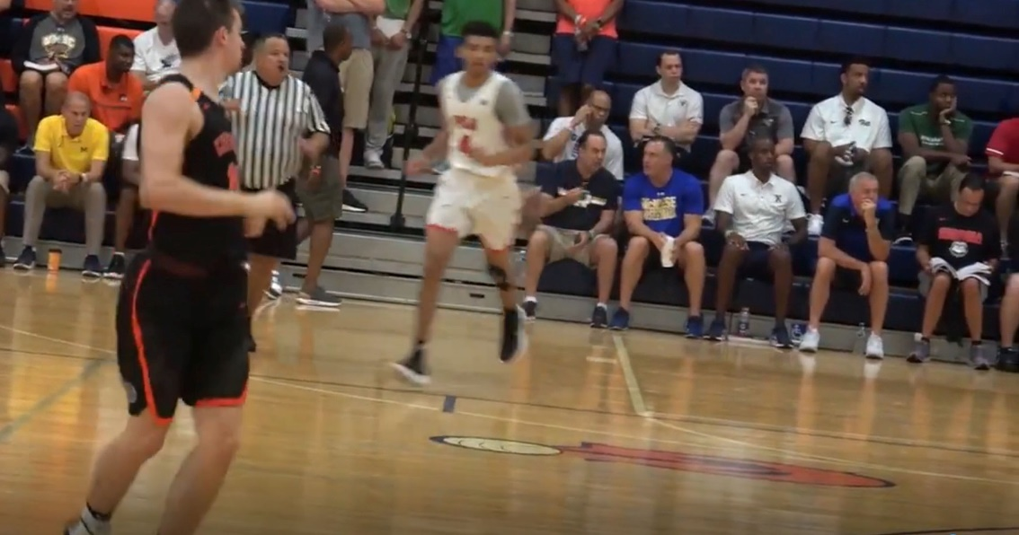

That is Dave Rose, bottom row, second from the right watching a game in the Las Vegas Fab 48 Tournament last week. It was PSA Cardinals of NYC vs. City Rocks of Albany, NY. City Rocks has Joseph Girard III playing. He broke Jimmer Fedette’s records at Glens Fall HS. BYU made a push, but he announced that his top six schools that have offered are Duke, Michigan, Notre Dame, Syracuse, Penn State and Boston College.

What’s a Good Clue that a Polynesian Football Prospect is LDS?

The fact that BYU is recruiting is your first clue. Need more confirmation? If Utah and Virginia are also recruiting, then it’s 99.89% sure that he is LDS.

Here are two prospects that bear that out. Aidan Keanaaina is a 6-2, 295-pound defensive tackle from Mullen HS in Denver. He recently made a visit to Ohio State. Others in the mix include CU, Nebraska, ND, Oregon, Wisconsin and of course BYU, Utah and Virginia.

Another prospect that has the LDS mark of the big three is Simote Pepa, another defensive tackle coming in at 6-2, 295. He is out of Bingham HS in South Jordan, Utah. Here’s a name that BYU is pushing hard and has a legit chance to land. Logan Sagapolu.

While Bronco Mendenhall’s recruiting net is much more diverse these days at Virginia, he still looks for LDS recruits, especially Polynesian recruits because he has a boatload of LDS Polynesian coaches and staff that get the door open for the Cavaliers. Here’s the latest UVA coaching staff.

Free Was Fun, But Not for Me!

The guy who said, "If wishes were fishes we'd all swim in riches” never published:


“Lite”

Turns out there weren’t enough golfers in my data base to make the marketing plan of “A Putt Partner in hand is worth two in the bush and bucks in the bank.

Which brings back the old tried and true marketing strategy I have used before.

“I write the letter, you write the check”

Enough Chit Chat.

The details are here:
oldmancougar.com

All those who bought Putt Partners or had credit from their old subscriptions will be taken care of. The rest of you I will be hoping to “reel in”.

Thanks,
HB Arnett

