
hbarnett@fiber.net
Somewhere in Orem
April 1, 2018

I’m still debating whether I want to continue publishing Cougar Sportsline or not. I will know sometime in July when I will have had time for a true read on what my golf handicap really is. Regardless of what the decision is, I will notify you either way. Meanwhile, I’m not sure I still can write anything interesting, so I am using this forum for a tiny trial run to help me in my decision making.

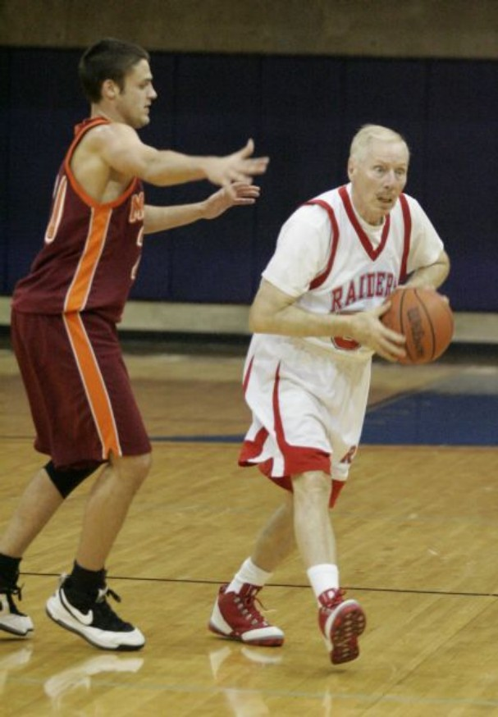
This is what “Elders Quorum Basketball” now looks like. New rules allow 9 seconds in the key and “shirts and skins” will be too wrinkly and just plain wrong. If there is anything virtuous, lovely, or of good report or praiseworthy, this is not it.

